Insulation Materials –

Product groups

Abstract
This learning unit presents the most important groups of insulation materials: for each insulation material, information is provided about raw materials, production, common areas of application, health aspects and disposal. Special attention is given to installing and practical tips.

Objectives
On completing this unit students are able to …
- Name the most relevant groups of insulation materials
- Name areas of application for individual insulation materials
- Select appropriate insulation materials for different areas (wall, roof etc.)
- Explain the most important rules for processing of insulation materials

Contents
Abstract 1
Objectives 1
1. Mineral insulation materials 5
1.1 Mineral wool 5
1.1.1 Raw materials and production 5
1.1.2 Areas of application 5
1.1.3 Processing/practical tips 5
1.1.4 Health aspects 6
1.1.5 Disposal 7
1.2 Foamed mineral panels 7
1.2.1 Raw materials and production 7
1.2.2 Areas of application 7
1.2.3 Processing/practical tips 7
1.2.4 Health aspects 7
1.2.5 Disposal 7
1.3 Calcium silicate panels 8
1.3.1 Raw materials and production 8
1.3.2 Areas of application 8
1.3.3 Processing/practical tips 8
1.3.4 Health aspects 9
1.3.5 Disposal 9
1.4 Expanded minerals (expanded perlite, expanded mica/vermiculite, expanded clay) 9
1.4.1 Raw materials and production 9
1.4.2 Areas of application 11
1.4.3 Processing/practical tips 11
1.4.4 Health aspects 11
1.4.5 Disposal 11
1.5 Cellular glass 11
1.5.1 Raw materials and production 11
1.5.2 Areas of application 12
1.5.3 Processing/practical tips 12
1.5.4 Health aspects 13
1.5.5 Disposal 13
2. Fossil-based insulation materials 13
2.1 Polystyrene, polyurethane, polyester, phenolic resin 13
2.1.1 Raw materials and production 13
2.1.2 Areas of application 14
2.1.3 Processing/practical tips 14
2.1.4 Health aspects 16
2.1.5 Disposal 16
3. High-efficiency insulation materials 16
3.1 Vacuum insulation 16
3.1.1 Raw materials and production 16
3.1.2 Areas of application 16
3.1.3 Processing/practical tips 17
3.1.4 Disposal 17
3.2 Aerogels 17
3.2.1 Raw materials and production 18
3.2.2 Areas of application 18
3.2.3 Processing/practical tips 18
3.2.4 Disposal 18
4. Insulation materials from renewable resources 19
4.1 Straw 19
4.1.1 Raw materials and production 19
4.1.2 Areas of application 19
4.1.3 Processing/practical tips 20
4.1.4 Disposal 20
4.2 Reed 20
4.2.1 Raw materials and production 20
4.2.2 Areas of application 21
4.2.3 Processing/practical tips 21
4.2.4 Disposal 21
4.3 Wood fibres and chips 21
4.3.1 Raw materials and production 21
4.3.2 Areas of application 22
4.3.3 Processing/practical tips 22
4.3.4 Disposal 23
4.4 Cellulose 23
4.4.1 Raw materials and production 23
4.4.2 Areas of application 23
4.4.3 Processing/practical tips 23
4.4.4 Health aspects 24
4.4.5 Disposal 24
5. List of figures 25
6. Legal notice 26

Mineral insulation materials

Mineral wool

Raw materials and production
Artificial mineral fibres are used for insulation in the form of glass or rock wool. They have very similar properties, but consist of different raw materials and are easily distinguishable at a glance. Glass wool is yellow, rock wool is brown.
The main constituent of glass wool is borosilicate glass. Rock wool is made from rocks such as diabase, basalt, dolomite and limestone. Up to 60 % of the raw material can be replaced with recyclates and production waste.
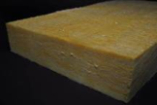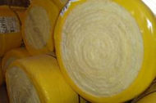
Figure 1: Mineral wool (source: GrAT) Figure 2: Mineral wool rolled up for storage (source: GrAT)
Producing mineral fibre:
https://www.youtube.com/watch?v=d7eHtMCK5r0

Areas of application
Mineral wool has many applications: rock wool insulation mats can be used as infill material for all lightweight structures, and in timber construction, e.g. for walls and roofs, but can also serve as insulation material in composite thermal insulation systems and curtain walls, and for floating floor screeds. Its thermal conductivity is very advantageous: λ = 0.032 to 0.045 W/mK.

Processing/practical tips
In order for rock wool not to lose its insulation effect, it should not be exposed to moisture and water, for example at the base of exterior wall structures.
The basic principles are: the substrate must be dry and clean, loose material must be removed. The substrate must be assessed as per ÖNORM B 6410. The wall must be flat enough to comply with ÖNORM DIN 18202. The substrate must not be exposed to moisture subsequently. No rising damp is permissible.
Installation: the adhesive can be applied all over the insulation panel. On a flat substrate the adhesive is applied with a combination of edge beads and dots; if the substrate is not quite flat, it is applied all over with a serrated trowel. Afterwards the panels are laid edge to edge and pressed firmly in place. In addition to bonding, they must be secured with suitable dowels.
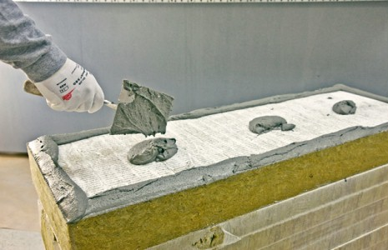 | 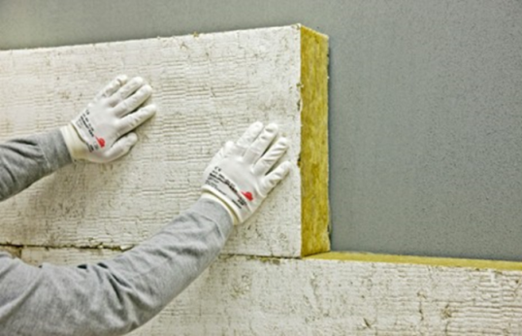
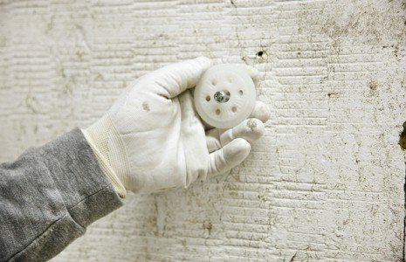 | 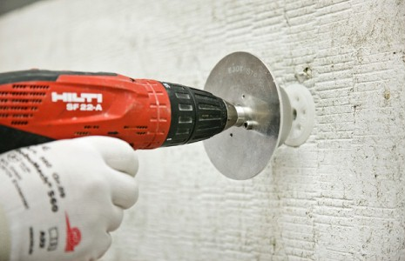
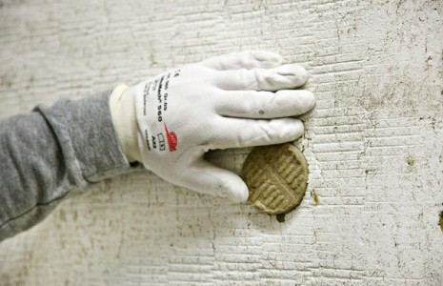 | 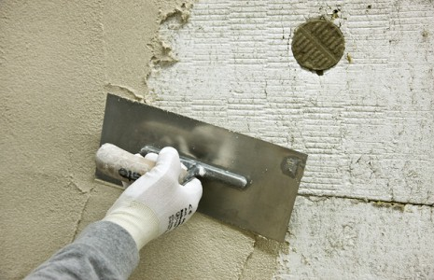
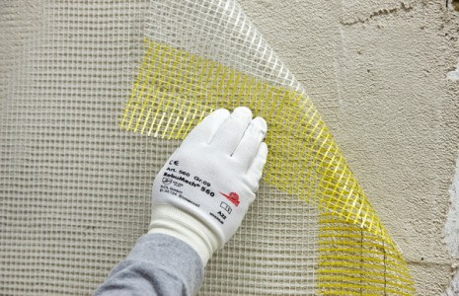
Figure 3: Processing of mineral wool panels (source: Sto SE & Co. KGaA)

Health aspects
Mineral wool can shed thin fibres which can cause mechanical irritation of the skin, the eyes, and the respiratory tract. If the fibres are long and thin and persistent in the body, cancer can be induced. This applies to mineral wool produced before 1996. Since then a switch has been made to products which are classified as safe.
When working with artificial mineral fibres, one should take care to minimize the amount of dust emitted. To achieve this, the materials can be stored accordingly, the building site should be as free as possible of exposed areas of mineral wool and should be cleaned up regularly during installation and removal.

Disposal
If mineral wool is removed undamaged it can be re-used. This does not apply to material produced before 1996, as artificial mineral fibres older than that date are classified as carcinogenic, mutagenic and toxic to embryos.
After use, mineral wool is disposed of at a landfill; material that has been produced after 1996 can be treated as non-hazardous.

Foamed mineral panels

Raw materials and production
Foamed mineral panels are made from lime, sand and water plus an air-entraining agent (e.g. surfactants, aluminium powder or organic substances). Due to its high pH value the insulation material is mould-resistant.
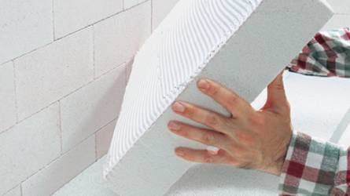
Figure 4: Foamed mineral panel for a composite thermal insulation system (source: Dennert)

Areas of application
Foamed mineral panels can be used in various areas, e.g. to insulate outside walls together with a composite thermal insulation system, or for indoor insulation without a vapour barrier. Their thermal conductivity is rather poor at approx. λ = 0.045 W/mK.

Processing/practical tips
Foamed mineral panels can be sawn or cut. Because their mechanical strength is relatively low, they must be handled carefully to avoid spalling. Usually the panels are also clad with plaster or gypsum boards. They are bonded by the dot-bead method and then secured with dowels.
Foamed mineral panels must be stored in a dry place.

Health aspects
In case dust develops, for example during cutting and grinding, dust masks should be worn.

Disposal
Foamed mineral panels can be re-used for sand-lime bricks and insulating plaster to some extent. What cannot be recycled must be disposed of at a landfill.

Calcium silicate panels

Raw materials and production
Calcium silicate panels consist of mineral ingredients such as lime (calcium oxide) and sand (silicon oxide) plus cellulose fibres and water. Water vapour (but also surfactants, aluminium powder, or organic substances) are used to entrain air. During production the panels develop a fine-pored structure.
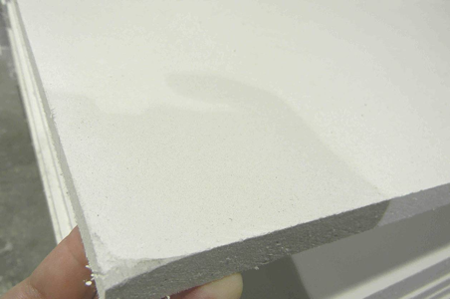
Figure 5: Calcium silicate panel (source: Achim Hering 2011; http://de.wikipedia.org/w/index.php?title=Datei:Promatect_250_sheets_corner.jpg&filetimestamp=20110616165151 - file)

Areas of application
With their fine-pored structure calcium silicate panels absorb moisture very well, and are vapour permeable at the same time, which means that any moisture absorbed can easily escape again. This is why calcium silicate panels are installed without a vapour barrier and are particularly suitable for indoor insulation (e.g. in listed buildings) or for renovating damp masonry. They are also used for roof insulation, cavity wall insulation and back-ventilated façades.
Calcium silicate panels’ thermal conductivity is relatively high, though, at a rather unfavourable value of approx. λ = 0.065 W/mK. The material is not cheap, either.

Processing/practical tips
Calcium silicate panels are processed like foamed mineral panels. They are easy to saw and drill.
The substrate must be clean and intact (cohesive). Non-cohesive plaster, dense paint and gypsum elements must be removed. For bonding the adhesive must be applied all over with a serrated trowel. The panels are aligned with offset butt joints.

Figure 6: Alignment of calcium silicate panels (left: correct; right: wrong)
Video on processing of insulation panels:
https://www.youtube.com/watch?v=njIDFfaDgGk

Edges of differing height at the butt joints can be ground level after drying.
Especially for interior insulation, panels should fully adhere to the surface so as to avoid air circulation behind.
No vapour-proof layers, such as tiles or wallpaper with several layers of coating, may be applied to calcium silicate panels, because this decreases their vapour permeability.

Health aspects
Protective clothing (dust masks, gloves, etc.) should be worn for processing calcium silicate panels.

Disposal
Remnants of insulation panels can usually be disposed of together with ordinary rubble.

Expanded minerals (expanded perlite, expanded mica/vermiculite, expanded clay)

Raw materials and production
Expanded perlite insulation materials are made from volcanic perlite. When ground perlite grains are heated to more than 1000 °C, they expand in volume. This is why they are classified as foamed mineral materials.
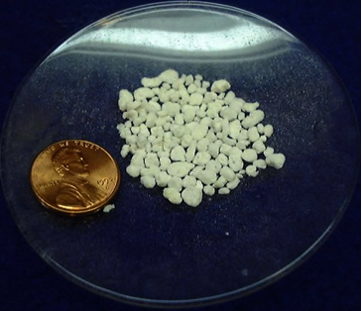
Figure 7: Expanded perlite (source: http://en.wikipedia.org/wiki/File:PerliteUSGOV.jpg)
If vermiculite, a mica-type mineral, is expanded, small air bubbles are created, which improves the insulation effect. Expanded mica can absorb moisture well without changing its loose consistency.
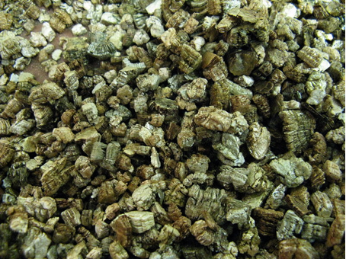
Figure 8: Expanded mica (vermiculite) (source: KENPEI, http://fr.wikipedia.org/wiki/Fichier:Vermiculite1.jpg)
Expanding fired clay produces small clay pellets, which can be bonded with cement as material for masonry.
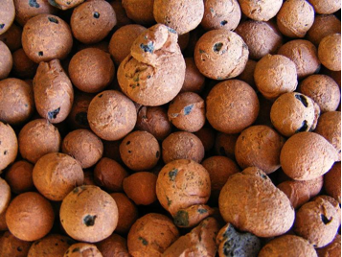
Figure 9: Expanded clay (source: Lucis 2007, http://en.wikipedia.org/wiki/File:Hydroton.jpg)

Areas of application
Expanded minerals can be used as loose-fill insulation material in cavities, or as levelling fill (e.g. for dry screeds).
Expanded perlite is also available as hydrophobated insulation for cavity walls and as panels, which can also be used where considerable pressure is involved (e.g. floors). Expanded mica is also used as an additive in building materials such as plaster, in order to prevent cracks forming due to temperature fluctuations. Bonded with cement, expanded clay is used as material for masonry; it is also an additive in lightweight concrete, mortar and clay.

Processing/practical tips
Expanded minerals can be used in all sorts of ways. Mineral insulation materials are non-flammable and thus suitable for structures with special fire protection requirements.
Quality control is particularly advisable with loose fills to ensure the necessary thickness of insulation.

Health aspects
During processing care should be taken that people on site are exposed to dust as little as possible; dust masks should be worn.

Disposal
If expanded minerals are correctly sorted on removal, they can be re-used in principle. Incineration or composting is not possible, though, so they must be disposed of at a landfill at the end of their useful life.

Cellular glass

Raw materials and production
Cellular glass is produced when glass is foamed with a foaming agent (carbon powder). Production costs are relatively high. Production is energy-intensive.
Cellular glass is available in the form of insulation panels or bricks, granulate/gravel, or as mouldings. It is resistant to pests, rot and frost.

Areas of application
Cellular glass is vapour diffusion resistant, rot-proof and resistant to rodents, insects, mould and chemicals. It also has high compressive strength in general, which makes it particularly suitable for construction components in contact with soil, e.g. as perimeter insulation.
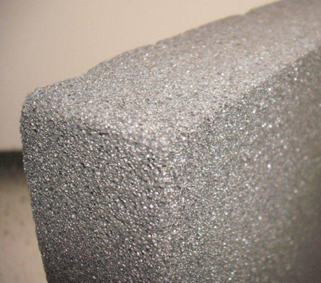
Figure 10: Cellular glass (source: FK1954 2010, http://de.wikipedia.org/w/index.php?title=Datei:Foamglas.JPG&filetimestamp=20100310091945)
Video on processing cellular glass panels:
https://www.youtube.com/watch?v=IGdsIO6_4bc

Processing/practical tips
Cellular glass granulate, e.g. for perimeter insulation: the surface must be prepared in accordance with current regulations. The fill material is tipped in place, distributed and compressed so as to minimize cavities.
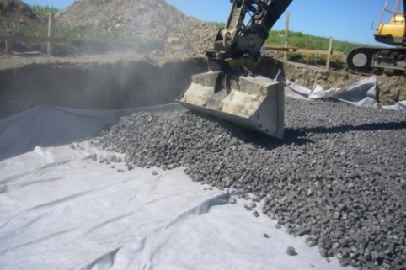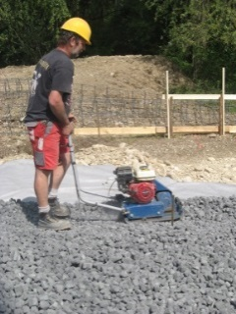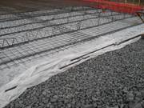
Figure 11: Processing of cellular glass granulate (source: GEOCELL Schaumglas GmbH)
Cellular glass panels: with these matched system components to the producer’s specifications are used. The panels are sawn. Before bonding, the substrate is prepared to ensure it is clean and free from grease and dust. Solvent-free cold adhesive is applied as an undercoat (on dry or moist substrate). In the case of roof or floor insulation with above-average moisture incidence, hot bitumen is used for bonding. Finally the panels are secured with anchors or dowels. The panels have to lie flat; bumps are ground down and kept dust-free. Alignment is with offset butt joints; the joints are filled with adhesive.

Health aspects
While the material is being cut and processed, glass dust, and the gases contained (hydrogen sulphide/non-hazardous smell pollution), may be emitted.

Disposal
If bitumen has not been used and the glass can be removed without damage, it can be re-used as insulation granulate, otherwise it has to be disposed of as non-recyclable rubble.

Fossil-based insulation materials

Polystyrene, polyurethane, polyester, phenolic resin

Raw materials and production
Insulation materials based on petroleum are produced in large quantities. They are mainly available in the form of EPS (expanded polystyrene), XPS (extruded polystyrene), and PUR (polyurethane foam) panels. PUR is also used in situ to fill cavities. Polyester is available in the form of mats or panels. Phenolic resin foam, which is available in panel form, has very favourable lambda values.
Video on production of XPS insulation materials:
https://www.youtube.com/watch?v=-DRGHIFuJZA
The foamed organic insulation materials have the advantage of being easy to process. Polystyrene, in particular, is relatively cheap to process. The disadvantages of these materials are tied up with their fossil origin. They are made from petroleum, a finite resource, in a series of chemical processing steps (some of them very complex), and involve very high primary energy consumption, i.e. production, transport and processing need a great deal of energy. When choosing an insulation material, one should make sure that it is free of CFC and HCFC.
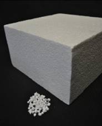
Figure 12: Polystyrene (source: GrAT)

Areas of application
There are many possible applications for insulation foams. A special focus is on composite thermal insulation systems, where cost-effective solutions can be achieved even with high-quality insulation structures. Here the goal should be a solution with high resistance to algal and fungal growth, e.g. through protection against moisture (for instance eaves to avoid rain beating against façades), with the outside layer of plaster implemented appropriately.
Other areas of application involve contact with soil, such as floor slab and dado insulation (with closed-cell insulation foams such as XPS or PUR), and insulation for flat roofs and screeds.
In cases where moisture gets in and causes damage, PS and PUR insulation responds better to drying out than many other insulation materials.
Insulation foams are less suitable as infill for timber and lightweight structures (walls and especially roofs). Other materials in the form of mats or injected insulation are preferable as regards processing; during planning their reaction to fire should also be taken into account.

Processing/practical tips
Processing is easy. The material can be shaped by cutting or sawing. Particularly with thicker layers of insulation, cutting with professional tools (thermal saw) yields more accurate results (for exact butt joints).
Matched system components to the producer’s specifications must be used.
Video on processing EPS insulation panels:
https://www.youtube.com/watch?v=gBcMktICxp8
For composite thermal insulation systems the panels are bonded onto the substrate of the outside wall. The adhesive is applied either with a combination of edge beads and dots, or all over with a serrated trowel, and the panels are bonded with offset butt joints. The panels are then secured with suitable dowels (at least 6 dowels per m², but not more than 12).
Dowels have to be distributed equally according to their number per m². They are fastened through the adhesive or very close to the adhesive. Depending on the type of insulation material used, specific schemes of dowelling apply.
Figure 13: Dowelling schemes for EPS panels. Above: T scheme; below: W scheme; both: 6 dowels/m² (source: Sto SE & Co. KGaA, adapted)
Arranging panels so that the corners of openings in masonry are in the middle of a panel is recommended:
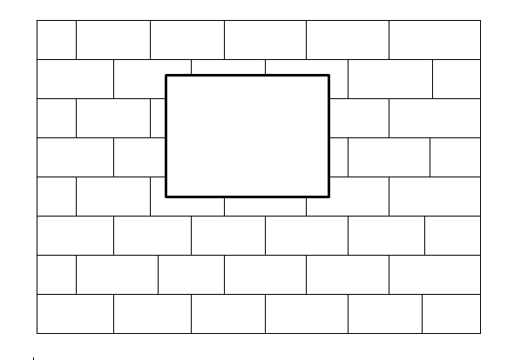
Figure 14: Arrangement of panels at corners of openings
Butt and wall joints are grouted with reinforcement fabric strips and adhesive, and sealed, after which plaster can be applied.

Two videos show the precise cutting of insulation panels:

http://www.youtube.com/watch?v=N-peFBssdUo
http://www.youtube.com/watch?v=4SYJOkULm88

For several other areas of application, such as insulating flat roofs, beneath floor slabs or for screeds, the panels are laid, to some extent in more than one layer (if the panels are of the same kind), either offset or dovetailed.

Health aspects
Attention must be paid to the health aspects of the substances contained in the products. Worker protection is important, because dust can develop during grinding, and gas be emitted as a result of heating. The products’ reaction to fire behaviour must be taken into account during planning; careful installation is important. With regard to immissions, reaction to fire and the effects of warmth in summer, it is advisable to separate foamed insulation from the interior with solid structural elements.

Disposal
Fossil-based insulation panels are usually bonded in place, after which they cannot be removed as a homogenous mass and re-used. They must be incinerated or disposed of at a landfill.
If they are incinerated, to take advantage of the caloric value contained, this should take place in high-grade incineration plants, ensuring that no hazardous exhaust gases are emitted.

High-efficiency insulation materials

Vacuum insulation
Vacuum insulation, commonly in the form of Vacuum Insulated Panels (VIPs), insulates excellently with a fifth of the thickness of standard insulation materials. With vacuum insulated panels (VIPs), a thermal conductivity less than λ = 0.004 W/mK can be achieved. The value approved for calculation purposes, though, is λ = 0.007 to 0.008 W/mK, because losses occur at butt joints, special fittings and fasteners. This value allows for the fact that the vacuum within gradually deteriorates.

Raw materials and production
VIPs consist of a porous core, usually made of fumed silica, surrounded by a composite metal foil which prevents gas from getting into the panel.
Production is energy and cost-intensive.

Areas of application
Vacuum insulation has been used for quite some time to insulate cooling appliances and for other specialized applications in industry. For some years prefabricated elements have been used for structures in residential buildings, and these turn out to work well in practice.
Due to its high cost vacuum insulation is used for preference where space for the insulation layer is restricted. Areas of application thus range from outside wall insulation on very expensive sites, via floor (slab) insulation in renovation projects where ceiling height is limited, to roof terrace insulation in order to provide level access from the apartments. Other applications involve special elements such as window panels, doors, special solutions for small areas, etc.

Processing/practical tips
The airtight panel envelope must not be damaged during installation or in use. This makes processing vacuum insulation panels in buildings a demanding task. For this reason, panels with a protective layer on one or both faces are available for certain applications.
In addition, the panels must be supplied custom-fitted, so as to insulate without gaps or chinks. Producers are going over to providing small gap-fillers made from high-grade adaptable insulation material.
The VIPs, and the shell if appropriate, must be secured at the joints without the panels being punctured. If panels are laid on the floor, it may make sense to make two layers in order to reinforce the weaknesses at the joints.
From the perspective of protecting the building it is not a problem if the vacuum in some areas fails in the course of time, because even without vacuum the thermal conductivity of the material is still in the range λ = 0.016 to 0.022 W/mK, and this loss is already allowed for in the higher value approved for calculation purposes.
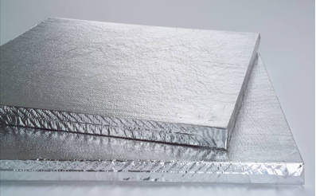
Figure 15: Vacuum insulation panels (source: Porextherm Dämmstoffe GmbH)

Disposal
Vacuum insulation should be installed in such a way that it can be removed tidily when the time comes. Because of the high material value of the panel core, re-using the material is recommended. The foil can be recycled separately.

Aerogels
Aerogels are highly porous solids with nanostructure; more than 99.9 % of their volume consists of air pores. In recent years they have been increasingly used in the construction sector, both for indoor insulation and as an additive for outside plaster systems.

Raw materials and production
Aerogels can be based on various raw materials. The most common ones are silicate-based, but it is also possible to produce them based on carbon, plastic or metal oxide. Production is energy and cost-intensive.
Background
Most aerogels used for construction are synthetic silica gels, either amorphous or crystalline, for example permeating a flexible non-woven substrate. This results in high thermal resistance, while processing is easier with a flexible blanket.

Areas of application
Aerogels were originally used between panes in multiple glazing, or as transparent thermal insulation. In recent years aerogel insulation with a thermal conductivity of λ = 0.013 to 0.020 W/mK has become available for indoor insulation. Outside insulation systems in the form of ETICS are also available. A very interesting solution for listed buildings is insulation plaster with aerogel additives, which achieves a thermal conductivity of approx. λ = 0.028 W/mK and can be applied to outside walls with standard thicknesses.
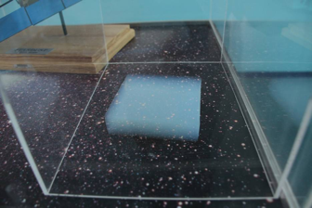
Figure 16: A piece of aerogel (source: Alcántara 2008, http://www.flickr.com/photos/sergiooaf/3086812722/#/)

Processing/practical tips
Aerogel insulation involves dust developing during production, processing and removal, which can cause feelings of skin dryness and irritation of the eyes, the skin and the respiratory tract. Appropriate measures must therefore be taken during processing to protect the respiratory tract and skin.

Disposal
Disposal can be done at a landfill; in this case the aerogels should be covered over immediately to avoid dust developing.

Insulation materials from renewable resources

Straw

Raw materials and production
Straw is a by-product of cultivating grain. It can stay within the agricultural cycle, or it can be used to generate energy (either heat, if it is burnt, or bioethanol/biofuel); it is also made into insulation, for instance.
Straw for insulation can be used loose (as chaff), or processed into bales or strawboard panels. In all three cases the most important criterion for processing is moisture content, which must not exceed 15 % at installation, otherwise mould may develop. In bales it is also important that the individual straws are aligned uniformly and that baling density is high and uniform. Density is important to provide thermal insulation and fire and pest protection, e.g. to keep mice away.
The thermal conductivity of straw bale insulation should not exceed λ = 0.067 W/mK along the length of the straws, and λ = 0.044 W/mK crosswise.

Areas of application
Straw bales have been used as building and insulation material in Europe for several centuries. In the USA, straw bales are a traditional building material, and are subsidized as a historical building technique. Historic buildings show that straw bale structures last for many decades. The oldest straw buildings still in use are more than 100 years old.
Straw bales can be used either to assemble load-bearing walls which at the same time provide thermal insulation, or as insulation for wall, roof or ceiling in timber structures.

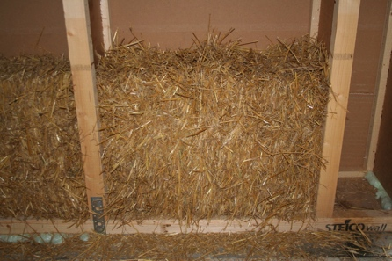 | 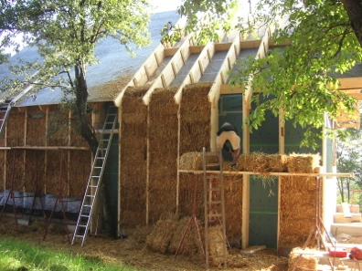 | 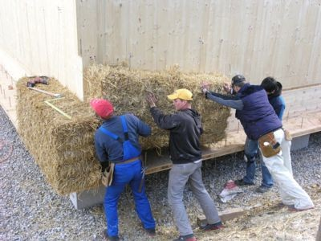
Figure 17: Straw wall in timber frame wall (source: GrAT) | Figure 18: Straw insulation in place (source: GrAT) | Figure 19: Installing straw bale insulation at the S-HOUSE in Lower Austria (source: GrAT)

Processing/practical tips
During production, transport and processing it is essential to monitor moisture content and (in the case of straw bales) density. This quality control is included for certified bales.
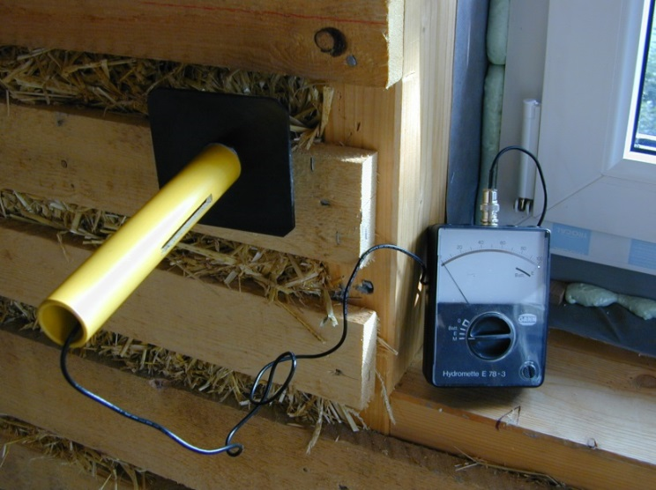
Figure 20: Measuring moisture content of straw in situ (source: GrAT)
For straw bale insulation to last, it must be processed correctly and installed to professional standard. The structure must be protected from long-term moisture. Since straw (like other plant-based insulation materials) is vapour permeable, moisture can easily escape again. This presupposes, though, that the plaster is vapour permeable too (clay and lime plaster are vapour permeable, for instance).

Disposal
As a plant-derived material straw can be used to generate energy after removal.

Reed

Raw materials and production
Reed grows in many parts of the world. It has considerable strength and is thus hard to break. An additional advantage for use as insulation material is its air-filled cavities, which provide thermal and soundproofing.
Reed is made untreated into mats and panels – the individual reeds are simply tied into bundles with galvanized wire. It can also be chopped and made into granulate panels.
Reed has a thermal conductivity of λ = 0.055 to 0.06 W/mK.

Areas of application
Reed is one of the oldest building materials and was formerly used for roofing. As a water plant, reed is adapted to water, which makes it resistant to long-term water exposure.
Reed panels are mostly used for insulation. However, they weigh a good deal, which is why structural analysis of the insulation structure is necessary. If the thickness of the insulation layer is reduced, though, it will be necessary to combine the reed panels with other materials in order to achieve a satisfactory U value.
Apart from their insulating effect, reed panels are also suitable as a plaster substrate. They can be combined with clay or lime plaster for overall vapour permeability.
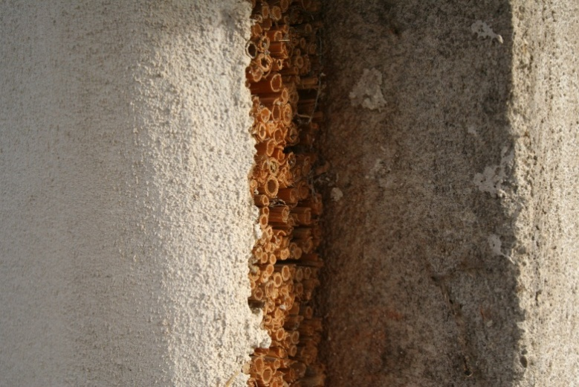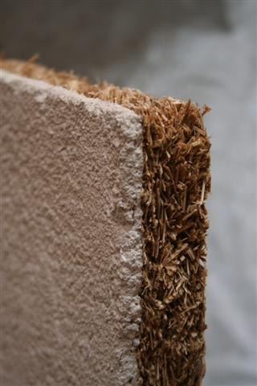
Figure 21: Lime plaster on reed panel (left) and on reed granulate panel (right) (source: GrAT)

Processing/practical tips
The moisture content of the harvested raw material should not exceed 18 %. After harvesting, reed needs to be aired thoroughly.

Disposal
Wire-tied reed panels need no additives for fire and pest protection, so disposing of them is straightforward.

Wood fibres and chips

Raw materials and production
Wood fibre is obtained from shredded small-diameter wood or wood waste from spruce or pine trees. It is pressed into panels (dry or wet process) or used as loose fill. In the dry process additives such as polyurethane resins or biocomponent synthetic fibres are needed for binding. In the wet process additives are used to activate the lignin in the wood. In both processes so-called hydrophobating agents (water repellents) such as bitumen, latex, wax, or bitumen substitutes based on natural resin are used to increase the panels' resistance to moisture.
Wood fibre insulation has a thermal conductivity of λ = 0.045 to 0.06 W/mK. Wood wool lightweight panels reach approx. λ = 0.09 W/mK.
Wood chips, on the other hand, are made from shavings of spruce and fir timber, from which dust must be removed; the chips can then be used as insulation material in timber structures in combination with clay, for example.
Wood chips and fibres can absorb a good deal of moisture without their insulating effect diminishing.
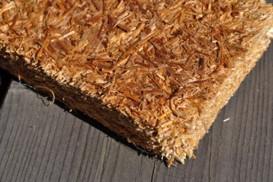 | 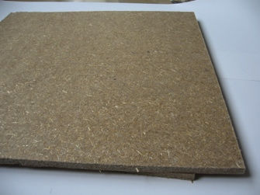 | 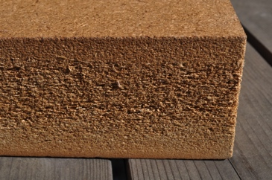
Figure 22: Wood chip insulation panel (source: GrAT) | Figure 23: Wood fibre insulation panel (source: GrAT) | Figure 24: Wood fibre insulation panel (source: GrAT)

Areas of application
Wood chip and fibre panels can be used for roof, wall and ceiling insulation and for impact soundproofing. Wood fibre panels are particularly suited for impact soundproofing because they are thinner and heavier. Wood chip and fibre panels have the advantage of being vapour permeable and dimensionally stable, while their raw materials are available locally.
Wood chips are filled in moulds by specialized processors.
Another application: magnesite-bound wood wool insulation panels (a product made from wood chips, from which dust is removed mechanically) are used for indoor and outside wall insulation.

Processing/practical tips
Care is essential as regards dust developing, particularly during injection; dust protection measures are needed.
The panels have to be processed in dry form. Before they are installed, the substrate must be checked to ensure it is flat and clean; its moisture content must also be checked.
In order to avoid structural damage, air circulation behind must be prevented – this applies to installing both on wooden frames and on a flat substrate.
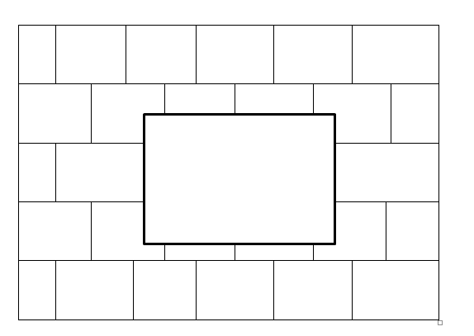
Figure 25: Installing wood fibre insulation panels

Disposal
Wood chip and fibre panels are easy to dispose of. Wood is basically compostable, but burning to obtain heat makes sense; however, contaminated wood material must never be burnt domestically, but incinerated in a plant designed for eliminate pollutants without residue.
Products containing binding and/or hydrophobating agents must be disposed of at a landfill.

Cellulose

Raw materials and production
Cellulose is a primary component of plant fibres and is used in papermaking, for example. To make insulation the main source is recycled paper: sorted newsprint is shredded and pest and fire protection agents such as boric acid are added.
Producing cellulose fibre panels takes much more energy than producing loose-fill cellulose.

Areas of application
Cellulose is used either as panels or as loose fill; both loose-fill insulation (cellulose fibre flakes) for injection and tamping wool are gaining in importance. Thermal conductivity is λ = 0.040 to 0.045 W/mK.

Processing/practical tips
Loose-fill cellulose can be installed in a wet or a dry process. In the dry process (the most common), dry cellulose is blown through a small opening into the cavity to be insulated.
Cellulose can also be used for indoor insulation: here cellulose fibres are sprayed onto the inside face of the wall, which creates an indoor insulation system with capillary action, with no vapour barrier. The producer’s instructions must be complied with.
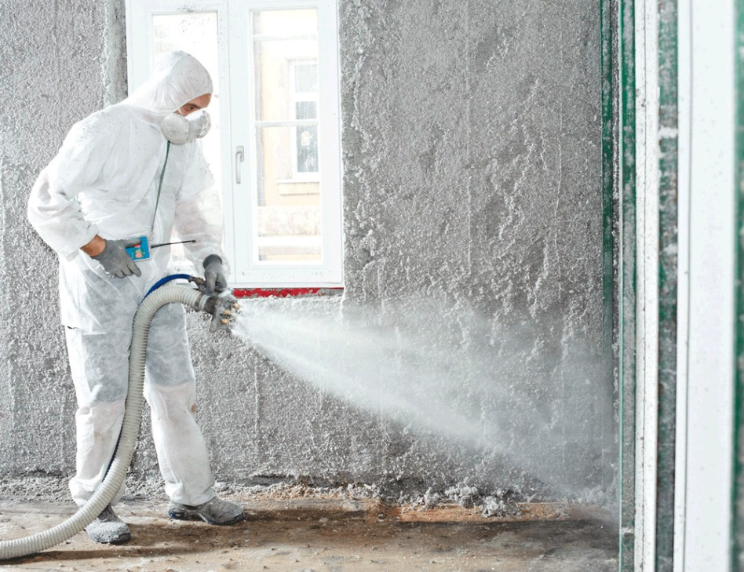
Figure 26: Spraying cellulose for indoor insulation (source: Isocell GmbH)

Health aspects
Dust forms during processing, which makes it necessary to use respiratory protection and to clean the site up after the insulation has been installed.

Disposal
After use, cellulose can be vacuumed and re-used. Because of boric-acid additives, it is not classified as disposable at a landfill and must be incinerated at high temperatures.

List of figures
Figure 1: Mineral wool (source: GrAT) Figure 2: Mineral wool rolled up for storage (source: GrAT) 5
Figure 3: Processing of mineral wool panels (source: Sto SE & Co. KGaA) 6
Figure 4: Foamed mineral panel for a composite thermal insulation system (source: Dennert) 7
Figure 5: Calcium silicate panel (source: Achim Hering 2011; http://de.wikipedia.org/w/index.php?title=Datei:Promatect_250_sheets_corner.jpg&filetimestamp=20110616165151 - file) 8
Figure 6: Alignment of calcium silicate panels (left: wrong; right: correct) 9
Figure 7: Expanded perlite (source: http://en.wikipedia.org/wiki/File:PerliteUSGOV.jpg) 10
Figure 8: Expanded mica (vermiculite) (source: KENPEI, http://fr.wikipedia.org/wiki/Fichier:Vermiculite1.jpg) 10
Figure 9: Expanded clay (source: Lucis 2007, http://en.wikipedia.org/wiki/File:Hydroton.jpg) 11
Figure 10: Cellular glass (source: FK1954 2010, http://de.wikipedia.org/w/index.php?title=Datei:Foamglas.JPG&filetimestamp=20100310091945) 12
Figure 11: Processing of cellular glass granulate (source: GEOCELL Schaumglas GmbH) 12
Figure 12: Polystyrene (source: GrAT) 14
Figure 13: Dowelling schemes for EPS panels. Above: T scheme; below: W scheme; both: 6 dowels/m² (source: Sto SE & Co. KGaA, adapted) 15
Figure 14: Arrangement of panels at corners of openings 15
Figure 15: Vacuum insulation panels (source: Porextherm Dämmstoffe GmbH) 17
Figure 16: A piece of aerogel (source: Alcántara 2008, http://www.flickr.com/photos/sergiooaf/3086812722/#/) 18
Figure 17: Straw wall in timber frame wall (source: GrAT) 20
Figure 18: Straw insulation in place (source: GrAT) 20
Figure 19: Installing straw bale insulation at the S-HOUSE in Lower Austria (source: GrAT) 20
Figure 20: Measuring moisture content of straw in situ (source: GrAT) 20
Figure 21: Lime plaster on reed panel (left) and on reed granulate panel (right) (source: GrAT) 21
Figure 22: Wood chip insulation panel (source: GrAT) 22
Figure 23: Wood fibre insulation panel (source: GrAT) 22
Figure 24: Wood fibre insulation panel (source: GrAT) 22
Figure 25: Installing wood fibre insulation panels 23
Figure 26: Spraying cellulose for indoor insulation (source: Isocell GmbH) 24

Legal notice
Published by:
e-genius – Verein zur Förderung und Entwicklung offener Bildungsmaterialien im technisch-naturwissenschaftlichen Bereich

Postfach 16
1082 Vienna
Austria
E-mail: info(at)e-genius.at

Project leader:
Dr. Katharina Zwiauer
E-mail: katharina.zwiauer(at)e-genius.at

Adapting for teaching purposes: Dr. Katharina Zwiauer
Translation and editing: Magdalena Burghardt, Andrew Kilpatrick
Layout: Magdalena Burghardt

August 2015

This learning unit was funded with support from the European Commission. This publication reflects the views only of the author, and the Commission cannot be held responsible for any use which may be made of the information contained therein.
The basis for this learning unit was developed within a project of „Building of Tomorrow“.
Terms of use
This learning unit is provided under the following Creative Commons Licence:
Creative Commons Attribution-NonCommercial-NoDerivatives 4.0 International License.
You are free to:
Share — copy and redistribute the material in any medium or format
The licensor cannot revoke these freedoms as long as you follow the license terms.
Under the following terms:
Attribution — You must give appropriate credit, provide a link to the license, and indicate if changes were made. You may do so in any reasonable manner, but not in any way that suggests the licensor endorses you or your use.
NonCommercial — You may not use the material for commercial purposes.
NoDerivatives — If you remix, transform, or build upon the material, you may not distribute the modified material.
No additional restrictions — You may not apply legal terms or technological measures that legally restrict others from doing anything the license permits.

Attribution to e-genius as the copyright owner must take the following form:
Texts: authors of the learning unit, year of publication, title of the learning unit, publisher: Verein e-genius, www.e-genius.at/en
Illustrations: attribution to owner of copyright, e-genius – www.e-genius.at/en

Exclusion of liability:
All content on the e-genius platform has been carefully checked. Nevertheless, we are unable to offer any guarantee as to the correctness, completeness, topicality and availability of the content. The publisher does not accept any liability for damage or disadvantages that may arise from the use or exploitation of the content. The provision of the content on e-genius is not intended to replace the obtaining of professional advice and the ability to access the content does not constitute an offer to create an advisory relationship.
e-genius contains links to external websites. The insertion of links is a reference to representations and (also other) opinions, but does not mean the content of such links are endorsed. The publisher of e-genius does not accept any liability for websites that are referred to via a link. This applies both to their availability and to the content that can be accessed on such websites. As far as the operators are aware, the linked pages do not contain any unlawful content; should such content be discovered, it will be immediately removed in fulfilment of the legal obligations of the electronic reference.
Third-party content is identified as such. Should you nevertheless become aware of an infringement of copyright, please let us know accordingly. Upon being notified of legal infringements, we will immediately remove or correct such content.
Link to the open content platform: http://www.e-genius.at/en

