Energy-efficient Buildings (Passive and Nearly Zero-energy Buildings) –
Introduction
- Abstract of the learning unit
In this learning unit we present the most important aspects of energy efficiency in buildings. The Energy Performance of Buildings Directive (EPBD) is explained in brief, and ways of saving energy in buildings are described. Various building strategies are presented.
- Objectives
On completing this unit students are able to …
- name measures for energy efficiency in buildings
- describe the most essential goals of the EU Directive on the energy performance of buildings
- list examples of various approaches to making buildings energy-efficient
- describe one approach to making buildings energy-efficient
- explain the most important differences between the approaches described

Content
Abstract of the learning unit 1
Objectives 1
1. Introduction 3
2. EU Directive on the energy performance of buildings 3
3. How can energy be conserved in buildings? 4
4. Building strategies 7
4.1 Passive house 8
4.2 Solar house 10
4.3 Minergie 11
5. List of figures 13
6. List of tables 13
7. Legal notice 14

Introduction
In the EU member states the building sector accounts for the largest individual share of energy consumed. The construction sector is a significant economic factor and will go on expanding, which will increase its energy consumption even more.

Figure 1: Energy consumption in the EU (source of data: DG Energy, 2012)
Reducing energy consumption and using energy from renewable sources in the building sector are crucial measures necessary for decreasing the European Union’s dependence on energy and its greenhouse gas emissions (Directive 2010/31/EU).

EU Directive on the energy performance of buildings
According to the Energy Performance of Buildings Directive (EPBD), every member state must ensure that by 31 December 2020 all new buildings (for public buildings 31 December 2018 is the relevant date) comply with the so-called “Nearly Zero-Energy Building” standard, based on the primary energy input (= high standards of energy efficiency and use of local sources of renewable energy).
A nearly zero-energy building is defined as follows: “a building that has a very high energy performance. The nearly zero or very low amount of energy required should be covered to a very significant extent by energy from renewable sources, including energy from renewable sources produced on-site or nearby”.

Figure 2: Example of a “Nearly Zero-Energy” building with photovoltaic system on roof and solar thermal system on front façade (source: Arch Wimmer – schulze darup & partner)
Additional goals of the Buildings Directive are:
- defining a method for calculating the energy performance of buildings
- defining minimum requirements for the energy performance of buildings
- certification of the energy performance of buildings: obligatory presentation of an energy performance certificate for new construction, renovation, sale or rental of a building or part thereof; obligation to display the certificate in public buildings
- regular inspection of heating and air-conditioning systems with regard to energy efficiency, plus testing of heating systems more than 15 years old
- setting cost-optimal energy performance requirements for major renovations and for improvements in the course of major renovations
The member states have submitted their national plans, which, however, differ from each other in many aspects. For example, interpretations differ as to whether energy consumption also includes the electricity consumption of appliances such as IT or electronics, or only building-specific consumption, such as space heating, cooling, hot water or lighting.

How can energy be conserved in buildings?
First, we have to consider all the areas where energy is needed in a building: energy that is used for operating the building, such as for space heating, hot water, lighting, etc., probably comes to mind first. But not only these services need energy; the production of building materials, the actual process of construction, any reconstruction or renovation, and finally the demolition of a building all consume energy (this is called “grey energy”, because how much energy a material or product contains is not visible to the naked eye).
There are various ways of reducing buildings’ resource and energy consumption and thus avoiding negative effects of construction. They can be summarized under the term “sustainable building”.

Background on “sustainable building”
Sustainability in the construction sector involves constantly taking the effects to be expected from construction into account during planning and implementation. Harmful effects on the climate, the ecosystem, the economy and public health should be avoided.
Important principles and goals of sustainable building are:
- resource efficiency, in order to conserve natural resources and avoid waste and expense for raw materials, for producing and disposing of building components
- energy efficiency, in order to avoid wasting energy, energy costs and CO2 emissions
- adapting to the users’ needs, so as not to produce more than is needed, and to ensure that the buildings will be used for a long time
- adapting to the local and regional environment (e.g. the climate, the existing infrastructure or available raw materials), in order to use what is available on site, and to avoid negative effects of construction on the environment (e.g. on bodies of water, air)
The following diagram outlines possible measures available to reduce energy consumption and greenhouse gas emissions in the building sector.
Reduce heat losses through the building envelope by high level of heat protection

Efficient building technologies

Reduction of ventilation heat losses by convenience ventilation system with heat recovery

Energy-efficient windows

Reduce the share of grey energy

Reduce demand for electricity for lighting and devices

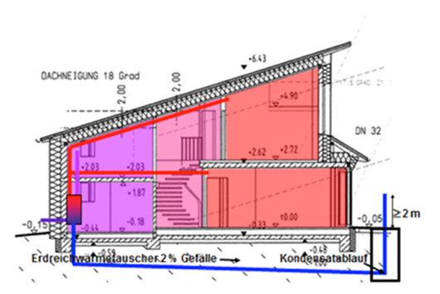

Figure 3: Measures which contribute to energy-efficiency (source: Schulze Darup, adapted)
A high level of thermal insulation, combined with energy-efficient windows, is seen as one of the most effective measures. An additional measure, e.g. for reducing heat losses by airing, is to install a convenience ventilation system with heat recovery. The consumption of electricity can be reduced by using energy-saving devices; the input of grey energy can be influenced by choosing appropriate building materials.

High level of thermal insulation | 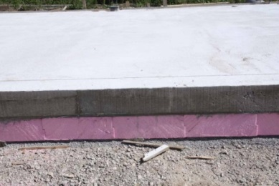  Figure 4: Floor slab with insulation layer (source: Schulze Darup)
High level of thermal insulation | 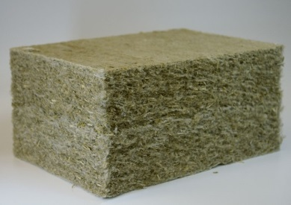  Figure 5: Hemp insulation material (source: Christian Gahle, nova-Institut GmbH; http://de.wikipedia.org/wiki/D%C3%A4mmstoff#/media/File:Hanfdaemmstoff_CG.jpg)
Energy-efficient windows | 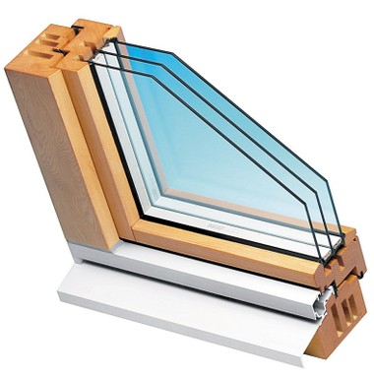  Figure 6: Passive-house window in solid timber (source: Sigg Tischlerei, Hörbranz)
Convenience ventilation system with heat recovery | 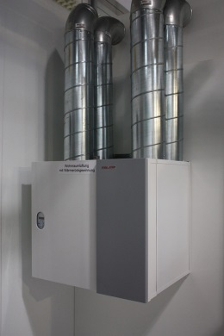  Figure 7: Convenience ventilation system with heat recovery (source: Bin im Garten; https://upload.wikimedia.org/wikipedia/commons/2/22/IFA_2010_Internationale_Funkausstellung_Berlin_104.JPG)
Table 1: Examples of measures which contribute to energy-efficiency
Background on national and international methods of certification for energy-efficient building strategies
In Europe there are a large number of specifications, voluntary standards and differing labels for energy-efficient buildings.
These definitions / quality labels / specifications use differing criteria, such as high efficiency, on-site energy, energy source, cost of emissions, grey energy, etc.
The most important international and national methods of certification and quality labels are:
- BREEAM (BRE Environmental Assessment Method): is the leading and most widespread method of certification for buildings. It defines the highest possible standards for best sustainable design and has in practice become a yardstick for describing a building’s environmental impact (standard for best practice in sustainable building design, http://www.breeam.org).
- Green Building: is a voluntary program from the European Commission that supports owners and users of commercial buildings private companies and state institutions) in improving energy efficiency and in introducing renewable sources of energy in their buildings (http://re.jrc.ec.europa.eu/energyefficiency/greenbuilding/index.htm).
- Minergie (Swiss label): is a voluntary building standard that enables efficient energy use and the broad application of renewable energies while at the same time improving quality of life, ensuring competitiveness and reducing environmental impact (http://www.minergie.ch/).
- Leed (Leadership in Energy and Environmental Design): is a system of classification for ecological building developed by the U.S. Green Building Council in 1998. It defines a range of standards for environmentally friendly, resource-conserving and sustainable building (http://www.leed.net/)
- Building strategies
Most strategies involve a thick layer of insulation, highly efficient windows, an airtight layer and convenience ventilation with heat recovery. In many cases renewable sources of energy are utilized for covering, or at least partly covering, energy consumption.

Two short videos presenting energy-efficient buildings:
http://www.youtube.com/watch?v=cP2Hm4rzuFI
https://www.youtube.com/watch?v=Prx6rJPZFIE

Below we present three examples of building strategies. Their shared features are minimal energy consumption together with real comfort for residents. While the goal of passive-house planners is to design a building with very low energy consumption, designers of net-zero-energy buildings aim to produce enough electricity through photovoltaics (PV) on site to balance the building’s energy account over a full year.
However, as can be seen from the following pictures, energy efficiency is not tied to any particular architectural design.
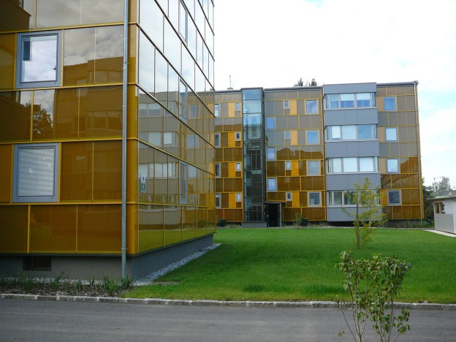 | 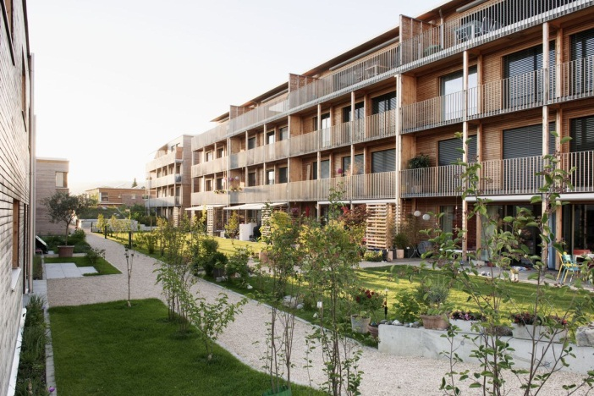
Figure 8 and Figure 9: on left: passive house with solar façade in Austria (source: Michael Paula, bmvit); on right: housing estate SunnyWatt in Switzerland, Minergie-P-Eco standard (source: kämpfen für architektur ag)

Passive house
“Passive house is no brand name and no energy concept, but a building concept open to anyone” (W. Feist, translation by author). The aim is to achieve a good overall result in terms of layout, comfort in the home and energy consumption by means of creative design and with the lowest possible investment. Never forget that the approach should result in a sustainable building that makes economic sense.
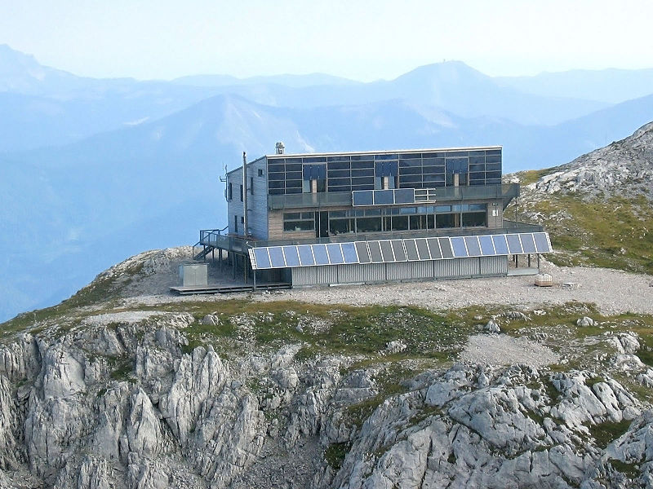
Figure 10: “Schiestlhaus” – first high-alpine passive house (source: Michael Schmid; http://commons.wikimedia.org/wiki/File:Schiestlhaus_Jul2007.jpg#/media/File:Schiestlhaus_Jul2007.jpg)
There are two main objectives in building a passive house:
1. The building should be constructed in such a way that a highly efficient building envelope results, and energy consumption is covered with renewable sources as far as possible, at maximum cost efficiency.
2. The building should offer residents real comfort in the home.
The following passive-house components form the basis for this:
- Building envelope with high-grade insulation
- Windows with high-grade triple glazing and insulated frames. Larger window openings in the south façade, smaller windows facing east and west, and very small windows facing north (or none at all)
- Overshadowing windows to protect against overheating in summer
- Minimizing / eliminating thermal bridges
- Airtight building envelope
- Ventilation system with heat recovery
- The heating system in a passive house can be a biomass stove or a heat pump
- The annual heating energy requirement must not exceed 15 kWh/m²a
- Total primary energy input must not exceed 120 kWh/m²a

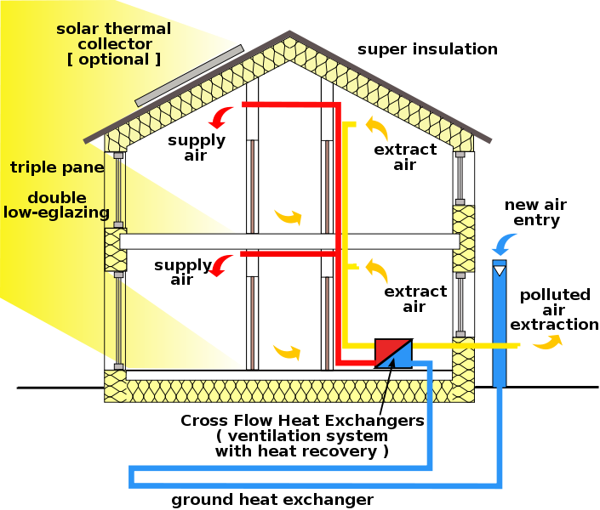
Figure 1: passive house with a supply air/extract air system with heat recovery (source: Passivhaus Institut; http://en.wikipedia.org/wiki/File:Passive_house_scheme_1.svg, adapted)
Additional aspects to be taken into account during planning are the location of the site and the orientation of the building.

Solar house
The solar-house approach is based on taking full advantage of the free energy potential provided by the sun for space heating and providing hot water.
Solar houses are low or ultra-low-energy buildings that cover the bulk or at least half of their annual heating energy requirement by means of a solar thermal system.
Here again, a basic prerequisite for this approach is a building envelope that insulates really well against heat loss.
The following components are foreseen for supplying heat:
- Solar thermal system
- A fairly large solar storage unit inside the building and/or building components made of concrete (floors) or brick centre walls to store solar heat for several days or weeks.
- A back-up heating system to maintain comfortable indoor temperatures even if heat in the storage unit runs low during extended periods with little sun in winter.
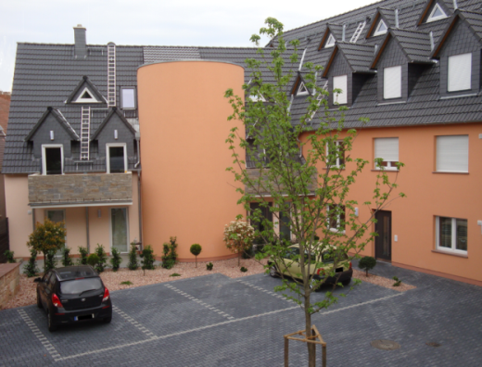
Figure 11: Solar house compound with solar storage unit (source: Andol; http://commons.wikimedia.org/wiki/File:Solarhauskomplex_mit_Solartank.png#/media/File:Solarhauskomplex_mit_Solartank.png)
- Low-temperature panel heating systems, or surfaces with thermo-active building components, distribute heat in line with actual needs and can be regulated individually room by room. In the case of thermo-active components, solar energy is actively stored in these on sunny days. This energy is then available to the building in the following days without solar heat gains.
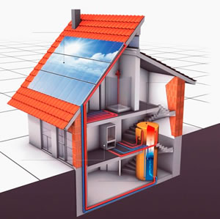
Figure 12: Diagram of a solar house (source: http://www.pink.co.at/sonnenhaus.htm)
With the solar house, too, the site location (climate, shade from trees, neighbouring buildings, etc.) as well as the orientation of the building must be taken into account.

Minergie
Minergie is a standard for buildings in Switzerland, with three categories: Minergie, Minergie-Plus and Minergie A.
Comfort at home/at work is central to Minergie-standard buildings. This comfort is achieved by a high-grade building envelope, as with the approaches described above. In contrast to many other approaches, comfort here also includes the building and the technical equipment being straightforward and satisfactory to use.
Another criterion for Minergie is economic efficiency.
It is also essential to view the building as a complete system, which means that the building envelope and services (heating, ventilation and hot water processing) add up to an appropriate combination, not just a concatenation of individual components.
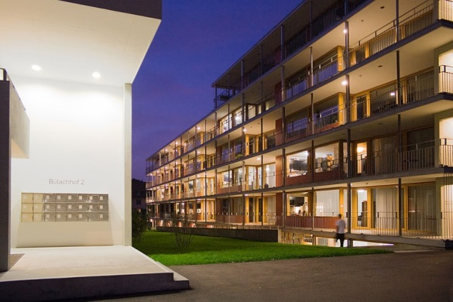
Figure 13: Student residence Bülachhof (Switzerland) – a large new Minergie building (source: Ikiwaner; http://de.wikipedia.org/wiki/Minergie#/media/File:Zuerich_Buelachhof.jpg)
The following comparison of Minergie-Plus and Minergie A shows which combinations are possible.
 | Minergie-Plus | Minergie-A
Heat index value | 30 kWh/m2a (equivalent to 3 litres of fuel oil) | 0 kWh/ m2a
Heating energy requirement | 60 % of the legal requirements | 90 % of the legal requirements
Airtightness of building envelope | Air changes per hour below 0.6/h at 50 pascal pressure difference
Supply of external air | Systematic air exchange
Auxiliary energy – heat | Is taken into account
Domestic electricity | Best devices available | Best devices available, best lighting available
Grey energy | No requirements | Below 50 kWh/m2a
Additional costs | At most 15% | No requirements
Comments | Minergie P is an ultra-low-energy building approach that requires a very good building envelope | Minergie A defines a zero energy or surplus-energy house. This standard can be reached only by utilizing solar energy on site.
Table 2: Excerpt from “Minergie Standards im Vergleich” (Minergie standards compared; source: http://www.minergie.ch/standard_minergie.html)

List of figures
Figure 1: Energy consumption in the EU (source of data: DG Energy, 2012) 3
Figure 2: Example of a “Nearly Zero-Energy” building with photovoltaic system on roof and solar thermal system on front façade (source: Arch Wimmer – schulze darup & partner) 4
Figure 3: Measures which contribute to energy-efficiency (source: Schulze Darup, adapted) 5
Figure 4: Floor slab with insulation layer (source: Schulze Darup) 6
Figure 5: Hemp insulation material (source: Christian Gahle, nova-Institut GmbH; http://de.wikipedia.org/wiki/D%C3%A4mmstoff#/media/File:Hanfdaemmstoff_CG.jpg) 6
Figure 6: Passive-house window in solid timber (source: Sigg Tischlerei, Hörbranz) 6
Figure 7: Convenience ventilation system with heat recovery(source: Bin im Garten; https://upload.wikimedia.org/wikipedia/commons/2/22/IFA_2010_Internationale_Funkausstellung_Berlin_104.JPG) 6
Figure 8 and Figure 9: on left: passive house with solar façade in Austria (source: Michael Paula, bmvit); on right: housing estate SunnyWatt in Switzerland, Minergie-P-Eco standard (source: kämpfen für architektur ag) 8
Figure 10: “Schiestlhaus” – first high-alpine passive house (source: Michael Schmid; http://commons.wikimedia.org/wiki/File:Schiestlhaus_Jul2007.jpg#/media/File:Schiestlhaus_Jul2007.jpg) 9
Figure 11: Solar house compound with solar storage unit (source: Andol; http://commons.wikimedia.org/wiki/File:Solarhauskomplex_mit_Solartank.png#/media/File:Solarhauskomplex_mit_Solartank.png) 11
Figure 12: Diagram of a solar house (source: http://www.pink.co.at/sonnenhaus.htm) 11
Figure 13: Student residence Bülachhof (Switzerland) – a large new Minergie building (source: Ikiwaner; http://de.wikipedia.org/wiki/Minergie#/media/File:Zuerich_Buelachhof.jpg) 12
- List of tables
Table 1: Examples of measures which contribute to energy-efficiency 6
Table 2: Excerpt from “Minergie Standards im Vergleich” (Minergie standards compared; source: http://www.minergie.ch/standard_minergie.html) 12

Legal notice
Published by:

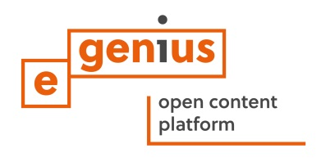
e-genius – Verein zur Förderung und Entwicklung offener Bildungsmaterialien im technisch-naturwissenschaftlichen Bereich

Postfach 16
1082 Vienna
Austria
E-mail: info(at)e-genius.at

Project leader:
Dr. Katharina Zwiauer
E-mail: katharina.zwiauer(at)e-genius.at

Authors: Dr. Burkhard Schulze Darup, Dr. Katharina Zwiauer, Stefan Prokupek
Adapting for teaching purposes: Dr. Katharina Zwiauer
Translation and editing: Magdalena Burghardt, Andrew Kilpatrick
Layout: Magdalena Burghardt

August 2015

This learning unit was funded with support from the European Commission. This publication reflects the views only of the author, and the Commission cannot be held responsible for any use which may be made of the information contained therein. | 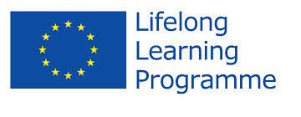
The basis for this learning unit was developed within a project of „Building of Tomorrow“. |  | 
Terms of use
This learning unit is provided under the following Creative Commons Licence:
Creative Commons Attribution-NonCommercial-NoDerivatives 4.0 International License.
You are free to:
- Share — copy and redistribute the material in any medium or format
The licensor cannot revoke these freedoms as long as you follow the license terms.
Under the following terms:
- Attribution — You must give appropriate credit, provide a link to the license, and indicate if changes were made. You may do so in any reasonable manner, but not in any way that suggests the licensor endorses you or your use.
- NonCommercial — You may not use the material for commercial purposes.
- NoDerivatives — If you remix, transform, or build upon the material, you may not distribute the modified material.
No additional restrictions — You may not apply legal terms or technological measures that legally restrict others from doing anything the license permits.

Attribution to e-genius as the copyright owner must take the following form:
Texts: authors of the learning unit, year of publication, title of the learning unit, publisher: Verein e-genius, www.e-genius.at/en
Illustrations: attribution to owner of copyright, e-genius – www.e-genius.at/en

Exclusion of liability:
All content on the e-genius platform has been carefully checked. Nevertheless, we are unable to offer any guarantee as to the correctness, completeness, topicality and availability of the content. The publisher does not accept any liability for damage or disadvantages that may arise from the use or exploitation of the content. The provision of the content on e-genius is not intended to replace the obtaining of professional advice and the ability to access the content does not constitute an offer to create an advisory relationship.
e-genius contains links to external websites. The insertion of links is a reference to representations and (also other) opinions, but does not mean the content of such links are endorsed. The publisher of e-genius does not accept any liability for websites that are referred to via a link. This applies both to their availability and to the content that can be accessed on such websites. As far as the operators are aware, the linked pages do not contain any unlawful content; should such content be discovered, it will be immediately removed in fulfilment of the legal obligations of the electronic reference.
Third-party content is identified as such. Should you nevertheless become aware of an infringement of copyright, please let us know accordingly. Upon being notified of legal infringements, we will immediately remove or correct such content.
Link to the open content platform: http://www.e-genius.at/en

