Insulation and Façade Systems –
Timber-based External Façade Systems

Preamble
Europe sees a great deal of potential for saving energy in the building sector. This is to be tapped by implementing the Directive on the Energy Performance of Buildings (EPBD), since this directive lays down not only thermal standards for major reconstructions of older buildings, but also the “Nearly Zero-Energy Building” standard for new buildings. These goals are to be reached by a combination of increased energy efficiency and utilizing renewable sources of energy. Even though not all member states have finally defined their implementation programs yet, the issue of optimal thermal insulation will play a vital part in terms of high energy-saving potential and economic efficiency.

Abstract
In this learning unit we show you the possibilities of timber-based external wall structures. Various types of structure and areas of application are shown and practical tips for selecting appropriate insulation materials, for installation and the physics of buildings are given. Planning criteria and feasible insulation standards are described. An important section deals with quality assurance regarding airtightness and minimizing thermal bridging.

Objectives
On completing this learning unit students are able to …
- list components of different systems for timber-based external wall insulation
- compare different insulation systems for timber-based external walls
- present solutions for difficult parts of insulation systems
- describe how various external wall structures are made up
- evaluate wall insulation systems with respect to their advantages and disadvantages
- apply quality criteria to insulation systems

Contents
Preamble 1
Abstract 1
Objectives 1
1 Types of external wall structure 3
1.1 Timber-based external walls 3
1.2 Timber stud/timber frame structures 3
1.2.1 Load-bearing structures in timber stud/timber frame buildings 3
1.2.2 Insulation materials in timber stud/timber frame structures 5
1.2.3 Fastening/securing in timber stud/timber frame structures 5
1.2.4 Services layer in timber stud/timber frame structures 5
1.2.5 Weatherproofing in timber stud/timber frame structures 6
1.2.6 U values in timber stud/timber frame structures 7
1.3 Non-frame timber structure with external insulation 8
1.3.1 Load-bearing structures in non-frame timber structures 9
1.3.2 Services layer in non-frame timber structures 10
1.3.3 Insulation in non-frame timber structures 10
1.3.4 Fastening/securing in non-frame timber structures 10
1.3.5 Weatherproofing in non-frame timber construction 10
1.3.6 U values in non-frame timber structures 11
1.3.7 Excursus 12
2 Quality criteria for producing an insulation system 12
2.1 Quality assurance at the planning stage 12
2.2 Quality assurance during construction 13
2.3 Airtightness 13
2.4 Minimizing thermal bridging 15
2.5 Additional quality criteria 15
3 List of figures 17
4 Legal notice 18

Types of external wall structure

Timber-based external walls
There are several ways of building with timber.
The classic option is a timber stud/timber frame structure. Skeleton structures or, increasingly, non-frame timber structures are also possible. For external walls, we shall look at timber stud/timber frame and non-frame timber structures here.

Timber stud/timber frame structures
Timber stud/timber frame structures are based on a load-bearing system of timber studs and connecting crosspieces or frames, which are mainly installed at the level of the respective ceilings.
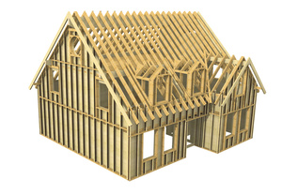
Figure 1: Example of timber frame structure (source: Holzbau Henz GmbH)

Load-bearing structures in timber stud/timber frame buildings
The load-bearing structural elements in timber stud/timber frame buildings consist of non-frame timber or wood-based materials.
Solid timber profiles can be used; they usually have a width of 6 to 12 cm, with stud bays measuring 14 to more than 20 cm. If glued laminated timber is used, profiles as slim as 4 cm (say) can be achieved.
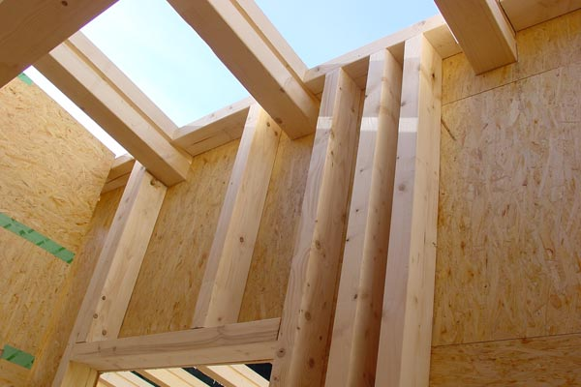
Figure 2: Timber frame structure (source: Holka Genossenschaft)
If I-joists made from wood-based materials are used, even slimmer profiles are feasible. With these slim structural elements wood-based materials have the advantage that the load-bearing structure involves less thermal bridging. However, the thermal conductivity of wood-based materials can exceed that of solid timber.
In general the structure should be laid out with a grid module that makes installing the cladding and, if used, insulation panels with standard dimensions as easy as possible.
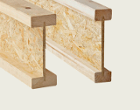
Figure 3: Timber I-joists (source: www.dataholz.com, ein Service der Holzforschung Austria)
What is thermal conductivity?
Thermal conductivity is a material property, namely the ability of a material to transport heat through thermal conduction.
The lower the thermal conductivity, the better the insulation effect.
The unit of thermal conductivity (λ) is W/mK.

Insulation materials in timber stud/timber frame structures
Any insulation material that can be fitted into a prefabricated timber structure can be used. Battens, which adapt to the grid geometry during installing with minor deviations, are particularly suitable. Blow-in insulation, to be injected between the profiles, may be even easier.
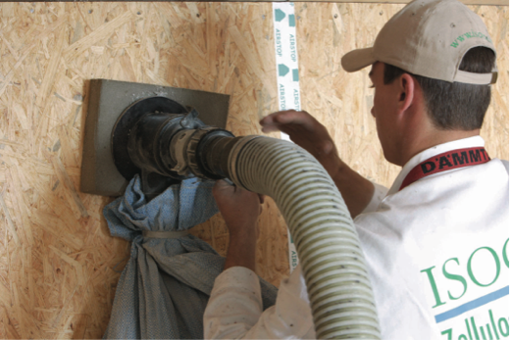
Figure 4: injecting cellulose into a timber stud wall (source: Isocell GmbH)

Fastening/securing in timber stud/timber frame structures
The insulation must be installed so as to achieve permanent dimensional stability and avoid compressing the materials further over time in some areas, leaving air spaces elsewhere.

Services layer in timber stud/timber frame structures
It may be a good idea to provide a services layer about 3 to 5 cm thick on the inside. The advantage of this is that lines for building services can be installed in this layer with no need to penetrate the airtight layer, which usually rests on the interior cladding of the main load-bearing structure; it can be installed and checked before work starts on installing the building services. The insulation of the services layer is on the inside of the airtight layer.

What is an airtight layer?
The airtight layer is a continuous layer in a building which is located at the inside of the external building components. The airtight layer surrounds the building without interruption. It can be drawn without interruption into a cross-section with a pen (“pen rule”). It surrounds the heated building volume.
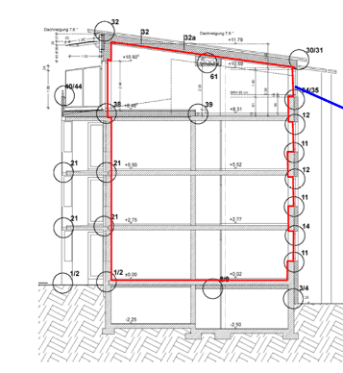
Figure 5: Continuous airtight layer of a building (source: Schulze Darup)
In brick buildings the airtight layer is formed by the interior plaster, in timber buildings it is implemented by foils, vapour barriers or vapour seals.

Weatherproofing in timber stud/timber frame structures
The classic version of weatherproofing in timber stud/timber frame structures is a curtain wall. The choice of material depends entirely on the promoters’ and architects’ preferences.
An alternative option is to apply an additional exterior thermal insulation system to the cladding on the load-bearing structure (see the following figure).
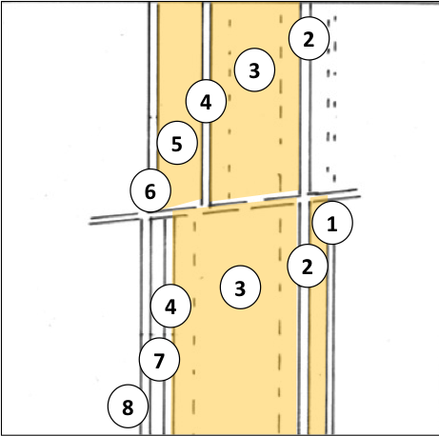
Timber stud / timber frame structure (1)
1 Optional: services layer
2 Gypsum fiber / wood-based panel
3 Load-bearing structure / insulation
4 Wood-based panel
5 Insulation
6 Exterior plaster

Timber stud / timber frame structure (2)
1 Insulated services layer
2 Gypsum fiber / wood-based panel
3 Load-bearing structure / insulation
4 Wood-based panel
7 Air space / battens
8 Exterior cladding
Figure 6: diagram of a timber stud/timber frame external wall; above, the stud structure with interior and external cladding plus an insulation shell with a plaster surface on the outside; below, a variant with an interior services layer and exterior cladding (source: Schulze Darup, adapted)
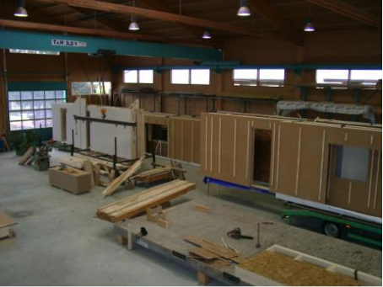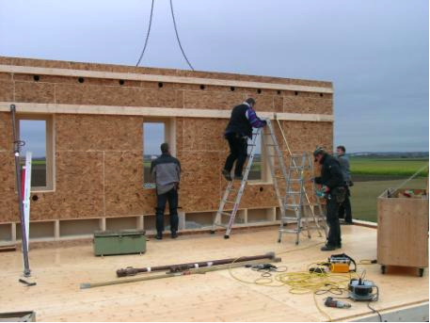
Figure 7: prefabricating and installing façade elements (source: Augsburger Holzhaus GmbH)

U values in timber stud/timber frame structures
Excellent U values can be achieved with timber stud structures. This is possible with comparatively modest wall thicknesses, since the insulation can be effective throughout almost the entire wall. If vacuum insulation is used, the result can be walls that reach passive-house standard with a structure 20 cm thick.

Sample calculation
The following U value calculation for a timber stud/timber frame wall is based on a typical passive-house structure. 8 % of the structure cross-section is taken up by the load-bearing timber structure, and a U value of 0.126 W/m²K results. If the timber element were ignored, the U value would be 0.108 W/m²K; if the timber made up 15 %, this would result in a U value of 0.143 W/m²K.

Layers (from inside to outside) d λ

1 Plasterboard 1.50 0.210
2 Battens in between: insulation installation 3.00 0.130 / 0.035
3 Gypsum fiber panel 1.50 0.350
4 Battens in between: insulation 28.00 0.130 / 0.035
5 Wood-based material 2.00 0.130
6 Airspace / battens * 3.00 0.000
7 Cladding * 2.00 0.000

Corr. 1.00 thickness [cm] 36.00 U value 0.126

Figure 8: U value calculation for a timber stud/timber frame wall; the load-bearing timber structure takes up 8 % of the structure’s thickness, which has a marked effect on the result – if the timber element were ignored, the U value would be 0.108 W/m²K; if the timber made up 15 %, this would result in a U value of 0.143 W/m²K. * Air circulation and cladding have not been taken into account in the calculation.

Non-frame timber structure with external insulation
Non-frame timber construction involves solid timber elements for walls, roof and ceilings. The great advantages of non-frame timber construction are: good structural properties in conjunction with comparatively slim structures; satisfactory properties as regards soundproofing, fire protection and overheating in summer; and the fact that this type of structure stores considerable amounts of CO₂ and thus has a positive impact on the climate balance throughout the useful life of the building.
As regards thermal insulation, conditions are similar to those applying to non-frame structures with curtain walls or composite thermal insulation systems.
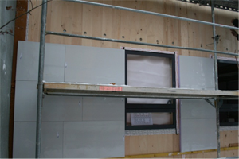
Figure 9: Vacuum insulation on a non-frame timber wall; cladding is provided by a curtain wall (source: Variotec, Neumarkt)

Load-bearing structures in non-frame timber structures
The load-bearing structure is made up of solid timber, actually glued or cross-laminated timber elements. The layers are either glued together or connected mechanically using wooden dowels or metal connectors. Arranging the layers crosswise counteracts swelling and shrinking across the width of the timber, so that dimensionally very stable elements result. Wide spans can be bridged with comparatively modest built heights, making this way of construction suitable not only for new buildings, but also for reinforcing weak ceiling structures during renovation.
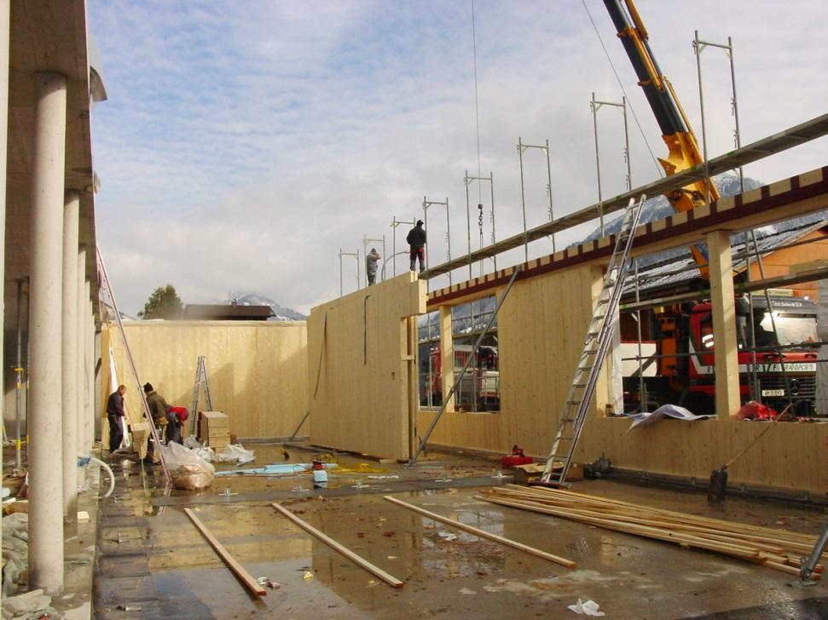
Figure 10: Dowelled board stack elements (source: Bruno Spagolla)

Services layer in non-frame timber structures
A services layer on the inside would considerably reduce the advantage of protection against overheating in summer, which is achieved by the mass of the non-frame wall. So it is advisable to choose solutions for the building services that do not require a separate layer, such as laying cables in the floor or in the skirting board, and vertical slits inside interior plasterboard cladding.

Insulation in non-frame timber structures
Because of the physics of buildings, the insulation should be located on the outside of the timber structure. Both a composite thermal insulation system and a curtain wall are options for this. Figure 10 compares possible configurations for these two systems. The U value calculation below (Figure 11) compares the structures and resulting wall thicknesses for a target U value of 0.125 W/m²K.

Fastening/securing in non-frame timber structures
A composite thermal insulation system is installed using either mechanical fastening, adhesive or a combination of both, depending on the system in question; in any case the manufacturer’s instructions for installing must be kept to.
A curtain wall is secured by methods appropriate to the system in question. Thermal decoupling should be as good as possible. The load-bearing structure has to be taken into account in calculating the U value. The sample calculation below shows this for a timber structure with a curtain wall.

Weatherproofing in non-frame timber construction
The same systems are possible as with timber frame structures: either plaster over the insulation, or a curtain wall with a wide choice of surface materials, depending on the promoters’ and architects’ preferences.
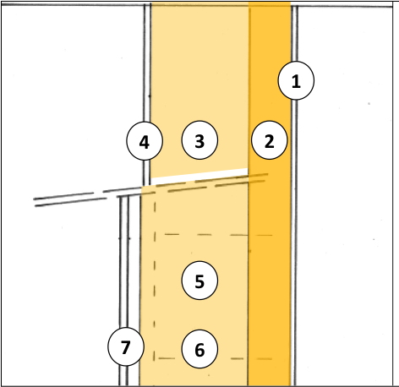
Non-frame timber structure with composite thermal insulation system
1 Optional: cladding
2 Solid timber
3 Insulation
4 Exterior plaster

Non-frame timber structure with curtain wall
1 Optional: cladding
2 Solid timber
5 Insulation
6 Load-bearing system
7 Air space / load-bearing system

Figure 11: diagram of the external wall of a non-frame timber structure; above, a plaster surface with a composite thermal insulation system; below, a version with a curtain wall (source: Schulze Darup, adapted)

U values in non-frame timber structures
Non-frame timber structures can achieve good U values with comparatively modest wall thicknesses.

Examples of U value calculations
- 1. Here we have a non-frame timber wall with a curtain wall. With this configuration (including air space and cladding) a wall approx. 45 cm thick with a U value of 0.125 W/m²K results. Let’s assume a timber structure for the curtain wall. The share of the load-bearing timber structure within the curtain wall should be as small as possible, and fastening should be done using measures to minimize thermal bridging.

Layers (from inside to outside) d λ
1 Plasterboard 1.50 0.210
2 Non-frame timber wall 12.00 0.130
3 Timber structure, in between: insulation 25.00 0.035 / 0.130
4 Softwood fiber 2.00 0.045
5 Air space * 3.00 0.000
6 Cladding * 2.00 0.000

Corr. 1.00 Thickness [cm] 40.50 U value 0.125
Figure 12: U value calculation for a non-frame timber wall with a timber-based curtain wall; the share of the load-bearing timber structure within the curtain wall should be as small as possible, and securing should be done so as to minimize thermal bridging. Assuming a 5 % timber share, a U value of 0.125 W/m²K results. * Air circulation and cladding have not been taken into account in the calculation.
- 2. For comparison, here is a calculation for a version of a non-frame timber structure with a composite thermal insulation system – often the more cost-effective choice. For a comparable U value the wall is about 6 cm less thick, which has a considerable effect on economic efficiency, especially in inner-city locations, because living space in a typical apartment building can be increased by almost 2 %.

Layers (from inside to outside) d λ
1 Plasterboard 1.50 0.210
2 Non-frame timber wall 12.00 0.130
3 Insulation 24.00 0.035
4 Exterior plaster 1.50 0.520

Corr. 1.00 Thickness [cm] 39.00 U value 0.124
Figure 13: U value calculation for a non-frame timber wall with a composite thermal insulation system (in comparison with the previous calculation). For almost the same U value the wall is a few centimetres less thick in this case.

Excursus
The following overview contrasts planning aspects of timber-based construction with those of non-frame construction and compares their advantages and disadvantages:

Timber-based construction
Advantages:  - Temporary carbon storage with favorable impact on the climate balance  - Primary energy input to the building is lower than that of most non-frame constructions  - Wider choice of insulation materials for most designs  - Considerable architectural freedom in façade design | Disadvantages:  - Soundproofing and fire protection  - Timber protection  - Emission behaviour of timber surfaces, particularly wood-based materials  - In general more elaborate planning required  - Construction costs are higher for high-quality implementation
Non-frame construction
Advantages:  - Cost  - Soundproofing (heavy building materials)  - Fire protection  - Practically no emissions from mineral construction elements with mineral plaster and coating  - Heat storage capacity for protection against overheating in summer  - Aura of value stability | Disadvantages:  - Primary energy balance sheet  - Choosing insulation materials is harder: polystyrene and mineral fibres are common, renewable or purely mineral insulation materials are possible, but more expensive

Regarding this comparison matrix, it should be noted that accurate assessment is possible only if the entire system of a building is taken into account.

Quality criteria for producing an insulation system

Quality assurance at the planning stage
Energy-optimized buildings should be planned by a planning team in which all relevant trades are represented.
In selecting the insulation system, for example, this involves taking users’ wishes into account together with structural requirements, and implementing them in terms of high-quality architecture. Along with this, numerous technical and legal aspects, such as soundproofing and fire protection, and of course energy-related requirements, play a part.
Nowadays a building is fit for the future only if high-grade heat protection is provided. This involves not only a U value of at most 0.15 W/m²K, but also requirements concerning airtightness and minimizing thermal bridging, which have to be taken into account as early as the planning phase. The simpler the design of the building and the less complicated the interfaces, the more cost-effective erecting the building can be.
The target should be simple systems which are easy for skilled workers to implement and which need only a minimum of maintenance during use.

Quality assurance during construction
If planning and scheduling have been done with the above-mentioned aspects in mind and have been described clearly in the tender documents, the contractors’ job is to carry out the work with as few defects as possible.
For this it is important to clarify and reach agreement on the details, and particularly the interfaces between the various trades, within the construction team at an early stage. If the contractors’ tasks are clarified in detail in advance, this will avoid some misunderstandings during the construction phase.
However, all contractors are obliged to inform every single tradesperson about their tasks on site and to train them in innovative techniques as appropriate. Advantage should be taken of training courses offered by energy agencies, trade associations or producers, too.
Finally, site management by the architect must ensure not only that the tasks are coordinated continuously, but also that they are performed without defects. Regular visits to the site are essential here, as are the interim and final acceptance procedures.

Airtightness
The passive-house standard for buildings requires an ACH₅₀ value of at most 0.6 1/h, to be demonstrated in a blower-door test.
The airtight layer must be taken into account right from the start of planning, and must be implemented with precision in detailed planning.
In timber stud and timber frame structures the airtight layer is generally located at the cladding or the vapour barrier on the inside of the load-bearing system.
In non-frame timber structures it is on the inside of the non-frame timber layer.
In non-frame external walls the airtight layer is formed by the interior plaster in all the configurations described. In non-frame construction an air seal is usually achieved by means of the interior plaster or by levelling on the inside of the external masonry.
The following diagram presents an overview of the potential weak spots in the airtight layer (junctions between and penetrations through building elements).

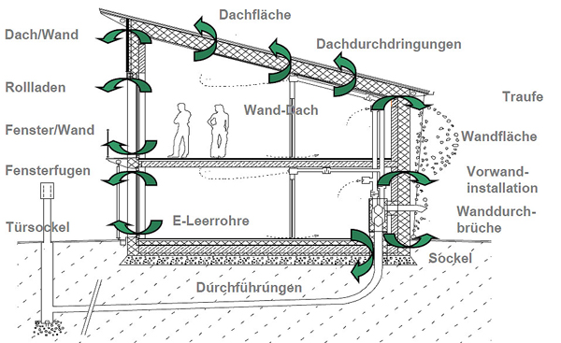
Roof surface
Penetrations through roof
Eave
Wall surface
Pre-wall installation
Penetrations through wall
Wall/roof
Roller shutters
Window/wall
Window joints
Empty electrical conduits
Wall/roof
Dado

Door base
Leadthroughs
Figure 14: Section through a passive house, showing the problem areas within the airtight layer (source: Schulze Darup, PHS 2.1 slide p. 20, adapted)
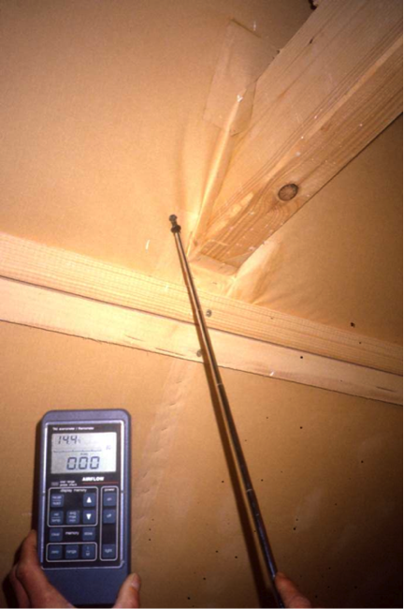  Figure 15: Measuring for leaks where a beam penetrates the roof (source: Schulze Darup) | 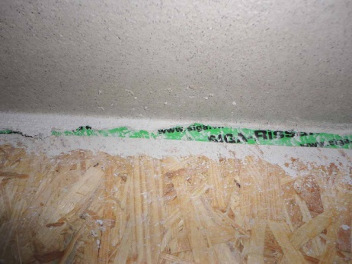  Figure 16: Airtight connection between timber wall and ceiling above ground floor (source: Schulze Darup)  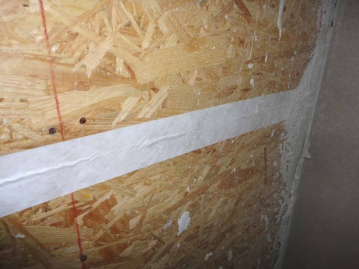  Figure 17: Airtight layer in timber construction (source: Schulze Darup)

A video on airtight building:
https://www.youtube.com/watch?v=S9-lsaMmqDQ

Minimizing thermal bridging
Thermal weak spots, as compared to the average heat transfer coefficient of an external construction element, are called thermal bridges. These spots must be analysed in terms of heat losses. The differential value is the coefficient of thermal bridging loss (Ψ) in W/mK.
Structure geometry involves a risk of thermal bridging at projections or corners, for example. However, if the insulation is drawn around the corner at almost the mean insulation thickness, this results in a “negative” thermal bridge.
This means a small plus when the heat losses through the external construction elements are calculated.
Interior corners always involve additional thermal bridging due to geometry.
To minimize the thermal bridging at windows/surrounds in all types of configuration, the insulation must be drawn over the window frame as far as possible.

Additional quality criteria
Depending on the type of structure, the following additional considerations apply:
Timber stud/timber frame structures:
In U value calculation, the first thing is to compare the timber and insulation shares of the structure; both enter into the U value of the area overall. In addition, thermal bridging at the dado, at the intersecting ceilings, at the roof transition and, if applicable, at intersecting inner walls must be taken into account.
Non-frame timber structures with external insulation:
If the thermal insulation is on the outside, intersecting construction elements do not generally form thermal bridges. Dado and roof intersection usually enter the calculations of heat flow as negative thermal bridges, due to the geometry of outside corners. Penetrations of the insulation layer to the outside, such as spot thermal bridges for anchors, are disadvantageous.
External wall structures with composite thermal insulation systems (ETICS):
As far as thermal bridging is concerned, these are similar to non-frame timber structures: no problems with intersections of inner walls and ceilings; advantages at outside corners such as dado and roof connection, if the insulation is drawn around the corner at full thickness. In recent years systems to minimize thermal bridging have been developed for mounting construction elements on the outside of the wall; these should be included in the thermal bridging balance sheet.
External wall structures with curtain wall:
Basically the same applies as for external walls with ETICS. But since there is a load-bearing scaffold for the facing on the outside, this has to be taken into account in the U value calculation. On the other hand attaching lightweight construction elements to the façade is not a problem, because they can be fixed to the load-bearing scaffold. Spot thermal bridges due to structurally relevant penetrations must be assessed individually.
Single-shell external wall structures:
All construction elements with deviating coefficients of thermal conductivity must enter the balance sheet as thermal bridges if they intersect the external wall. This is the case for ceilings, due to the necessary load transfer, and possibly for walls because of soundproofing requirements. On the other hand, dado and roof connections can usually be implemented with negative heat transfer coefficients, which means they yield a small bonus in the energy balance sheet.
Double-shell external wall structures:
Basically the same applies to these as to external wall structures with a curtain wall.

List of figures
Figure 1: Example of timber frame structure (source: Holzbau Henz GmbH) 3
Figure 2: Timber frame structure (source: Holka Genossenschaft) 4
Figure 3: Timber I-joists (source: www.dataholz.com, ein Service der Holzforschung Austria) 4
Figure 4: injecting cellulose into a timber stud wall (source: Isocell GmbH) 5
Figure 5: Continuous airtight layer of a building (source: Schulze Darup) 6
Figure 6: diagram of a timber stud/timber frame external wall; above, the stud structure with interior and external cladding plus an insulation shell with a plaster surface on the outside; below, a variant with an interior services layer and exterior cladding (source: Schulze Darup, adapted) 7
Figure 7: prefabricating and installing façade elements (source: Augsburger Holzhaus GmbH) 7
Figure 8: U value calculation for a timber stud/timber frame wall; the load-bearing timber structure takes up 8 % of the structure’s thickness, which has a marked effect on the result – if the timber element were ignored, the U value would be 0.108 W/m²K; if the timber made up 15 %, this would result in a U value of 0.143 W/m²K. * Air circulation and cladding have not been taken into account in the calculation. 8
Figure 9: Vacuum insulation on a non-frame timber wall; cladding is provided by a curtain wall (source: Variotec, Neumarkt) 9
Figure 10: Dowelled board stack elements (source: Bruno Spagolla) 9
Figure 11: diagram of the external wall of a non-frame timber structure; above, a plaster surface with a composite thermal insulation system; below, a version with a curtain wall (source: Schulze Darup, adapted) 10
Figure 12: U value calculation for a non-frame timber wall with a timber-based curtain wall; the share of the load-bearing timber structure within the curtain wall should be as small as possible, and securing should be done so as to minimize thermal bridging. Assuming a 5 % timber share, a U value of 0.125 W/m²K results. * Air circulation and cladding have not been taken into account in the calculation. 11
Figure 13: U value calculation for a non-frame timber wall with a composite thermal insulation system (in comparison with the previous calculation). For almost the same U value the wall is a few centimetres less thick in this case. 11
Figure 14: Section through a passive house, showing the problem areas within the airtight layer (source: Schulze Darup, PHS 2.1 slide p. 20, adapted) 14
Figure 15: Measuring for leaks where a beam penetrates the roof (source: Schulze Darup) 14
Figure 16: Airtight connection between timber wall and ceiling above ground floor (source: Schulze Darup) 14
Figure 17: Airtight layer in timber construction (source: Schulze Darup) 14

Legal notice
Published by:
e-genius – Verein zur Förderung und Entwicklung offener Bildungsmaterialien im technisch-naturwissenschaftlichen Bereich

Postfach 16
1082 Vienna
Austria
E-mail: info(at)e-genius.at

Project leader:
Dr. Katharina Zwiauer
E-mail: katharina.zwiauer(at)e-genius.at

Authors and Adapting for teaching purposes: Dr. Burkhard Schulze Darup, Dr. Katharina Zwiauer, Magdalena Burghardt
Translation and editing: Magdalena Burghardt, Andrew Kilpatrick
Layout: Magdalena Burghardt

August 2015

This learning unit was funded with support from the European Commission. This publication reflects the views only of the author, and the Commission cannot be held responsible for any use which may be made of the information contained therein.
The basis for this learning unit was developed within a project of „Building of Tomorrow“.
Terms of use
This learning unit is provided under the following Creative Commons Licence:
Creative Commons Attribution-NonCommercial-NoDerivatives 4.0 International License.
You are free to:
Share — copy and redistribute the material in any medium or format
The licensor cannot revoke these freedoms as long as you follow the license terms.
Under the following terms:
Attribution — You must give appropriate credit, provide a link to the license, and indicate if changes were made. You may do so in any reasonable manner, but not in any way that suggests the licensor endorses you or your use.
NonCommercial — You may not use the material for commercial purposes.
NoDerivatives — If you remix, transform, or build upon the material, you may not distribute the modified material.
No additional restrictions — You may not apply legal terms or technological measures that legally restrict others from doing anything the license permits.

Attribution to e-genius as the copyright owner must take the following form:
Texts: authors of the learning unit, year of publication, title of the learning unit, publisher: Verein e-genius, www.e-genius.at/en
Illustrations: attribution to owner of copyright, e-genius – www.e-genius.at/en

Exclusion of liability:
All content on the e-genius platform has been carefully checked. Nevertheless, we are unable to offer any guarantee as to the correctness, completeness, topicality and availability of the content. The publisher does not accept any liability for damage or disadvantages that may arise from the use or exploitation of the content. The provision of the content on e-genius is not intended to replace the obtaining of professional advice and the ability to access the content does not constitute an offer to create an advisory relationship.
e-genius contains links to external websites. The insertion of links is a reference to representations and (also other) opinions, but does not mean the content of such links are endorsed. The publisher of e-genius does not accept any liability for websites that are referred to via a link. This applies both to their availability and to the content that can be accessed on such websites. As far as the operators are aware, the linked pages do not contain any unlawful content; should such content be discovered, it will be immediately removed in fulfilment of the legal obligations of the electronic reference.
Third-party content is identified as such. Should you nevertheless become aware of an infringement of copyright, please let us know accordingly. Upon being notified of legal infringements, we will immediately remove or correct such content.
Link to the open content platform: http://www.e-genius.at/en

