Insulation and Façade Systems –

Non-frame External Walls

Preamble
Europe sees a great deal of potential for saving energy in the building sector. This is to be tapped by implementing the Directive on the Energy Performance of Buildings (EPBD), since this directive lays down not only thermal standards for major reconstructions of older buildings, but also the “Nearly Zero-Energy Building” standard for new buildings. These goals are to be reached by a combination of increased energy efficiency and utilizing renewable sources of energy. Even though not all member states have finally defined their implementation programs yet, the issue of optimal thermal insulation will play a vital part in terms of high energy-saving potential and economic efficiency.

Abstract
In this learning unit we show you the possibilities of external insulation combined with different wall structures. Various types of structure and areas of application are shown and practical tips for selecting appropriate insulation materials, for installation and the physics of buildings are given. Planning criteria and feasible insulation standards are described. An important section deals with quality assurance regarding airtightness and minimizing thermal bridging.

Objectives
On completing this learning unit students are able to …
- list components of different systems for non-frame external wall insulation
- compare different insulation systems for non-frame external walls
- present solutions for difficult parts of insulation systems
- describe how various non-frame external wall structures are made up
- evaluate wall insulation systems with respect to their advantages and disadvantages
- apply quality criteria to insulation systems

Contents
Preamble 1
Abstract 1
Objectives 1
1. External wall structures with composite thermal insulation systems (ETICS) 4
1.1 Non-frame load-bearing structures 4
1.2 Insulation in non-frame structures 4
1.3 Fastening/securing in non-frame structures 6
1.4 Weatherproofing in non-frame structures 6
1.5 Airtightness and services in the external wall 6
2. External wall structures with curtain wall 8
2.1 Load-bearing structure in curtain walls 9
2.2 Insulation materials in curtain walls 9
2.3 Anchoring curtain walls 10
2.4 Weatherproofing curtain walls 10
3. Single-shell external wall structures 12
3.1 Load-bearing structure/insulation materials in single-shell external wall structures 12
3.2 Weatherproofing for single-shell external wall structures 12
3.3 Services layer in single-shell external wall structures 12
3.4 U values of single-shell external wall structures 13
3.5 Sustainability aspects 13
4. Double-shell external wall structures 14
4.1 Load-bearing structure of double-shell external wall structures 15
4.2 Insulation materials in double-shell external wall structures 15
4.3 Anchoring double-shell external wall structures 15
4.4 Weatherproofing double-shell external wall structures 15
4.5 U values of double-shell external wall structures 16
5. Quality criteria for producing an insulation system 18
5.1 Quality assurance at the planning stage 18
5.2 Quality assurance during construction 19
5.3 Airtightness 19
5.4 Minimizing thermal bridging 21
5.5 Additional quality criteria 21
5.5.1 External wall structures with composite thermal insulation systems (ETICS) 21
5.5.2 External wall structures with curtain wall 21
5.5.3 Single-shell external wall structures 21
5.5.4 Double-shell external wall structures 21
6. List of figures 22
7. Legal notice 24

External wall structures with composite thermal insulation systems (ETICS)
Where an external wall structure consists of masonry or reinforced concrete in combination with a composite thermal insulation system (ETICS), the functions of these two layers are separated:
The load-bearing layer performs structural functions and, due to its considerable mass, has advantages for soundproofing and protection against overheating in summer. The insulation layer is implemented with thermally optimized materials. As regards economic efficiency these systems are very satisfactory, and they have the largest market share of wall systems.
What is a composite thermal insulation system?
ETAG 004 describes ETICS as comprising a prefabricated insulation product which is bonded onto the wall, or mechanically fixed using anchors, profiles, special pieces, etc. ..., or a combination of adhesive and mechanical fixings and faced with a rendering. This rendering consists of one or more layers (site applied), one of which contains a reinforcement and is applied directly to the insulating panels, without any air gap or disconnecting layer.

Non-frame load-bearing structures
The load-bearing function is performed by the masonry or reinforced-concrete wall. In this case buildings of five storeys or more can be built with highly load-bearing walls only 17.5 cm thick. In less tall buildings the properties of the load-bearing shell can be varied; then additional aspects such as fire protection are relevant.

Insulation in non-frame structures
The composite thermal insulation system can be selected from a wide range of possible insulation materials. The market leaders are polystyrene insulation foams, which have been continually improved in terms of thermal conductivity in recent years, and which are offered by most producers with a thermal conductivity λ of as little as 0.032 W/mK. The same applies to insulation consisting of artificial mineral wool. Mineral foam insulation is a purely mineral insulation variant with a slightly less favorable thermal conductivity λ of approx. 0.04 W/mK.
Insulation materials from renewable raw materials, such as wood fibre insulation materials, generally have a thermal conductivity λ in the range 0.035 to 0.05 W/mK and feature in many ETICS suppliers’ product range.
For every single building an individual decision must be made about which insulation material comes closest to true sustainability. However, a U value of 0.12 to 0.16 W/m²K should not be exceeded in new buildings.
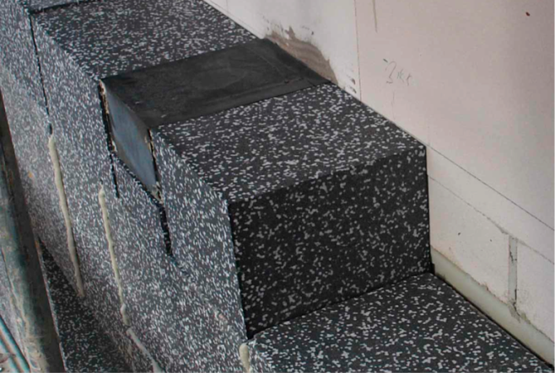
Figure 1: ETICS insulation with an anchoring point (implemented to minimize thermal bridging) for a light (source: Schulze Darup)
Fire protection measures must be taken in line with the manufacturer’s instructions or as per certification. If carried out properly, the systems offer a high degree of safety in the case of fire.
In general it can be said that the “recognized rules of engineering” apply to implementation. The box below lists relevant norms and guidelines. In addition, the manufacturer’s instructions for implementing the ETICS should be obeyed to the letter.
EUROPEAN NORMS / DIRECTIVES / GUIDELINES
a. ETAG 004 Guideline for European Technical Approval of External Thermal Insulation Composite Systems with Rendering
b. ETAG 014 Guideline for European Technical Approval of Plastic Anchors for Fixing External Thermal Insulation Composite Systems with Rendering
c. EN 13162 (MW) Thermal insulation products for buildings – Factory made mineral wool (MW) products
d. EN 13163 (EPS) Thermal insulation products for buildings – Factory made expanded polystyrene (EPS) products
e. EN 15824 Specifications for external renders and internal plasters based on organic binders
Among other things the following considerations apply to the individual processing steps:
Preparation and basics: A log is useful for preparation and documentation. You must check and document, among other things: the existing substrate; whether the ETICS selected complies with the requirements of the physics of the building and the statutory building standards; whether all system components are on hand; whether the substrate is adequately prepared; whether all connections, windows, downpipes, awnings, etc. have been taken into account.

Fastening/securing in non-frame structures
Composite thermal insulation systems in new buildings are mostly bonded with mortar (in some cases polymer-modified). Additional mechanical fastening may be necessary. Where walls are thermally renovated, additional fastening with dowels is the rule. In exceptional cases, if testing the adhesive tensile strength establishes that the existing substrate is functional, it may turn out that its load-bearing capacity is sufficient, in which case additional dowelling can be omitted.

Weatherproofing in non-frame structures
A levelling coat plus reinforcement fabric is applied to the insulation. After this functional layer has dried, the finishing coating with the selected surface structure and colour is applied. In recent years there has been a tendency to implement renderings with an increased thickness of 15 to 20 mm. This not only makes the surface more solid and deters woodpeckers from nest-building; hygrothermal behavior is also improved, resulting in fewer algae colonizing the plaster surface.
Ceramic plates, brick slips or other surfacings can be glued onto ETICS, so a wide variety of finishes are possible.

Airtightness and services in the external wall
In non-frame construction services such as electrical cables are traditionally slotted into the masonry. As an alternative, some system suppliers provide perforated bricks through which for instance electrical cables are laid or wall heating systems are integrated. The essential point is that the airtight layer is formed by the interior plaster, which means that all penetrations must be made airtight. If a service line is installed on the inside of the external wall, e.g. the service wall of a sanitary cell, then the masonry must first be trowelled in order to make it airtight.
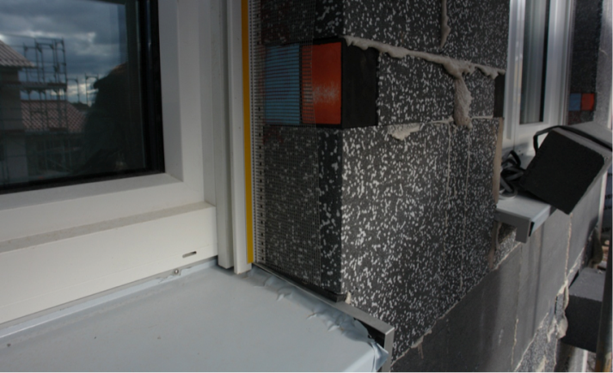
Figure 2: ETICS insulation with an anchoring point (implemented to minimize thermal bridging) for a baluster (source: Schulze Darup)
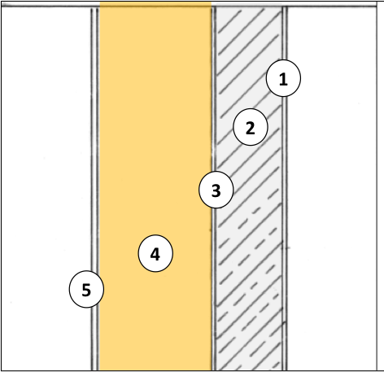
Masonry / reinforced concrete with composite thermal insulation system

1 Interior plaster
2 Masonry/reinforced concrete
3 Adhesive
4 Insulation
5 Exterior plaster

Figure 3: diagram of a non-frame wall with a composite thermal insulation system (source: Schulze Darup, adapted)
Frequent ERRORS in implementing ETICS:
- base rendering thickness incorrect (layer thickness as per ÖNORM B 6410:Table 6 [OEN11a])
- damage caused by insulation panels shrinking
- insulation panels not anchored properly
- top rendering not thick enough
- faulty execution of connections at dado level
- substantial gaps between insulation panels not plugged with foam
- minimum width of offcuts not kept to, joints not offset correctly, no diagonal reinforcement at windows
- defects involving base rendering, execution of joints, distribution and insertion of dowels

Sample calculation
For a non-frame wall with composite thermal insulation, assuming 17.5 cm of high-strength masonry, 26 cm of insulation and λ = 0.035 W/mK, the calculation yields a U value of 0.127 W/m²K.
To reach a U value of 0.10 W/m²K, the insulation would need to be 30 cm thick, with an λ value of 0.032 W/mK.
If highly insulating porous masonry with an λ value of 0.09 W/mK is selected, a U value of 0.127 W/m²K can be achieved with a mere 20 cm of insulation, resulting in a total wall thickness of less than 40 cm. However, in this calculation additional thermal bridging via the floor abutments must be taken into account. If this optimization is carried to the limit, and an insulation material available on the market with an λ value of 0.022 W/mK is selected, a total wall thickness of 33 cm is sufficient.

Layers (from inside to outside) d λ
1 Interior plaster 1.50 0.700
2 Masonry 17.50 0.900
3 Insulation 26.00 0.035
4 Exterior plaster 1.50 0.520

Corr. 1.00 Thickness [cm] 46.50 U value 0.127
Figure 4: U value calculation for a non-frame wall with a composite thermal insulation system. Insulation 26 cm thick with an λ value of 0.035 W/mK yields a U value of 0.127 W/m²K.

External wall structures with curtain wall
If weatherproofing is provided by cladding over the entire insulation, this is called a curtain wall.
There is a choice between timber and wood-based materials, mineral panels, natural and artificial stone slabs, metal and glass surfaces, plus photovoltaic panels.
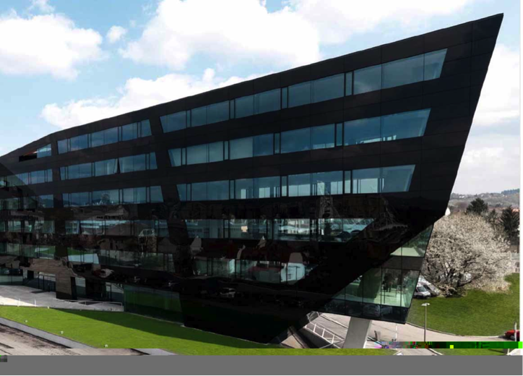
Figure 5: “Schwarzer Panther” (“Black Panther”), Graz, Austria, architects: GSarchitects Graz. Curtain wall as glass façade (source: STO)
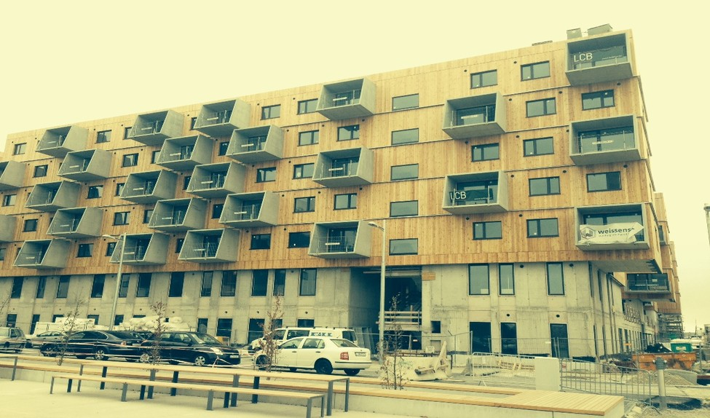
Figure 6: External wall system with timber curtain wall in Seestadt Aspern, Vienna, Austria (source: Weissenseer Holz-System-Bau GmbH)

Load-bearing structure in curtain walls
The curtain wall is suspended in front of the building and carries only its own weight. The load is transferred to the wall behind it via an anchoring system.
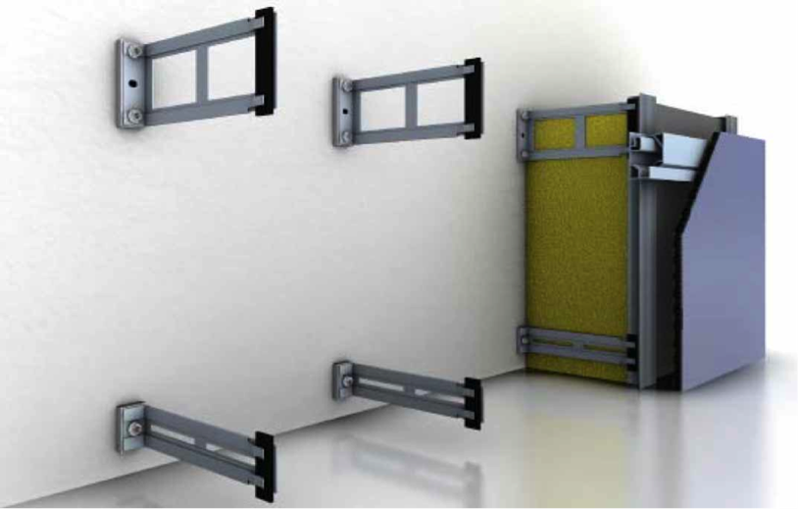
Figure 7: anchoring system for a curtain wall with minimal thermal bridging – ΔU_{WB} ≤ 0.01 W/m²K (source: Fa. STO)
In skeleton structures the curtain wall load is taken up by a load-bearing system that spans all storeys. In this case the anchoring system reaches from floor to floor, or is fixed to the load-bearing structure of the building by other means.

Insulation materials in curtain walls
The insulation material can be selected from a wide variety of possible materials. They range from panels via battens, which are pressed into the load-bearing system, to loose-fill insulation, which is injected into a prepared mould. Insulation foams are another option. Insulation made from artificial mineral wool is of particular advantage for buildings with stricter fire protection requirements.
The thermal conductivity of both groups of materials λ is between 0.032 and 0.040 W/mK. Insulation made from renewable raw materials can also be used, with a thermal conductivity λ of 0.035 to 0.050 W/mK. Especially cellulose should be mentioned as a loose-fill insulation material with favourable properties as regards product system assessment and primary energy input.

Anchoring curtain walls
A curtain wall can be anchored using very different systems. Timber structures are possible, as are metal systems, which can be installed in the form of a frame scaffold or with individual anchors. Aluminium should in no case be used, due to its very poor thermal conductivity λ of 200 W/mK. Steel is around 60 W/mK and stainless steel lies between 25 and 15 W/mK, thus being the most suitable.
The important thing is that the system is thermally decoupled from the load-bearing wall.
For this purpose, spacers made from heat-insulating and pressure-resistant material can be used, for instance. The anchoring system as a whole should conduct as little heat as possible from inside to outside. High-quality systems are almost free from thermal bridging, differing from a system with no anchoring by ΔUWB ≤ 0.01 W/m²K. This means that the U value of a structure deteriorates from, say, 0.12 to 0.13 W/m²K, assuming the same insulation thickness.
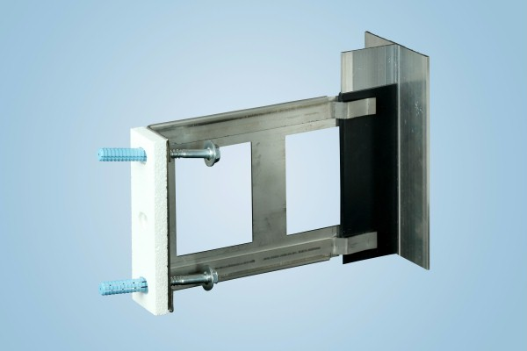
Figure 8: Spacer made of stainless steel (source: Sto SE & Co. KGaA)

Weatherproofing curtain walls
The façade surface can be chosen freely. The choice ranges from cladding with timber and wood-based materials, via mineral panels with various types of surface, natural and artificial stone slabs, to metal or glass surfaces. If the façade of an energy-surplus building is equipped with photovoltaic units, the design is also based on the principle of curtain walls.
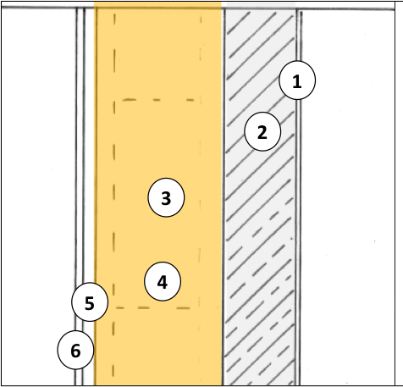
Masonry / reinforced concrete with curtain wall

1 Interior plaster
2 Masonry / reinforced concrete
3 Insulation
4 Anchoring system
5 Air space / load-bearing system
6 Exterior cladding

Figure 9: diagram of a non-frame wall with curtain wall; it is important to choose an anchoring system that will minimize thermal bridging (source: Schulze Darup, adapted)
Layers (from inside to outside) d λ
1 Interior plaster 1.50 0.700
2 Masonry 17.50 0.900
3 Insulation in between: insulation 25.00 0.045 / 0.035
4 Load-bearing syst. stainless steel in between: insulation 2.00 15.00 / 0.035
5 Airtight layer 0.10 0.500
6 Air space * 3.00 0.000
7 Cladding * 2.00 0.000

Corr. 1.00 Thickness [cm] 46.10 U value 0.128
Figure 10: U value calculation for a curtain wall; as compared to a composite thermal insulation system, the structure is thicker overall, due to the addition of the load-bearing system and the cladding. * Air space and cladding have been left out of account in the calculation.
Curtain wall made of glass and metal (source: http://www.wolfzargen.at/de/leistungen/fassaden)

Figure Fehler! Es wurde keine Folge festgelegt.Fehler! Es wurde keine Folge festgelegt.: U value calculation for a curtain wall; as compared to a composite thermal insulation system, the structure is thicker overall, due to the addition of the load-bearing system and the cladding. * Air space and cladding have been left out of account in the calculation.
Layers (from inside to outside) d λ
1 Interior plaster 1.50 0.700
2 Masonry 17.50 0.900
3 Insulation in betw.: vacuum insul. 6.50 0.045 / 0.008
4 Load-bearing syst. stainless steel in betw.: insul./protection 0.50 15.00 / 0.035
5 Airtight layer 0.10 0.500
6 Air space plus battens * 3.00 0.000
7 Cladding * 2.00 0.000

Corr. 1.00 Thickness [cm] 26.10 U value 0.125
Figure 11: U value calculation for a curtain wall with vacuum insulation (VIP); the excellent thermal conductivity λ of only 0.008 W/mK makes a slim structure possible with a total wall thickness of approx. 31 cm (including air space and cladding) and a VIP insulation thickness of 6.5 cm. * Air space and cladding have been left out of account in the calculation.

Single-shell external wall structures
Nowadays single-shell walls can be produced to achieve values as low as λ = 0.07 W/mK. This involves using bricks of gross-density class 0.6, combined with insulation inlays inside the brick which are made from materials such as perlites or artificial mineral fibres, or using porous concrete bricks.
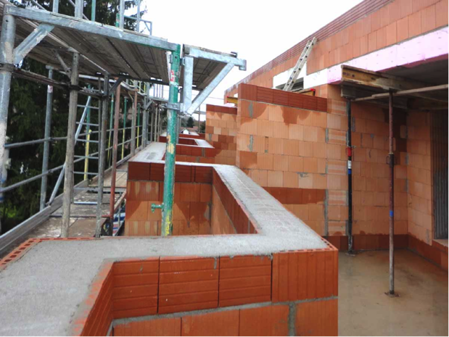
Figure 12: single-shell brick masonry for a passive house; the thermal bridge connections with the roof terrace had to be assessed in detail in this project (source: Schulze Darup)

Load-bearing structure/insulation materials in single-shell external wall structures
The masonry performs both functions, load-bearing and thermal protection. For detached houses and low-rise apartment buildings, a gross density of 0.6 together with a thermal conductivity λ of 0.07 W/mK is suitable. If soundproofing and increased load-bearing capacity are required, bricks of the gross density class 0.65 and compressive strength class > 6 should be selected, with a thermal conductivity λ of 0.09 W/mK.
Combining this masonry with an additional insulation system or a curtain wall, for example based on timber, also leads to good results.

Weatherproofing for single-shell external wall structures
Weatherproofing is provided by the exterior plaster, which can also be a heat-insulating plaster with an additional thermal effect.

Services layer in single-shell external wall structures
As in masonry structures, the services are slotted into the masonry. Particularly with porous stone materials, great care must be taken that the airtight layer is provided by the interior plaster.
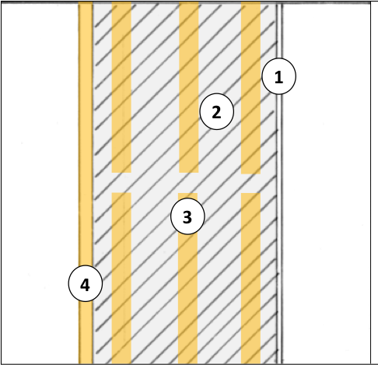
Single-shell masonry

1 Interior plaster
2 Porous masonry
3 Optional: insulation inlay
4 Exterior plaster in the form of insulating plaster
Figure 13: diagram of single-shell masonry wall to passive-house standard; cavities are filled with insulation materials; about 4 cm of insulating plaster is applied on the outside (source: Schulze Darup, adapted)
A video on airtight electrical installation:

https://www.youtube.com/watch?v=1xwWLmfnsPU

U values of single-shell external wall structures
External wall structures suitable for passive houses, with an excellent U value of 0.127 W/m²K, can be achieved with single-shell masonry 49 cm thick and with a thermal conductivity λ of 0.070 W/mK plus 4 cm of insulating plaster. If, for structural reasons or for the sake of soundproofing, only a thermal conductivity λ of 0.090 W/mK is possible, the U value shifts to 0.159 W/m²K.

Layers (from inside to outside) d λ
1 Interior plaster 1.50 0.700
2 Masonry 49.00 0.070
3 Insulating plaster 4.00 0.060

Corr. 1.00 Thickness [cm] 54.50 U value 0.127
Figure 14: U value calculation for a single-shell external wall to passive-house standard with masonry 49 cm thick (λ = 0.070 W/mK) plus 4 cm of insulating plaster

Sustainability aspects
When we assess our buildings from an overall perspective, the “grey energy”, i.e. the energy used to construct them, gains in importance. Biogenic building materials bind carbon long-term and thus provide a CO₂ sink as long as they are in place, which counteracts global warming. Since the 1980s renewable building materials have been gaining ground in the building sector, too. Some materials, such as softwood fibreboard and cellulose insulation, are now in widespread use for numerous applications. The planner making decisions, though, has to bear the whole product system assessment of the materials in mind and weigh up all aspects of sustainability. For example, single-shell masonry made from bricks is a monolithic, purely mineral material. On the other hand, the energy input to brickmaking (which is rather high due to the high firing temperature for bricks) must also be taken into account.
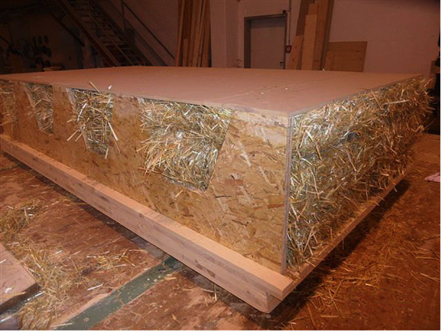
Figure 15: prototype of a prefabricated wall element insulated with straw bales (source: GrAT)
Video on grey energy of building materials:
https://www.youtube.com/watch?v=_phZsqSjtds

Double-shell external wall structures
Double-shell external wall structures are not often implemented in Austria. In many respects they are similar to the curtain wall, except that the outer shell is a solid outer wall.
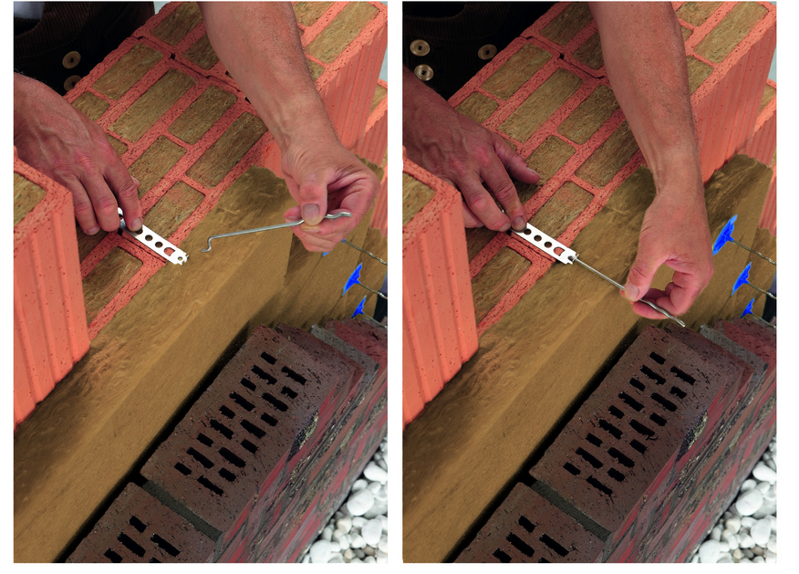
Figure 16: Double-shell wall structure, anchors for installing insulation (source: Wienerberger GmbH)

Load-bearing structure of double-shell external wall structures
The structural function is performed by the inner shell of the double-shell wall. The outer shell carries only its own weight, and is fixed to the load-bearing masonry by anchors.

Insulation materials in double-shell external wall structures
In most cases insulation foam panels are used as core insulation. Because the insulation thickness is limited to 20 cm, a material with λ = 0.022 to 0.028 W/mK should be chosen to achieve passive-house standard.

Anchoring double-shell external wall structures
The outer wall is secured with wall anchors. Approved anchors are available for core insulation spaces of up to 20 cm.

Weatherproofing double-shell external wall structures
The outer wall must be made weatherproof. Clinker bricks, exposed sand-lime brickwork, or concrete facing bricks are all possible options.
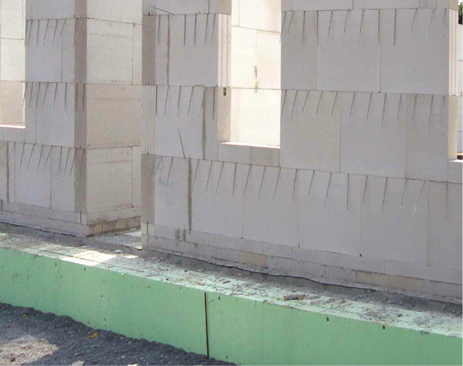
Figure 17: inner masonry shell with wall anchors for the façade shell (source: Schulze Darup)
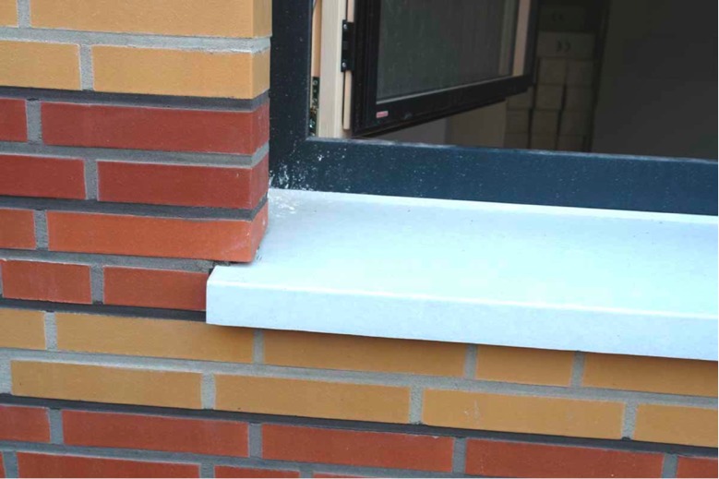
Figure 18: facing brickwork at window surround, backed by layer of insulation 20 cm thick with λ = 0.025 W/mK and a U value of 0.12 W/m²K (source: Schulze Darup)
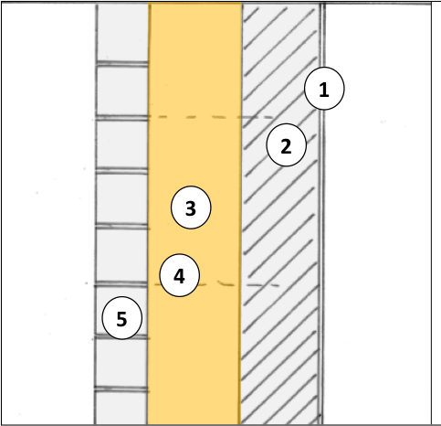
Double-shell masonry

1 Interior plaster
2 Masonry
3 Insulation
4 Wall anchor
5 Façade shell
Figure 19: diagram of double-shell masonry to passive-house standard; the insulation must be implemented using high-grade insulation material with λ ≅ 0.02 to 0.025 W/mK; it is important to select wall anchors certified for up to 20 cm of space between the shells (source: Schulze Darup, adapted)

U values of double-shell external wall structures
Since the outer shell is secured with wall anchors, the space between for insulation is limited to 20 cm. The calculation for this double-shell masonry wall yields a U value of 0.126 W/m²K for a wall structure with 20 cm of insulation and a thermal conductivity λ of at most 0.027 W/mK.
If the double-shell masonry is realized with a porous inner wall and an insulation with a coefficient of at most λ = 0.025 W/mK, then a U value of 0.12 to 0.13 W/m²K, i.e. up to passive-house standard, can be achieved with a mere 16 cm of insulation.
Layers (from inside to outside) d λ
1 Interior plaster 1.50 0.700
2 Masonry 17.50 0.900
3 Insulation 20.00 0.027
4 Optional air space * 0.00 0.000
5 Outer shell 11.50 1.000

Corr. 1.00 Thickness [cm] 50.50 U value 0.126
Figure 20: U value calculation for a double-shell masonry; if the insulation material has a thermal conductivity of at most λ = 0.027 W/mK, then a wall structure to passive-house standard can be achieved with insulation 20 cm thick. * The air space has not been taken into account in calculating the U value.
Layers (from inside to outside) d λ
1 Interior plaster 1.50 0.700
2 Masonry 17.50 0.140
3 Insulation 16.00 0.025
4 Layer of stationary air (50 mm), upward * 5.00 0.000
5 Outer shell 11.50 1.000

Corr. 1.00 Thickness [cm] 46.50 U value 0.126
Figure 21: if the double-shell masonry wall is implemented with a porous inner wall and the insulation coefficient λ is at most 0.025 W/mK, then a U value of 0.12 to 0.13 W/m²K, i.e. up to passive-house standard, can be achieved with insulation 16 cm thick. * The air space has not been taken into account in calculating the U value.
Excursus on façade-integrated energy-surplus technology
In the near future energy generation will no longer be tied to centralized power plant structures. Even today, any promoter can build an energy-surplus house. For this purpose, technologies to exploit renewable sources of energy can be integrated into the building envelope or incorporated in the structure architecturally. A wide variety of surfaces with photovoltaic potential, be they curtain walls or coatings, will be available in a few years’ time to provide new openings for energy strategies and architectural design.
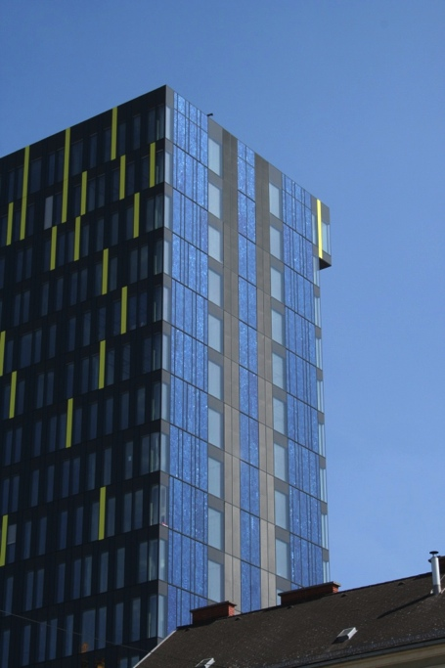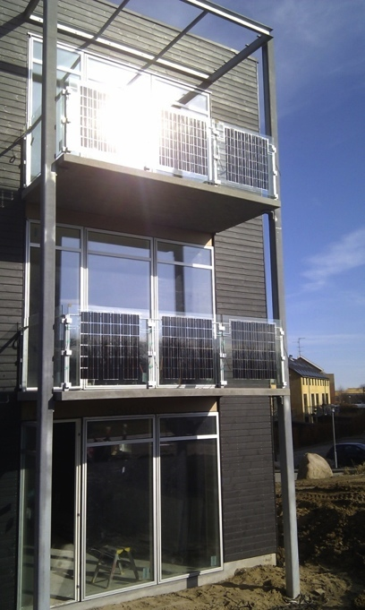
Figure 22: Solarmodule in die Fassade (links) und in Balkonbrüstungen (rechts) integriert (Quelle: Fa. Ertex Solar)

Quality criteria for producing an insulation system

Quality assurance at the planning stage
Energy-optimized buildings should be planned by a planning team in which all relevant trades are represented.
In selecting the insulation system, for example, this involves taking users’ wishes into account together with structural requirements, and implementing them in terms of high-quality architecture. Along with this, numerous technical and legal aspects, such as soundproofing and fire protection, and of course energy-related requirements, play a part.
Nowadays a building is fit for the future only if high-grade heat protection is provided. This involves not only a U value of at most 0.15 W/m²K, but also requirements concerning airtightness and minimizing thermal bridging, which have to be taken into account as early as the planning phase. The simpler the design of the building and the less complicated the interfaces, the more cost-effective erecting the building can be.
The target should be simple systems which are easy for skilled workers to implement and which need only a minimum of maintenance during use.

Quality assurance during construction
If planning and scheduling have been done with the above-mentioned aspects in mind and have been described clearly in the tender documents, the contractors’ job is to carry out the work with as few defects as possible.
For this it is important to clarify and reach agreement on the details, and particularly the interfaces between the various trades, within the construction team at an early stage. If the contractors’ tasks are clarified in detail in advance, this will avoid some misunderstandings during the construction phase.
However, all contractors are obliged to inform every single tradesperson about their tasks on site and to train them in innovative techniques as appropriate. Advantage should be taken of training courses offered by energy agencies, trade associations or producers, too.
Finally, site management by the architect must ensure not only that the tasks are coordinated continuously, but also that they are performed without defects. Regular visits to the site are essential here, as are the interim and final acceptance procedures.

Airtightness
The passive-house standard for buildings requires an ACH₅₀ value of at most 0.6 1/h, to be demonstrated in a blower-door test.
The airtight layer must be taken into account right from the start of planning, and must be implemented with precision in detailed planning.
In timber stud and timber frame structures the airtight layer is generally located at the cladding or the vapour barrier on the inside of the load-bearing system.
In non-frame timber structures it is on the inside of the non-frame timber layer.
In non-frame external walls the airtight layer is formed by the interior plaster in all the configurations described. In non-frame construction an air seal is usually achieved by means of the interior plaster or by levelling on the inside of the external masonry.
The following diagram presents an overview of the potential weak spots in the airtight layer (junctions between and penetrations through building elements).

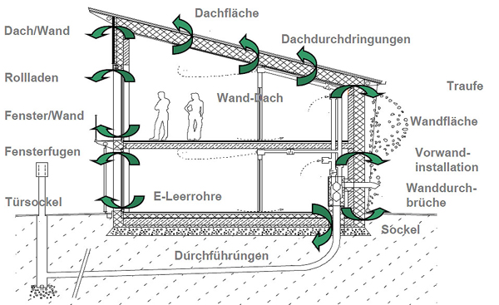
Roof surface
Penetrations through roof
Eave
Wall surface
Pre-wall installation
Penetrations through wall
Wall/roof
Roller shutters
Window/wall
Window joints
Empty electrical conduits
Wall/roof
Dado

Door base
Leadthroughs
Figure 23: Section through a passive house, showing the problem areas within the airtight layer (source: Schulze Darup, PHS 2.1 slide p. 20, adapted)
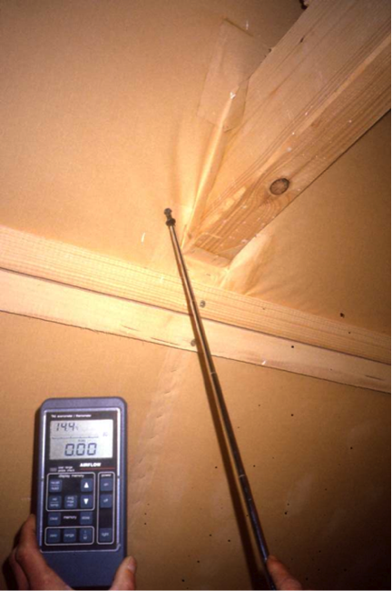  Figure 24: Measuring for leaks where a beam penetrates the roof (source: Schulze Darup) | 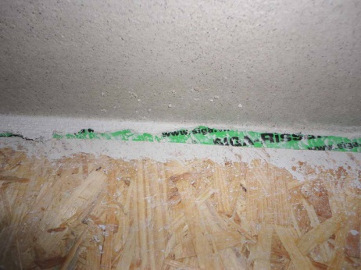  Figure 25: Airtight connection between timber wall and ceiling above ground floor (source: Schulze Darup)  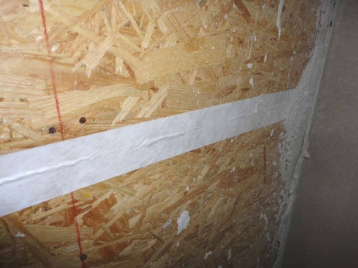  Figure 26: Airtight layer in timber construction (source: Schulze Darup)

A video on airtight building:
https://www.youtube.com/watch?v=S9-lsaMmqDQ

Minimizing thermal bridging
Thermal weak spots, as compared to the average heat transfer coefficient of an external construction element, are called thermal bridges. These spots must be analysed in terms of heat losses. The differential value is the coefficient of thermal bridging loss (Ψ) in W/mK.
Structure geometry involves a risk of thermal bridging at projections or corners, for example. However, if the insulation is drawn around the corner at almost the mean insulation thickness, this results in a “negative” thermal bridge.
This means a small plus when the heat losses through the external construction elements are calculated.
Interior corners always involve additional thermal bridging due to geometry.
To minimize the thermal bridging at windows/surrounds in all types of configuration, the insulation must be drawn over the window frame as far as possible.

Additional quality criteria
Depending on the type of structure, the following additional considerations apply:

External wall structures with composite thermal insulation systems (ETICS)
As far as thermal bridging is concerned, these are similar to non-frame timber structures: no problems with intersections of inner walls and ceilings; advantages at outside corners such as dado and roof connection, if the insulation is drawn around the corner at full thickness. In recent years systems to minimize thermal bridging have been developed for mounting construction elements on the outside of the wall; these should be included in the thermal bridging balance sheet.

External wall structures with curtain wall
Basically the same applies as for external walls with ETICS. But since there is a load-bearing scaffold for the facing on the outside, this has to be taken into account in the U value calculation. On the other hand attaching lightweight construction elements to the façade is not a problem, because they can be fixed to the load-bearing scaffold. Spot thermal bridges due to structurally relevant penetrations must be assessed individually.

Single-shell external wall structures
All construction elements with deviating coefficients of thermal conductivity must enter the balance sheet as thermal bridges if they intersect the external wall. This is the case for ceilings, due to the necessary load transfer, and possibly for walls because of soundproofing requirements. On the other hand, dado and roof connections can usually be implemented with negative heat transfer coefficients, which means they yield a small bonus in the energy balance sheet.

Double-shell external wall structures
Basically the same applies to these as to external wall structures with a curtain wall.

List of figures
Figure 1: ETICS insulation with an anchoring point (implemented to minimize thermal bridging) for a light (source: Schulze Darup) 5
Figure 2: ETICS insulation with an anchoring point (implemented to minimize thermal bridging) for a baluster (source: Schulze Darup) 6
Figure 3: diagram of a non-frame wall with a composite thermal insulation system (source: Schulze Darup, adapted) 7
Figure 4: U value calculation for a non-frame wall with a composite thermal insulation system. Insulation 26 cm thick with an λ value of 0.035 W/mK yields a U value of 0.127 W/m²K. 8
Figure 5: “Schwarzer Panther” (“Black Panther”), Graz, Austria, architects: GSarchitects Graz. Curtain wall as glass façade (source: STO) 8
Figure 6: External wall system with timber curtain wall in Seestadt Aspern, Vienna, Austria (source: Weissenseer Holz-System-Bau GmbH) 9
Figure 7: anchoring system for a curtain wall with minimal thermal bridging – ΔU_{WB} ≤ 0.01 W/m²K (source: Fa. STO) 9
Figure 8: Spacer made of stainless steel (source: Sto SE & Co. KGaA) 10
Figure 9: diagram of a non-frame wall with curtain wall; it is important to choose an anchoring system that will minimize thermal bridging (source: Schulze Darup, adapted) 11
Figure 10: U value calculation for a curtain wall; as compared to a composite thermal insulation system, the structure is thicker overall, due to the addition of the load-bearing system and the cladding. * Air space and cladding have been left out of account in the calculation. 11
Figure 11: U value calculation for a curtain wall with vacuum insulation (VIP); the excellent thermal conductivity λ of only 0.008 W/mK makes a slim structure possible with a total wall thickness of approx. 31 cm (including air space and cladding) and a VIP insulation thickness of 6.5 cm. * Air space and cladding have been left out of account in the calculation. 11
Figure 12: single-shell brick masonry for a passive house; the thermal bridge connections with the roof terrace had to be assessed in detail in this project (source: Schulze Darup) 12
Figure 13: diagram of single-shell masonry wall to passive-house standard; cavities are filled with insulation materials; about 4 cm of insulating plaster is applied on the outside (source: Schulze Darup, adapted) 13
Figure 14: U value calculation for a single-shell external wall to passive-house standard with masonry 49 cm thick (λ = 0.070 W/mK) plus 4 cm of insulating plaster 13
Figure 15: prototype of a prefabricated wall element insulated with straw bales (source: GrAT) 14
Figure 16: Double-shell wall structure, anchors for installing insulation (source: Wienerberger GmbH) 14
Figure 17: inner masonry shell with wall anchors for the façade shell (source: Schulze Darup) 15
Figure 18: facing brickwork at window surround, backed by layer of insulation 20 cm thick with λ = 0.025 W/mK and a U value of 0.12 W/m²K (source: Schulze Darup) 16
Figure 19: diagram of double-shell masonry to passive-house standard; the insulation must be implemented using high-grade insulation material with λ ≅ 0.02 to 0.025 W/mK; it is important to select wall anchors certified for up to 20 cm of space between the shells (source: Schulze Darup, adapted) 16
Figure 20: U value calculation for a double-shell masonry; if the insulation material has a thermal conductivity of at most λ = 0.027 W/mK, then a wall structure to passive-house standard can be achieved with insulation 20 cm thick. * The air space has not been taken into account in calculating the U value. 17
Figure 21: if the double-shell masonry wall is implemented with a porous inner wall and the insulation coefficient λ is at most 0.025 W/mK, then a U value of 0.12 to 0.13 W/m²K, i.e. up to passive-house standard, can be achieved with insulation 16 cm thick. * The air space has not been taken into account in calculating the U value. 17
Figure 22: Solarmodule in die Fassade (links) und in Balkonbrüstungen (rechts) integriert (Quelle: Fa. Ertex Solar) 18
Figure 23: Section through a passive house, showing the problem areas within the airtight layer (source: Schulze Darup, PHS 2.1 slide p. 20, adapted) 20
Figure 24: Measuring for leaks where a beam penetrates the roof (source: Schulze Darup) 20
Figure 25: Airtight connection between timber wall and ceiling above ground floor (source: Schulze Darup) 20
Figure 26: Airtight layer in timber construction (source: Schulze Darup) 20

Legal notice
Published by:
e-genius – Verein zur Förderung und Entwicklung offener Bildungsmaterialien im technisch-naturwissenschaftlichen Bereich

Postfach 16
1082 Vienna
Austria
E-mail: info(at)e-genius.at

Project leader:
Dr. Katharina Zwiauer
E-mail: katharina.zwiauer(at)e-genius.at

Authors and Adapting for teaching purposes: Dr. Burkhard Schulze Darup, Dr. Katharina Zwiauer, Magdalena Burghardt
Translation and editing: Magdalena Burghardt, Andrew Kilpatrick
Layout: Magdalena Burghardt

August 2015
This learning unit was funded with support from the European Commission. This publication reflects the views only of the author, and the Commission cannot be held responsible for any use which may be made of the information contained therein.
The basis for this learning unit was developed within a project of „Building of Tomorrow“.
Terms of use
This learning unit is provided under the following Creative Commons Licence:
Creative Commons Attribution-NonCommercial-NoDerivatives 4.0 International License.

You are free to:
Share — copy and redistribute the material in any medium or format
The licensor cannot revoke these freedoms as long as you follow the license terms.
Under the following terms:
Attribution — You must give appropriate credit, provide a link to the license, and indicate if changes were made. You may do so in any reasonable manner, but not in any way that suggests the licensor endorses you or your use.
NonCommercial — You may not use the material for commercial purposes.
NoDerivatives — If you remix, transform, or build upon the material, you may not distribute the modified material.
No additional restrictions — You may not apply legal terms or technological measures that legally restrict others from doing anything the license permits.

Attribution to e-genius as the copyright owner must take the following form:
Texts: authors of the learning unit, year of publication, title of the learning unit, publisher: Verein e-genius, www.e-genius.at/en
Illustrations: attribution to owner of copyright, e-genius – www.e-genius.at/en

Exclusion of liability:
All content on the e-genius platform has been carefully checked. Nevertheless, we are unable to offer any guarantee as to the correctness, completeness, topicality and availability of the content. The publisher does not accept any liability for damage or disadvantages that may arise from the use or exploitation of the content. The provision of the content on e-genius is not intended to replace the obtaining of professional advice and the ability to access the content does not constitute an offer to create an advisory relationship.
e-genius contains links to external websites. The insertion of links is a reference to representations and (also other) opinions, but does not mean the content of such links are endorsed. The publisher of e-genius does not accept any liability for websites that are referred to via a link. This applies both to their availability and to the content that can be accessed on such websites. As far as the operators are aware, the linked pages do not contain any unlawful content; should such content be discovered, it will be immediately removed in fulfilment of the legal obligations of the electronic reference.
Third-party content is identified as such. Should you nevertheless become aware of an infringement of copyright, please let us know accordingly. Upon being notified of legal infringements, we will immediately remove or correct such content.
Link to the open content platform: http://www.e-genius.at/en

Source: http://www.schoeberlpoell.at/download/forschung/endbericht_sanierungshandbuch.pdf (23.03.2015)

