Thermal Building Renovation –
Basics
- Abstract
This learning unit provides an introduction to the topic “Thermal Building Renovation”. Reasons for such a renovation are shown, as well as the right time for it. It is described which energy standards can be achieved with which renovation measures. Cost-effectiveness and quality control are further relevant aspects.
- Objectives
On completing this learning unit students are able to …
- list advantages of thermal renovation
- explain the best time for renovation
- explain quality control procedures

Contents
Abstract 1
Objectives 1
1. Why is it so important to renovate old buildings? 3
2. How do we decide on the most appropriate energy-related measures? 3
2.1 What energy standard can buildings achieve as a result of renovation? 3
2.2 When is the best time for thermal renovation? 4
2.3 Which renovation measure saves how much energy? 5
2.4 What counts as energy-efficient renovation? 6
2.5 Transmission heat loss 6
2.6 Ventilation heat loss 6
2.7 What are the key aspects of cost-effectiveness? 7
2.8 Building services 8
3. What dimensions of quality control apply to renovation? 9
4. Concluding arguments for thermal renovation 9
5. List of figures 10
6. Legal notice 11

Why is it so important to renovate old buildings?
Many older buildings do not satisfy today’s requirements. They may be structurally impaired, not provide sufficient comfort for residents, be too cold in winter or too hot in summer, and therefore consume a lot of energy for heating or cooling. Both historic buildings and the building stock from the 1930s to the 1970s are known to be real energy guzzlers. Walls, windows, roof and cellar are barely or not at all insulated or sealed, and thus provide no heat and sound protection. Outdated heating systems also consume much more energy than necessary, due to two factors: actual heating and high electricity consumption. Space heating alone accounts for 15 % of greenhouse gas emissions.
Nevertheless a great number of (residential) buildings do not meet today’s energy standards. Current renovation standards are not sufficient to reach climate protection goals. The rate of renovation (in Austria) is currently 1 to 1.3 %; it ought to go up to 2 % in the next few years. There is considerable future employment potential for planners and skilled craftsmen here.
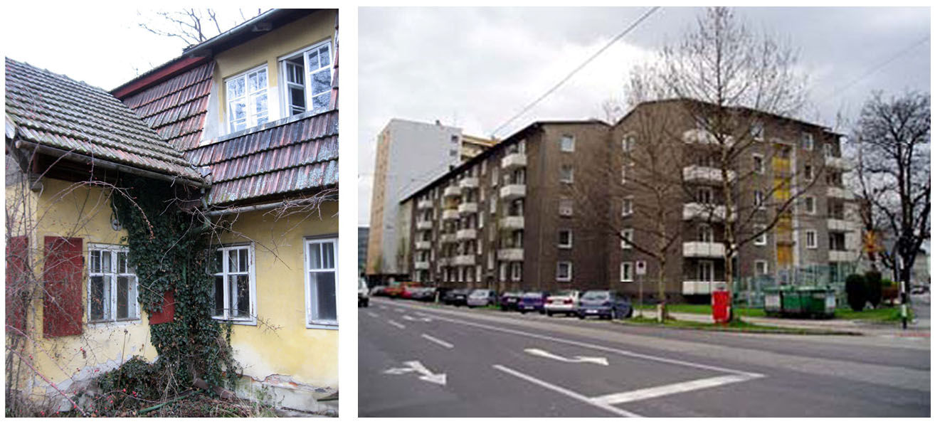
Figure 1: On the left: nineteenth-century villa before renovation (source: GrAT); on the right: housing complex in Linz, Austria, before renovation (source: Domenig-Meisinger/Willensdorfer 2007)
This video shows what thermal insulation can do for older buildings:
http://youtu.be/kfly8kY_Yqw

How do we decide on the most appropriate energy-related measures?
  - What energy standard can buildings achieve as a result of renovation?
With up-to-date zero-energy-building technologies a comprehensive renovation of an existing building can achieve energy consumption ratings between 15 and 35 kWh/m2a. The heating energy requirement can be reduced by 75 to 95 % if zero-energy-building components (or passive house components, respectively) are used.
What are zero-energy-building (or passive house) components?
The essential elements of passive house technology consist of excellent heat protection, very good airtightness and a highly efficient heat recovery from waste air.
While going for higher energy standards may involve more initial expenditure, such measures are bound to pay off in the long run if they are implemented cost-effectively. Building owners will find it helpful to imagine what standards will be like 20 years from now; the point is that investments should last twice as long – 40 years is the usual depreciation period for measures applying to the building envelope.
Background on building size and compactness
The energy-saving potential through thermal renovation depends to a large extent on the size and compactness of the building.
Blocks of flats, office and administration buildings, and other types of building with a satisfactory ratio between building envelope surface area and building volume (A/V ratio) can achieve a building envelope with a low heating energy requirement, if 20 to 25 cm of insulation are used for walls and 30 to 40 cm for the roof. In many cases nearly zero-energy-building standard (which means 15 kWh/a/m2) can be reached with measures like this. Single-family houses need thicker layers of insulation because the A/V ratio is less advantageous.

When is the best time for thermal renovation?
In most cases the best time for thermal renovation is when urgent repairs are necessary. It is ideal when at the same time the roof starts leaking, the façade is unsightly and the windows are draughty. Then there are strong arguments in favour of repairing the roof comprehensively (including insulating it), renovating and insulating the outside walls and installing new windows. If the heating system is also outdated, it makes sense to replace the building services right away and install a ventilation system with heat recovery. At all events professional advice should be taken, so as to settle which measures add up to the best combination for the building in question.

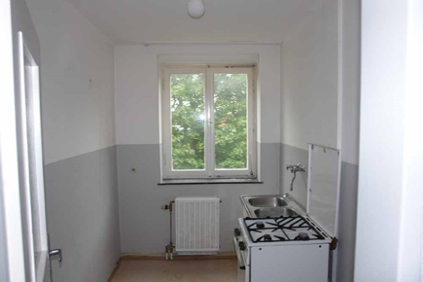 | 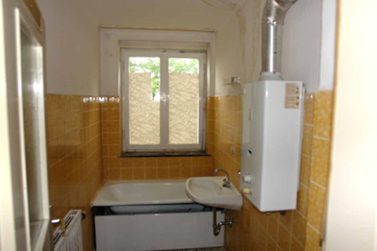
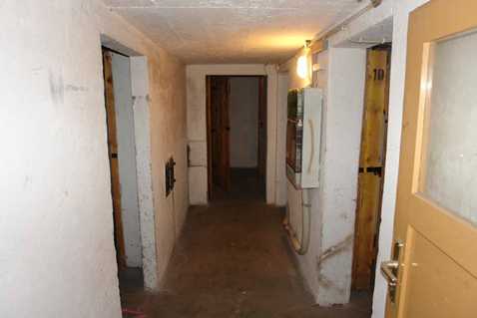 | 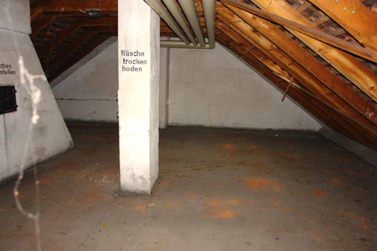
Figure 2: Apartment building before thermal renovation (source: Schulze Darup)

Which renovation measure saves how much energy?
As part of an energy assessment process (advisory service), potential heating cost savings can be estimated for each building component to be renovated. This makes it possible to assess which measures make economic sense, and thus to put a comprehensive package together. The potential savings to be expected from the various measures are assessed during building assessment or in the planning phase.
Rule of thumb
How much can be saved if the thermal insulation of the external walls is improved?
A simple rule of thumb is:
difference between U values (“unrenovated” minus “renovated”) x 8.4 = annual savings in litres of oil or cubic metres of natural gas per square metre of the external building component in question

Example:
If a U value of 1.15 W/m2K is reduced to 0.15 W/m2K by means of thermal insulation, the difference between the two U values is 1.0 W/m2K. Multiplying this figure by 10, we get annual savings of approx. 10 litres of fuel oil or 10 m3 of natural gas per m2 of external wall area. If this figure is multiplied by the current price of oil or gas, the result is the expected annual energy cost saving per m2 of external wall area. Multiplied by a useful life of 40 years, savings amount to 400 litres of fuel oil per m2 of external wall area, equivalent to 300 Euro at current energy prices. However, these prices are expected to rise substantially, in which case savings of more than 500 Euro per m2 of external wall area can be expected over 40 years.
An inferior U value of, say, 0.4 W/m2K seems more cost-effective at first sight, because it involves lower investment costs. This may be the case at current energy prices. In the long term, though, with energy costs constantly increasing and in order to protect the climate, the building component in question will probably have to be renovated again before its 40 years of useful life are over. This is uneconomical in any case.
Thus the following applies to renovation: “If you’re going to do it, do it right!”

What counts as energy-efficient renovation?
To count as energy-efficient renovation, thermal renovation measures should be of such high quality that heat loss from the building is reduced by up to 90 percent.
Heat loss from the building consists of transmission heat loss through the building envelope (heat conduction through building components) and ventilation heat loss (heat convection through openings and leaks in the building envelope).
Building envelope
The building envelope consists of all building components which surround the (used and heated) interior. These are: external walls, roof or top-floor ceiling, and floor slab or basement ceiling.

Transmission heat loss
Transmission heat loss accounts for about 60 to 80 % of all heat loss in an unrenovated building. Transmission heat loss through the above-mentioned building components is mainly reduced by insulation and by avoiding or reducing thermal bridges. If renovation is only half-hearted, a second round of thermal renovation will probably be necessary after 15 to 20 years, which is definitely uneconomical.
Thermal renovation of the building envelope not only significantly decreases heating (and cooling) energy consumption, but also solves localized problems to do with the physics of buildings. For this the physical properties of the individual building components must be known and taken into account before renovation.

Ventilation heat loss
Ventilation heat loss can be reduced by up to 90 percent, at best by means of a ventilation system with heat recovery.
Ventilation heat loss amounts to between 40 and more than 50 kWh/m2a (calculated values) and can be decreased to about 5 kWh/m2a by means of ventilation systems with heat recovery.
However, allowance must be made for the fact that many residents do not air the rooms regularly. As opposed to a calculated air change rate of 0.6 to 0.7 per hour, airing by opening windows twice a day results in 0.2 to 0.3 air changes per hour in actual practice. This is why ventilation heat loss is reduced by no more than 20 to 25 kWh/m2a in many cases. On the other hand, room air quality is at least as important, and is particularly good with a ventilation system because of the constant supply of fresh air, which makes things much pleasanter for the residents.

What are the key aspects of cost-effectiveness?
Renovation is often confined to individual thermal protection measures such as replacing or repairing windows, insulating external walls and/or the top-floor ceiling (better), or replacing the heating system. Whether these measures make sense depends on whether a comprehensive approach to renovation has been worked out for the building beforehand.
Basically the following options are available for thermal renovation. In all cases a comprehensive energy assessment process (advisory service), which defines the individual renovation steps within the overall strategy, is a necessary prerequisite:
- Low-cost measures: these make sense if the building is mainly in good condition, such that drastic renovation measures will not be necessary for another 10 to 20 years. In this case, low-cost measures can be taken, such as insulating the top-floor ceiling, insulating parts of the basement ceiling, sealing windows and the like. Building services can be improved by, say, insulating pipes and hydronic balancing. In certain cases it is advisable to overhaul or replace the heating system.
- Renovating individual components: this is done if only individual components in the building need replacing. In this case it is essential to work out an overall strategy, so that future construction phases can be matched to the current measures and no additional costs are incurred due to interface problems. As a first step, roof and basement ceiling can be renewed and insulated. A second step involves façade and windows (which should not be implemented separately), and a third step tackles building services.
- Comprehensive strategy: in general a complete package of renovation measures should be preferred, as this is the most cost-effective solution. Compared to piecemeal measures, comprehensive renovation is more economical, especially in the long run, because expenditure on interface problems and setting the building site up repeatedly is saved. Then again, the building’s owners can relax for several decades after comprehensive renovation, and need not carry out another renovation phase a few years later.
With respect to cost-effectiveness the same principle applies to all approaches: every building component has to be renovated to the highest standards to be expected during up to 50 years of useful life. This is the only way to avoid the need for another renovation after 15 to 20 years (the average in practice)!
Many planners and architects take the view that a half-hearted renovation is the most expensive and uneconomical solution, because incidental costs make up the largest share of costs. If a renovation is carried out anyway, one should not stint on quality.
Background on planning an energy-efficient renovation
If a building is to be renovated, the first step is to assess the state of the building and work out an energy strategy.
Developing a cost-effective renovation strategy demands careful planning. In this respect, energy standards, the technical state and remaining useful life of the various building components are crucial. Renovation is cost-effective when all or almost all building components have reached the end of their useful life and need to be replaced anyway. Sometimes it makes more sense to wait for a few more years and then implement a comprehensive strategy for the whole building.
After 30 to 40 years it is advisable to renovate a building fundamentally. If individual measures are carried out earlier, they should not get in the way of an overall strategy or lead to duplication of investment, as described in the previous section.
Apart from this, planning should also take the users or residents of a building into account. For single-family houses, planning always involves a “design for living”.
In many cases there is a wish for more comfort, more well-being, or more usable space. In such cases major reconstruction is almost always unavoidable. The resulting impact on energy consumption must be taken into account.
Who does the planning depends on the scale of the project and how many different tasks are involved. Whereas in the case of straightforward measures in a single-family house the architect can probably handle most of the tasks, a more complex construction project needs an interdisciplinary team in order to fulfil all planning requirements. Integral planning of this kind should start right at the beginning of the project, during preliminary planning.

Bear in mind!
A satisfactory renovation result can be achieved only with experienced planners. For major projects a planning team capable of integral planning should be set up.

Building services
Renovating building services involves the space heating, the plumbing (hot water supply) and the electrics (electricity saving measures), plus a controlled ventilation system with heat recovery. They should be tackled on their own only if the building envelope will last for another 15 to 20 years.
Otherwise the rule is: first the envelope, then the building services.

What dimensions of quality control apply to renovation?
In the field of planning and implementing building renovation, quality control has the following dimensions:
- staying within budget
- meeting deadlines
- faultless implementation
- quality control of thermal bridges
- quality control concerning airtightness and draught-proofing
- reliably achieving the performance promised (e.g. energy consumption after renovation)
There are currently several planning and calculation tools which can be used for quality control. Each tool contains an evaluation system as a basis for objective comparability (between different buildings or between properties before and after renovation).

Concluding arguments for thermal renovation
It is up to the building’s owner to decide whether a building should be demolished or renovated, or if nearly zero-energy building standard or passive house standard is a goal of the renovation. However, the planners and contractors should have the necessary “tools” to assess which option should be realized in the end. Such a tool is provided by the following compact list of arguments in favour of the alternative of thermal renovation:
- Significant decrease in energy and running costs, due to a reduced heating energy requirement.
- Additional grants are available for thermal renovation.
- The useful life of a building is extended through energy-efficient building and renovation, and its value is thus secured or increased.
- If building components are renovated anyway, the best possible energy standards should be implemented, otherwise more renovation will be necessary after a relatively short time.
- Comfort in use improves.
- The emotional value of the building to its users (attachment to an old building) is preserved.
- Renovation contributes actively to climate protection (saving resources because of renovation instead of putting up a new building, less CO2 emitted due to a reduced heating energy requirement).

List of figures
Figure 1: On the left: nineteenth-century villa before renovation (source: GrAT); on the right: housing complex in Linz, Austria, before renovation (source: Domenig-Meisinger/Willensdorfer 2007) 3
Figure 2: Apartment building before thermal renovation (source: Schulze Darup) 5

- Legal notice
Published by:

e-genius – Verein zur Förderung und Entwicklung offener Bildungsmaterialien im technisch-naturwissenschaftlichen Bereich

Postfach 16
1082 Vienna
Austria
E-mail: info(at)e-genius.at

Project leader:
Dr. Katharina Zwiauer
E-mail: katharina.zwiauer(at)e-genius.at

Authors and Adapting for teaching purposes: Dr. Burkhard Schulze Darup, Dr. Katharina Zwiauer, Magdalena Burghardt
Translation and editing: Magdalena Burghardt, Andrew Kilpatrick
Layout: Magdalena Burghardt

August 2015

This learning unit was funded with support from the European Commission. This publication reflects the views only of the author, and the Commission cannot be held responsible for any use which may be made of the information contained therein. | 
The basis for this learning unit was developed within a project of „Building of Tomorrow“. |  | 
Terms of use
This learning unit is provided under the following Creative Commons Licence:
Creative Commons Attribution-NonCommercial-NoDerivatives 4.0 International License.
You are free to:
Share — copy and redistribute the material in any medium or format
The licensor cannot revoke these freedoms as long as you follow the license terms.
Under the following terms:
Attribution — You must give appropriate credit, provide a link to the license, and indicate if changes were made. You may do so in any reasonable manner, but not in any way that suggests the licensor endorses you or your use.
NonCommercial — You may not use the material for commercial purposes.
NoDerivatives — If you remix, transform, or build upon the material, you may not distribute the modified material.
No additional restrictions — You may not apply legal terms or technological measures that legally restrict others from doing anything the license permits.

Attribution to e-genius as the copyright owner must take the following form:
Texts: authors of the learning unit, year of publication, title of the learning unit, publisher: Verein e-genius, www.e-genius.at/en
Illustrations: attribution to owner of copyright, e-genius – www.e-genius.at/en

Exclusion of liability:
All content on the e-genius platform has been carefully checked. Nevertheless, we are unable to offer any guarantee as to the correctness, completeness, topicality and availability of the content. The publisher does not accept any liability for damage or disadvantages that may arise from the use or exploitation of the content. The provision of the content on e-genius is not intended to replace the obtaining of professional advice and the ability to access the content does not constitute an offer to create an advisory relationship.
e-genius contains links to external websites. The insertion of links is a reference to representations and (also other) opinions, but does not mean the content of such links are endorsed. The publisher of e-genius does not accept any liability for websites that are referred to via a link. This applies both to their availability and to the content that can be accessed on such websites. As far as the operators are aware, the linked pages do not contain any unlawful content; should such content be discovered, it will be immediately removed in fulfilment of the legal obligations of the electronic reference.
Third-party content is identified as such. Should you nevertheless become aware of an infringement of copyright, please let us know accordingly. Upon being notified of legal infringements, we will immediately remove or correct such content.
Link to the open content platform: http://www.e-genius.at/en

