Insulation and Façade Systems –
Internal Insulation

Abstract
In this learning unit internal insulation is presented with its advantages and disadvantages. Practical tips for selecting appropriate insulation materials, for installation and the physics of buildings are given. Planning criteria and feasible insulation standards are described. An important section deals with quality assurance regarding airtightness and minimizing thermal bridging.

Objectives
On completing this module students are able to …
- name areas of application of internal insulation
- compare different internal insulation systems
- point out problem areas in internal insulation
- apply quality criteria to insulation systems
- evaluate individual wall insulation systems regarding their advantages and disadvantages

Contents
Abstract 1
Objectives 1
1. Introduction 3
2. Areas of application for internal insulation 3
3. Planning criteria and achievable results with internal insulation 4
3.1 Examples and U value calculations 6
3.2 U values in internal insulation 7
4. Quality criteria for producing an insulation system 9
4.1 Quality assurance at the planning stage 9
4.2 Quality assurance during construction 9
4.3 Airtightness 9
4.4 Minimizing thermal bridging 10
5. List of figures 11
6. List of tables 11
7. Legal notice 12

Introduction
Internal insulation is advisable if thermal insulation cannot be applied to the outside of a wall during building renovation, for example in the case of listed buildings. However, external insulation of walls is preferable in terms of the physics of buildings; this is because thermal bridging can be minimized more easily and more energy-efficient structures can be produced with external insulation.

Areas of application for internal insulation
The main areas of application for internal insulation involve the preservation of listed buildings and historic ensembles, as well as of other buildings whose façades must be preserved because they define the cityscape. The most suitable solution should be negotiated between the building owner, the planner, the physics-of-buildings specialist and the authority responsible for preserving listed buildings.
Planning must take into account that, in the context of the physics of buildings, residential buildings must always meet the users’ needs, while providing a good indoor climate and hygienic indoor air quality.
Internal insulation can be implemented in a technically sound manner in most types of building and external wall structures – as exemplified by numerous highly energy-efficient projects which have been implemented in recent years.

Two short videos show internal insulation in practice:
https://www.youtube.com/watch?v=oH-M9jFjK5E
https://www.youtube.com/watch?v=7O3gCsNCfSY

Background on the disadvantages of internal insulation
The main disadvantages of internal insulation are connected with the difficult situation in terms of the physics of buildings. Reliable solutions must be achieved that rule out moisture problems resulting in mould developing. In addition care must be taken that the moisture content of wood does not increase, particularly in structures with timber components.
The attainable U values are usually less good than with external insulation systems. The energy-saving potential is further limited by thermal bridging that usually occurs at intersecting construction elements. A preliminary slight cost advantage can turn into its opposite if expensive work needs to be done on the connections of intersecting construction elements (walls and especially timber beam ceilings). This is particularly true if structures have to be opened up and details have to be implemented at relatively great expense, for example in intersecting timber beam ceilings.
Another point: living space is diminished if the insulation is applied on the inside. The usable or rentable space shrinks, impairing economic efficiency further.

Planning criteria and achievable results with internal insulation
Planning internal insulation requires a detailed analysis of the situation in question. If implementation is faulty, damage due to the physics of buildings is more likely than if the insulation system is on the outside of the thermal envelope.
For example, the following aspects must be taken into account:
- Hygiene and comfort in the living space: the aim is to achieve a higher hygienic standard in the living space by raising the surface temperature on the inside of the external wall. On the one hand this improves thermal comfort and avoids condensation and mould developing on the surface. On the other hand it is necessary to prevent damage from moisture, which can be caused by diffusion, convection, driving rain or thermal bridges.
- Quantification of heat losses and moisture situation: the energy balance sheet must include the losses at thermal bridges. It is advisable to minimize the thermal bridges in detail and quantify the residual losses. The moisture situation should also be quantified, so as to avoid damage from moisture after the internal insulation is installed.
- Implementation of construction work: the details and transitions must be implemented very precisely. Particular care is needed as regards convection and, in consequence, airtightness.
- Insulation thickness for achieving high-grade U values: excellent energy efficiency can be achieved with internal insulation. Various insulation standards for typical structures are shown as examples in Table 1. The calculation was based on an insulation thermal conductivity λ of 0.040 W/mK. Numerous approved insulation materials for internal insulation have λ values between 0.04 and 0.05 W/mK. But there are also a number of areas of application for ultra-efficient insulation materials such as aerogel insulation (λ = 0.16 W/mK) or vacuum insulation (λ = 0.08 W/mK). If specially energy-efficient solutions are implemented, special attention should be paid to details as regards airtightness and protection against driving rain.
- Resistance to driving rain: wall structures with internal insulation should in principle be made proof against driving rain, in order to avoid moisture getting into the wall from outside.
- Airtightness: a particularly high risk of damage arises at leaky spots, e.g., along construction elements which penetrate the internal insulation towards the cold area. In the case of such leaky spots humid indoor air can flow outwards and precipitate moisture (condensate) as it cools down. This condensate can cause severe damage, which is why airtightness is of special importance with internal insulation.
- Indoor air humidity: buildings with internal insulation should have the lowest possible indoor air humidity, especially in the cold winter months, so as to minimize the risk of damage caused by diffusion or convection. The simplest solution is to install a fan-based ventilation system, preferably with waste heat recovery.
- Room heating: in internally insulated rooms, heat should basically be transferred over the entire external wall area. Skirting-board radiators or panel heating systems are possible here. The most sensitive areas in terms of the physics of buildings, the intersecting parts of the ceilings, can for example be slightly warmed by directing the heat distribution system accordingly, thus preventing damage from moisture.

 |  | Existing structure | U ≤ 0.35 W/m²K | U ≤ 0.28 W/m²K | U ≤ 0.23 W/m²K | U ≤ 0.20 W/m²K
 |  | W/m²K | cm | cm | cm | cm
1 | late 19th century,  45 cm,  λ = 0.96 W/mK | 1.40 | 8.5 | 11.5 | 14.5 | 17
2 | built 1930,  37.5 cm,  λ = 0.96 W/mK | 1.59 | 9 | 11.5 | 14.5 | 17
3 | built 1950,  30 cm,  λ = 0.62 W/mK | 1.38 | 8.5 | 11.5 | 14.5 | 17
4 | built 1960,  30 cm,  λ = 0.50 W/mK | 1.20 | 8 | 11 | 14 | 16.5
5 | built 1970,  30 cm,  λ = 0.36 W/mK | 0.93 | 7 | 10.5 | 13 | 15.5
6 | built 1980,  36.5 cm,  λ = 0.26 W/mK | 0.60 | 5 | 7.5 | 10.5 | 13
7 | double-shell, air space | 1.38 | 8.5 | 11.5 | 14.5 | 17
8 | double-shell,  4 cm cavity insulation | 0.74 | 6 | 8.5 | 12 | 14.5
9 | double-shell,  6 cm cavity insulation | 0.57 | 4.5 | 7 | 10 | 12.5
Table 1: Thickness of insulation with λ = 0.040 W/mK for internal insulation that is needed to reach different U values, depending on the existing structure of selected typical building constructions. Especially with structures 6 to 9, excellent U values can be achieved. However, this makes sense only if thermal bridging is minimized as well, for example by using flanking insulation for intersecting elements. Double-shell walls have an advantage in terms of thermal bridging because the air space in between can be insulated.

Examples and U value calculations
One example of installed vacuum insulation on the inside of the external wall and the basement ceiling is shown in the following diagram.
Internal insulation of external wall
1 Plasterboard cladding
2 Vacuum insulation panel
3 Interior plaster / existing
4 Masonry
5 Exterior plaster, proof against driving rain

Insulation of basement ceiling
6 Screed
7 Vacuum insulation panel
8 Reinforced-concrete ceiling
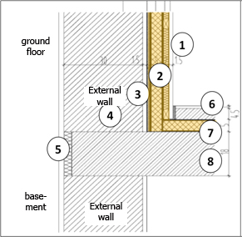Figure 1: internal insulation for building renovation using vacuum insulation panels with a thermal conductivity λ of 0.008 W/mK (source: Schulze Darup)
Example box
Internal insulation can also be combined with wall heating systems, as shown in Figure 2 and Figure 3. Figure 4 and Figure 5 show internal insulation with sprayed cellulose and with aerogel insulation, respectively.
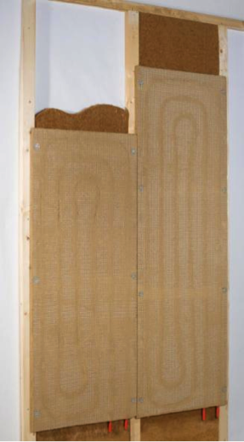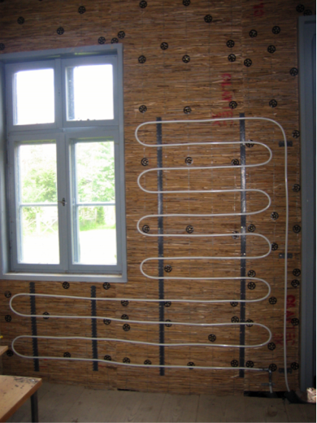
Figure 2 (left): dry construction wall heating element made of clay on a supporting structure with softwood fibre insulation panel (source: WEM Wandheizung GmbH)
Figure 3 (right): wall heating pipes on an internal insulation made of bast fibre (source: Oesker 2007; Fehler! Hyperlink-Referenz ungültig.)
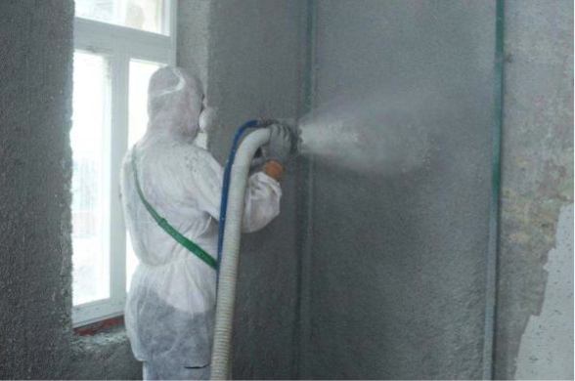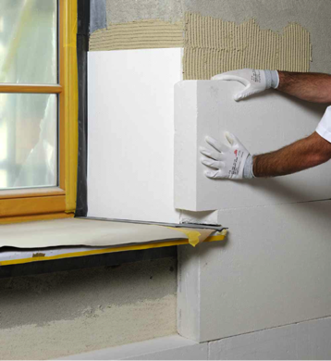
Figure 4 (left): internal insulation system applied by spraying on cellulose; particularly useful for very uneven surfaces (source: Isocell GmbH)
Figure 5 (right): applying highly efficient aerogel internal insulation with a thermal conductivity λ of 0.16 W/mK (source: Schulze Darup)

U values in internal insulation
In calculating the U value of internal insulation, special attention should be paid, aside from the area, to thermal bridging at intersecting construction elements. The first calculation (Figure 6) for a typical existing wall with 12 cm of cellulose internal insulation results in a U value of 0.260 W/m²K.

Layers (from inside to outside) d λ
1 Plasterboard 1.50 0.210
2 Vapour barrier 0.10 0.400
3 Cellulose insulation 12.00 0.040
4 Adhesive/plaster 1.50 0.700
5 Masonry 30.00 0.560
6 Exterior plaster 2.00 0.520

Corr. 1.00 Thickness [cm] 47.10 U value 0.260
Figure 6: U value calculation of the internal insulation of a typical existing wall with 12 cm of cellulose insulation: the area shows a U value of 0.260 W/m²K; in addition the thermal bridges at intersecting walls and ceilings have to be taken into account.
If insulation materials with better thermal conductivity are used, an excellent U value can be achieved even if insulation is implemented so as to save space. Calculating the U value of an aerogel internal insulation (Figure 7) with a thermal conductivity λ of 0.16 W/mK, we get a U value below 0.2 W/m²K with insulation 7 cm thick. However, especially with such high-quality insulation, the structure must be analysed regarding the physics of the building in question.

Layers (from inside to outside) d λ
1 Interior plaster 1.00 0.700
2 Aerogel insulation 7.00 0.016
3 Adhesive/plaster 1.50 0.700
4 Masonry 30.00 0.560
5 Exterior plaster 2.00 0.520

Corr. 1.00 Thickness [cm] 41.50 U value 0.194
Figure 7: U value calculation for an aerogel internal insulation with a thermal conductivity λ of 0.16 W/mK: even with insulation only 70 mm thick a U value below 0.2 W/m²K can be achieved.
Investigating the physics of the building in question is even more necessary in the case of higher-grade internal insulation with vacuum panels. With this approach it is technically possible to achieve very high-quality internal insulation, up to passive house standard. However, this does not apply to all existing structures.
In any case a detailed analysis of the physics of the building in question is required; in addition the effects of intersecting structural elements should be considered. Timber structures with intersecting beams that extend into the cold area, and structures that do not provide secure protection against driving rain, are especially difficult.

Layers (from inside to outside) d λ
1 Plaster board 1.50 0.210
2 Insulation / Protection 1.00 0.035
3 Vacuum insulation 5.50 0.008
4 Adhesive/plaster 1.50 0.700
5 Masonry 30.00 0.560
6 Exterior plaster 2.00 0.520

Corr. 1.00 Thickness [cm] 41.50 U value 0.125
Figure 8: it is technically possible to realize internal insulation of very high quality in the form of vacuum insulation, up to passive house standard. Apart from the physics of the building in question, one must take the effects of intersecting structural elements into account.

Quality criteria for producing an insulation system

Quality assurance at the planning stage
Energy-optimized buildings should be planned by a planning team in which all relevant trades are represented.
In selecting the insulation system, for example, this involves taking users’ wishes into account together with structural requirements, and implementing them in terms of high-quality architecture. Along with this, numerous technical and legal aspects, such as soundproofing and fire protection, and of course energy-related requirements, play a part.
Nowadays a building is fit for the future only if high-grade heat protection is provided. This involves not only a U value of at most 0.15 W/m²K, but also requirements concerning airtightness and minimizing thermal bridging, which have to be taken into account as early as the planning phase. The simpler the design of the building and the less complicated the interfaces, the more cost-effective erecting the building can be.
The target should be simple systems which are easy for skilled workers to implement and which need only a minimum of maintenance during use.

Quality assurance during construction
If planning and scheduling have been done with the above-mentioned aspects in mind and have been described clearly in the tender documents, the contractors’ job is to carry out the work with as few defects as possible.
For this it is important to clarify and reach agreement on the details, and particularly the interfaces between the various trades, within the construction team at an early stage. If the contractors’ tasks are clarified in detail in advance, this will avoid some misunderstandings during the construction phase.
However, all contractors are obliged to inform every single tradesperson about their tasks on site and to train them in innovative techniques as appropriate. Advantage should be taken of training courses offered by energy agencies, trade associations or producers, too.
Finally, site management by the architect must ensure not only that the tasks are coordinated continuously, but also that they are performed without defects. Regular visits to the site are essential here, as are the interim and final acceptance procedures.

Airtightness
The passive-house standard for buildings requires an ACH₅₀ value of at most 0.6 1/h, to be demonstrated in a blower-door test.
The airtight layer must be taken into account right from the start of planning, and must be implemented with precision in detailed planning.
In non-frame external walls the airtight layer is formed by the interior plaster in all the configurations described. In non-frame construction an air seal is usually achieved by means of the interior plaster or by levelling on the inside of the external masonry.
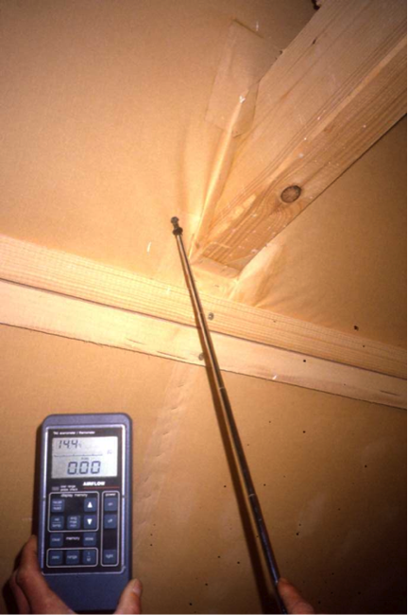
Figure 9: Measuring for leaks where a beam penetrates the roof (source: Schulze Darup)

Minimizing thermal bridging
Thermal weak spots, as compared to the average heat transfer coefficient of an external construction element, are called thermal bridges. These spots must be analysed in terms of heat losses. The differential value is the coefficient of thermal bridging loss (Ψ) in W/mK.
Structure geometry involves a risk of thermal bridging at projections or corners, for example. However, if the insulation is drawn around the corner at almost the mean insulation thickness, this results in a “negative” thermal bridge.
This means a small plus when the heat losses through the external construction elements are calculated.
Interior corners always involve additional thermal bridging due to geometry.
To minimize the thermal bridging at windows/surrounds in all types of configuration, the insulation must be drawn over the window frame as far as possible.
Depending on the type of structure, the following additional considerations apply:
- In internal insulation, load-bearing ceilings and intersecting interior walls penetrate the insulation layer of the external wall. These spots involve high thermal bridge loss coefficients, which not only compromise the energy balance sheet, but can also cause problematic cold areas on the inner surface where moisture can condense. This is why it is urgently recommended to assess individual thermal bridges in such structures. Thermal bridging caused by intersecting elements can be reduced if an insulation wedge or an insulation panel 30 cm deep is installed in the area of intersection. This lengthens the path of heat flow, and thermal bridging is reduced.
- More detailed information on how to deal with thermal bridges can be found in the learning unit „Energy-efficient Buildings – Passive House” on
http://www.e-genius.at/en.

List of figures
Figure 1: internal insulation for building renovation using vacuum insulation panels with a thermal conductivity λ of 0.008 W/mK (source: Schulze Darup) 6
Figure 2 (left): dry construction wall heating element made of clay on a supporting structure with softwood fibre insulation panel (source: WEM Wandheizung GmbH) 6
Figure 3 (right): wall heating pipes on an internal insulation made of bast fibre (source: Oesker 2007; http://de.wikipedia.org/w/index.php?title=Datei:Wallheating_pipes_on_bast_fiber_ insulation.jpg&filetimestamp=20071223213245) 6
Figure 4 (left): internal insulation system applied by spraying on cellulose; particularly useful for very uneven surfaces (source: Isocell GmbH) 7
Figure 5 (right): applying highly efficient aerogel internal insulation with a thermal conductivity λ of 0.16 W/mK (source: Schulze Darup) 7
Figure 6: U value calculation of the internal insulation of a typical existing wall with 12 cm of cellulose insulation: the area shows a U value of 0.260 W/m²K; in addition the thermal bridges at intersecting walls and ceilings have to be taken into account. 7
Figure 7: U value calculation for an aerogel internal insulation with a thermal conductivity λ of 0.16 W/mK: even with insulation only 70 mm thick a U value below 0.2 W/m²K can be achieved. 8
Figure 8: it is technically possible to realize internal insulation of very high quality in the form of vacuum insulation, up to passive house standard. Apart from the physics of the building in question, one must take the effects of intersecting structural elements into account. 8
Figure 9: Measuring for leaks where a beam penetrates the roof (source: Schulze Darup) 10

List of tables
Table 1: Thickness of insulation with λ = 0.040 W/mK for internal insulation that is needed to reach different U values, depending on the existing structure of selected typical building constructions. Especially with structures 6 to 9, excellent U values can be achieved. However, this makes sense only if thermal bridging is minimized as well, for example by using flanking insulation for intersecting elements. Double-shell walls have an advantage in terms of thermal bridging because the air space in between can be insulated. 5

Legal notice
Published by:
e-genius – Verein zur Förderung und Entwicklung offener Bildungsmaterialien im technisch-naturwissenschaftlichen Bereich

Postfach 16
1082 Vienna
Austria
E-mail: info(at)e-genius.at

Project leader:
Dr. Katharina Zwiauer
E-mail: katharina.zwiauer(at)e-genius.at

Authors and Adapting for teaching purposes: Dr. Burkhard Schulze Darup, Dr. Katharina Zwiauer, Magdalena Burghardt
Translation and editing: Magdalena Burghardt, Andrew Kilpatrick
Layout: Magdalena Burghardt

August 2015

This learning unit was funded with support from the European Commission. This publication reflects the views only of the author, and the Commission cannot be held responsible for any use which may be made of the information contained therein.
The basis for this learning unit was developed within a project of „Building of Tomorrow“.
Terms of use
This learning unit is provided under the following Creative Commons Licence:
Creative Commons Attribution-NonCommercial-NoDerivatives 4.0 International License.
You are free to:
Share — copy and redistribute the material in any medium or format
The licensor cannot revoke these freedoms as long as you follow the license terms.
Under the following terms:
Attribution — You must give appropriate credit, provide a link to the license, and indicate if changes were made. You may do so in any reasonable manner, but not in any way that suggests the licensor endorses you or your use.
NonCommercial — You may not use the material for commercial purposes.
NoDerivatives — If you remix, transform, or build upon the material, you may not distribute the modified material.
No additional restrictions — You may not apply legal terms or technological measures that legally restrict others from doing anything the license permits.

Attribution to e-genius as the copyright owner must take the following form:
Texts: authors of the learning unit, year of publication, title of the learning unit, publisher: Verein e-genius, www.e-genius.at/en
Illustrations: attribution to owner of copyright, e-genius – www.e-genius.at/en

Exclusion of liability:
All content on the e-genius platform has been carefully checked. Nevertheless, we are unable to offer any guarantee as to the correctness, completeness, topicality and availability of the content. The publisher does not accept any liability for damage or disadvantages that may arise from the use or exploitation of the content. The provision of the content on e-genius is not intended to replace the obtaining of professional advice and the ability to access the content does not constitute an offer to create an advisory relationship.
e-genius contains links to external websites. The insertion of links is a reference to representations and (also other) opinions, but does not mean the content of such links are endorsed. The publisher of e-genius does not accept any liability for websites that are referred to via a link. This applies both to their availability and to the content that can be accessed on such websites. As far as the operators are aware, the linked pages do not contain any unlawful content; should such content be discovered, it will be immediately removed in fulfilment of the legal obligations of the electronic reference.
Third-party content is identified as such. Should you nevertheless become aware of an infringement of copyright, please let us know accordingly. Upon being notified of legal infringements, we will immediately remove or correct such content.
Link to the open content platform: http://www.e-genius.at/en

