Energy-efficient Buildings (Passive and Nearly-zero-energy Buildings) –

Passive House

# Abstract of the learning unit

The goal in building passive houses is to provide buildings that are comfortable in use while at the same time minimizing their primary energy requirement. Essential criteria in planning such buildings are: improved geometry and orientation of the buildings, and a building envelope structured to provide excellent thermal protection, together with high-grade windows. The buildings need to be constructed with great care – this includes quality assurance applying to elements, comfort and quality of execution, e.g. as regards airtightness and minimizing thermal bridging. A ventilation system with heat recovery decreases ventilation heat loss in winter; and the heating can be implemented in a very simple and cost-efficient way. This learning unit shows how all these factors interact, and how to verify whether a building meets the passive-house standard.

# Objectives

**On completing this unit students are able to …**

* name aspects of the passive-house approach
* describe structural measures to maximize solar gains
* explain the importance of planning criteria such as shading, window size and window orientation
* explain the significance of the surface-area-to-volume ratio for a building
* name types of thermal bridge
* explain the significance of thermal bridges in planning and construction practice
* argue for the necessity of an airtight building envelope, and explain the relevant problem areas and quality assurance measures
* explain the importance of a controlled ventilation system

**Content**

Abstract of the learning unit 1

Objectives 1

1. Introduction 4

2. Planning a passive house 4

2.1 How do the site and the building’s location and orientation influence the building’s energy requirement? 5

2.2 Wind loads 5

2.3 What shape is particularly advantageous for a passive house? 5

2.4 Effects of shape and orientation on solar gains 7

2.5 How should the rooms be laid out in a passive house in Central Europe? 7

3. The building envelope 9

3.1 Walls 9

3.1.1 Timber-based external walls 9

3.1.2 Non-frame external walls 10

3.2 Roof 11

3.3 Floor slab and basement ceiling 11

3.4 Windows in the passive house – how to size them right 11

3.5 Protection against overheating in summer and shading systems 12

3.5.1 Measures to protect against overheating in summer in Central Europe 13

3.5.2 Natural protection from sun 13

3.5.3 Artificial protection against the sun 14

4. What is a thermal bridge and why is it important? 15

4.1 Identifying the thermal bridges in the energy balance 15

4.2 Types of thermal bridges 16

4.3 Planning and construction practice in Central Europe 17

4.4 Planning tools to avoid thermal bridges 17

5. How to plan the “airtight layer” 18

5.1 What benefits are provided by a proper air seal? 18

5.2 Planning principles for airtightness 19

5.3 What are the problem areas to take into account? 19

5.4 Blower door test 20

6. Ventilation 21

7. Building technology in passive and surplus-energy houses 23

8. List of figures 24

9. List of tables 24

10. Legal notice 25

# Introduction

The target of the passive-house standard, as defined by the Passivhaus Institut in Darmstadt, Germany, is to plan buildings that need so little heating energy that a conventional heating system is unnecessary.

For measuring this standard the following values have been defined. To be labelled a passive house, a building must fulfil these requirements:

* annual heating energy requirement at most 15 kWh/m²a or heating load limited to at most 10 W/m² (in relation to living space)
* total primary energy input at most 120 kWh/m²a

# Planning a passive house

As buildings become more and more complex overall structures, the planning phase becomes ever more important. For complex construction projects a larger team is necessary, consisting (say) of an architect, a physics-of-buildings expert, and specialized planners for energy, statics, soundproofing, fire protection, building services (heating, plumbing, ventilation, electricals), open space, etc. This approach is known as integral planning.

**At least three things should be considered in the selection of the team:**

1. that all the relevant special skills are available
2. that the number of participants is as small as possible
3. that the structure for working together is clearly defined.

For an ordinary detached house, it will in most cases not be necessary to put a large planning team together.

**The team planning a passive house must take the following criteria into account:**

|  |  |
| --- | --- |
| **Planning criterion** | **Key aspects** |
| **Orientation of site and building** | South-facing site and orientation towards south, avoid shading |
| **Compactness** | Best possible S/V ratio, favourable building geometry, appropriate building depth |
| **Orientation of windows** | Solar gains, protection against overheating in summer |
| **Room layout** | Room depth, use of daylight, soundproofing |
| **Solar shading** | Natural/structural/active solar shading |
| **Structure of building elements** | Excellent U values, freedom from thermal bridging |
| **Air seal** | Simple solutions for junctions, as few transitions between building elements as possible, careful planning of details |

Table 1: overview of planning criteria for passive houses

## How do the site and the building’s location and orientation influence the building’s energy requirement?

Every building stands on a site and is influenced by the surroundings and the conditions applying on this site, such as **shading** by **neighbouring buildings**, **wind loads**, etc.

If these aspects are taken into account in siting and orienting the building, energy can be saved on a significant scale.

**The individual aspects are presented in detail in the following sections.**

## Wind loads

**Windy sites** have an unfavourable effect on the thermal energy requirement in the colder part of the year, because the building cools down more quickly due to the flow of cold air. With ordinary buildings this makes a considerable difference, but even in highly energy-efficient buildings the **requirement** can be **2–3 kWh/m2a higher**.

In windy areas, a (natural or built) **windbreak** **can** significantly reduce air flow and thus **save thermal energy**.

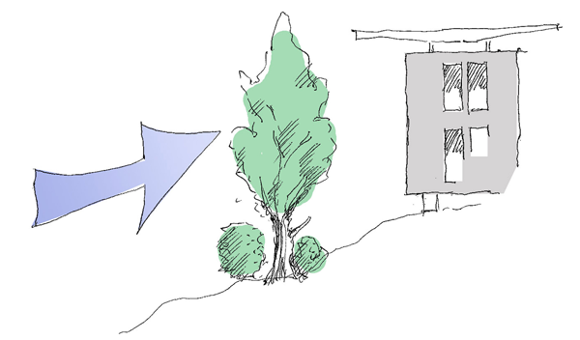

Figure 1: windbreak provided by natural tree and bush growth (source: Stefan Prokupek, GrAT)

## What shape is particularly advantageous for a passive house?

**The more compact a building is, the easier it is to meet an energy-efficiency standard.** Factors determining compactness include building depth, number of storeys and the presence or absence of protrusions.

The **surface-area-to-volume ratio** (S/V ratio for short) has a **considerable influence on a building’s energy requirement**.

The S/V ratio indicates how large the surface area S (such as wall, ceiling, roof and window surface areas) is in relation to the building volume V, and thus to the living space provided.

The larger this ratio, i.e. **the higher the S/V value, the greater the thermal energy requirement per m2 living space/usable space is**, for a given set of energy-efficiency measures. **The more compact** a building is made, **the more cost-efficiently** it can be constructed, partly because the requirements applying to insulation thickness are then less strict.

**Larger buildings** have a lower and therefore **more favourable S/V ratio than smaller buildings**. Very small detached houses need massive thermal protection to keep the thermal energy requirement below 15 kWh/m2a.

Buildings with a **simple geometrical shape**, such as **cuboids or cubes**, have less surface area in relation to their volume and thus a **better S/V ratio** than buildings with numerous protrusions, oriels or dormers.

The following sketches show different (building) shapes and their degree of compactness in terms of surface-area-to-volume ratio (S/V ratio).

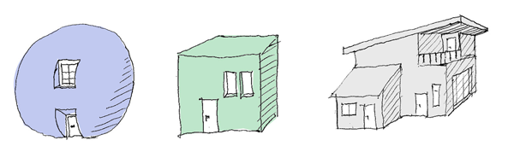

Figure 2: on left: spherical form (< 0.3); in centre: cube (approx. 0.5), on right: large surface area (> 0.8) (source: Stefan Prokupek, GrAT)

Detached houses **typically** have **S/V values between 0.7 and 1.0**, large buildings achieve lower values, down to 0.2. Detached **passive houses** should have values **below 0.8**, if possible. A higher S/V ratio must be made good by rather thicker insulation, in order to comply with the required thermal energy rating of 15 kWh/m2a.

**Example box**

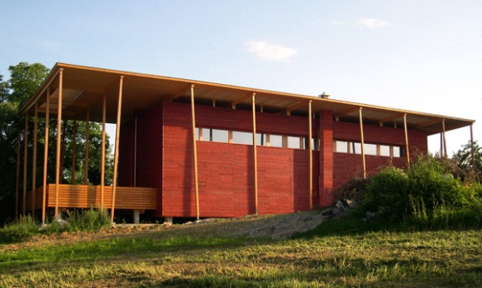

Figure 3: S-HOUSE in Böheimkirchen, Lower Austria (source: GrAT)

The S-HOUSE in Lower Austria is located on a site with a slight slope to the south and east. The building’s long side faces south. Its cross-section is almost square. The gross built volume is approx. 1200 m3. With its simple shape and large volume the S-HOUSE achieves an S/V ratio of 0.6, which meets the passive-house standard.

## Effects of shape and orientation on solar gains

Apart from optimizing the S/V ratio, the design should take potential solar gains into account.

In the case of a building with limited depth, one option is to have all relevant day rooms face south.

## How should the rooms be laid out in a passive house in Central Europe?

**With an intelligent room layout energy can be saved.**

The following aspects may play a part here:

* **Orientation: day rooms** should be placed **on the south side as far as possible**, so as to use the sun’s warmth (**direct passive solar gains**).
* **Zoning:** large differences in temperature are not possible in passive houses – the temperature inside the thermal envelope is very uniform. However, if residual heat is deliberately directed into (say) the living room in the early evening, the temperature there will rise for a few hours; during the night the temperature will even out throughout the whole building. In this way the temperature in separate bedrooms can be kept between 18 and 19 °C even in passive houses, while the day rooms are at 20 to 21 °C.
* **Lighting:** **orienting the rooms** in the required direction **facilitates** **using daylight during the day**. Here it is important that the windows provide the best possible angle of incidence, i.e. the windows should preferably reach up to the ceiling.
* **Lighting of interior rooms:** glazed partitions or windows on interior rooms that do not need much light, such as side rooms or hallways, provide daylight in areas which could otherwise only be lit artificially.
* **Ventilation:** if rooms air is supplied to, overflow areas and rooms air is exhausted from are distributed sensibly, the ventilation system can be scaled so as to minimize air flowrates in operation.

**Example box**

**Example 1:**

Glazed partitions in the north-south axis of a building let daylight well into the interior. The photograph shows the upper floor of the S-HOUSE in Böheimkirchen, where this principle was applied.

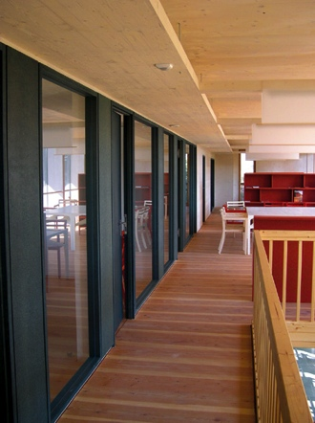

Figure 4: S-HOUSE – interior glazing (source: GrAT)

**Example 2:**

The relevant **day rooms** all **face south**. The ground floor comprises the living or shared rooms including the kitchen, and an additional multi-purpose room. The **building services** are located **on the north side of the building in the smallest possible space**.



Figure 5: Floor plan of ground floor (source: Benjamin Wimmer)

# The building envelope

Passive houses should manage a **U value for opaque (non-transparent) building elements of at most 0.15 W/m²K**. **Good thermal insulation is an essential prerequisite** for cost-effective, energy-efficient buildings. Good thermal insulation is also a prerequisite for real comfort indoors.

## Walls

The choice of a wall system has major effects on the thermal quality and the cost of a building. As regards thermal insulation, the external wall of a passive house should achieve a U value below 0.15 W/m²K. A wide choice of design options is available. Almost all types of external wall structure can be implemented to passive-house standard:

### Timber-based external walls

|  |  |
| --- | --- |
| Timber stud/timber frame structures | http://www.holka.it/fileadmin/_migrated/pics/08_01.jpg  Figure 6: Timber frame structure (source: Holka Genossenschaft) |
| Solid timber structures with external insulation | http://www.e-genius.at/fileadmin/user_upload/fassadensysteme/abb39w.png  Figure 7: Vacuum insulation on a non-frame timber wall; cladding is provided by a curtain wall (source: Variotec, Neumarkt) |

### Non-frame external walls

|  |  |
| --- | --- |
| External wall structures with composite thermal insulation systems (ETICS) | http://www.e-genius.at/fileadmin/user_upload/fassadensysteme/abb12w.png  Figure 8: ETICS insulation with an anchoring point (implemented to minimize thermal bridging) for a light (source: Schulze Darup) |
| External wall structures with curtain wall | Figure 9: “Schwarzer Panther” (“Black Panther”), Graz, Austria, architects: GSarchitects Graz. Curtain wall as glass façade (source: STO) |
| Single-shell external wall structures | Figure 10: Single-shell brick masonry for a passive house (source: Schulze Darup) |
| Double-shell external wall structures | Figure 11: Inner masonry shell with wall anchors for the façade shell (source: Schulze Darup) |

A detailed description of how these structures are implemented can be found in the learning unit “Façade systems” on [www.e-genius.at](http://www.e-genius.at).

## Roof

Providing excellent thermal insulation in/around the roof is generally very straightforward. Thus a **U value** better than the required **0.15 W/m²K** is achieved in many buildings.

In the case of timber structures, the rafters or beams should be slim and tall, so that the insulation can be 30 to 40 cm thick or more. Mutatis mutandis this applies to flat roofs, too.

## Floor slab and basement ceiling

The base of a passive house should not exceed a **U value of 0.15 W/m²K**, either. In general the downward heat loss coefficient is of the order of 0.6 down to around 0.2 for very extensive buildings; the thermal insulation should be planned accordingly.

The easiest arrangement to implement is a **thermally really well-insulated floor slab**. Ideally we have a load-bearing floor slab in contact with the entire insulation layer, which then merges into the wall insulation over its full thickness. Because (in view of humidity) such insulation is implemented as perimeter insulation, and also needs to stand up to increased pressure loads, it is usually fairly expensive. As an alternative, the insulation can be split and installed below and above the floor slab beneath the screed. In planning the latter solution, however, the thermal bridges at the top of the basement walls must be taken into account.

## Windows in the passive house – how to size them right

Windows let in daylight and heat from the sun. Their most important effect in a passive house with its high efficiency is the **“passive” utilization of solar gains**. This way of tapping energy works on the same principle as a glasshouse does.

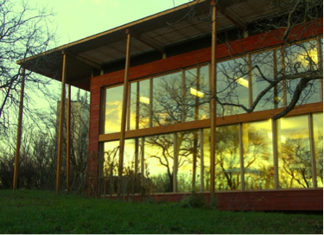

Figure 12: Glazed southern façade (source: GrAT)

The annual heat input from the sun lies between 10 and 20 kWh/m2a, referring to the heated surface of the building. This means that solar gains in well-planned and oriented buildings are higher than the required residual thermal energy of 15 kWh/m²a.

The **solar energy transmittance of the windows should be as high as possible**. This is particularly true for the south-facing windows, for which a value of g ≥ 0.5 to 0.6 is the goal.

**At the planning stage it is important to analyse very carefully what sizes and positions of window yield the best results.**

**The following aspects should be taken into account for windows:**

* Glazing with Ug of at most 0.7 W/m²K
* Thermal-bridge-minimized edge seal on glazing, with a thermally optimized spacer made of plastic or stainless steel (with minimal wall thickness, less than 0.2 mm) and a resulting loss coefficient Ψg of at most 0.035 W/mK
* Frame design with the lowest possible edge-seal coefficient ΨF
* Deep edge-seal overlap within frame
* Overlapping window frame with insulation generously at installation to minimize thermal bridging
* The resulting Uw value should be less than 0.8 W/m2K, and less than 0.85 W/m2K when installed.

**Two videos on passive house windows:**

<https://www.youtube.com/watch?v=Lwyv1YkObTk>

<https://www.youtube.com/watch?v=g3AgZ0Rp5f8>

Triple glazing is available with glass panes 2 mm thick and a total depth of 18 mm. Where passive-house windows with very slim profiles are installed, the glass area is enlarged, which increases solar gains, while Uw values are improved to between 0.5 and 0.6 W/m²K.

## Protection against overheating in summer and shading systems

In winter a passive house has a thermal energy requirement of less than 10 W/m2. This means that if the windows are sized appropriately, irradiation is considerably greater than the amount of thermal energy needed.

In general passive houses have advantages over poorly insulated buildings when it comes to protection against overheating in summer. A thermally unsatisfactory building envelope is not only unfavourable in winter, but also lets some heat in during summer. This is specially noticeable with poorly insulated top floors, e.g. in detached houses.

### Measures to protect against overheating in summer in Central Europe

Measures to protect against overheating in summer can be summarized as follows:

* Design with **appropriate sizes of window**; in particular, the windows facing east and west should be kept rather small, otherwise the low sun in summer heats up the rooms on the east and west too much.
* **Considerable building mass:** the materials in the 5 to 10 cm closest to the indoor walls are effective here.
* **Ventilation at night:** reducing the indoor air temperature by ventilating at night, of the order of a threefold to fivefold air change.
* **Shading** against insolation.

### Natural protection from sun

While heat from the sun makes an important contribution to covering the thermal requirement in winter, an essential aspect of protecting against overheating in summer is sensibly arranged **shading to guard against high temperatures indoors**. The planner’s task is therefore to **design the shading in such a way that the sun’s rays reach through the glazing into the building as far and as long as possible in the cooler half of the year, but are prevented from doing so in the warmer half of the year**.

A deciduous tree provides shade with its leaves in summer. In fall it loses them and lets through part of the sun’s radiation. This effect can be taken into account if trees are on hand, or in long-term planning. It must be noted, however, that even deciduous trees may provide 15 to 25 percent shade or more with their branches alone.

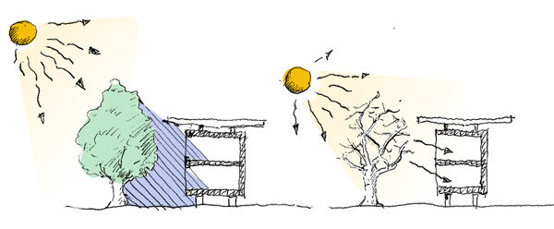

Figure 13: on left: shade from a deciduous tree in summer; on right: taking advantage of the low sun in winter to warm the interior, as the tree has no leaves then (source: Stefan Prokupek, GrAT)

**Example box**

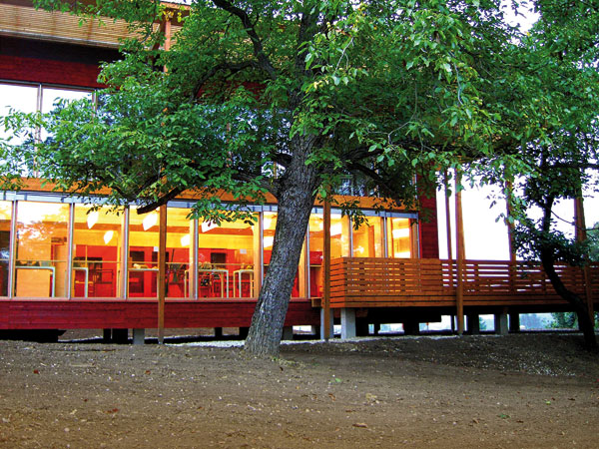

Figure 14: S-HOUSE – natural shading (source: GrAT)

Construction to the south of the S-HOUSE took the existing trees into account and preserved them. As a result, natural shade from the deciduous trees can be taken advantage of.

### Artificial protection against the sun

**Artificial shade fulfills various requirements:**

* It prevents indoor overheating through direct insolation.
* Shading can be adjusted **in line with the rhythm of day/night and patterns of use**.
* It can make indirect lighting feasible for **brightening the interior by means of light-directing elements**, particularly in the upper portion of the slat system.

**External shading systems are way more effective than internal.** This is mainly because the sun’s rays can pass through the window glass if shading is installed on the inside, and can then contribute to heating up the interior, regardless of whether there is additional shading inside.

Adjustable external shading systems are generally preferable to fixed systems. However, **the electricity consumption of shading systems should always be taken into account**.

|  |  |
| --- | --- |
| http://www.e-genius.at/typo3temp/yag/01/06/StudentInnenwohnheim_Molkereistrasse_10661_545cebce90.jpg  Figure 15: Student residence in Vienna (source: GrAT) | Figure : SunnyWatt settlement in Switzerland (source: kämpfen für architektur ag) |

Adjustable external shading systems are generally preferable to fixed systems. However, **the electricity consumption of shading systems should always be taken into account**.

# What is a thermal bridge and why is it important?

Thermal bridges are parts of the building envelope where more heat is lost than elsewhere. Depending on design and implementation, heat loss through thermal bridges accounts for between 10 and more than 30 % of overall heat loss.

**The main consequences of thermal bridges are:**

* an increased thermal energy requirement due to cooling via the thermal bridges
* lower surface temperature on the inside of the wall
* condensation in this area, leading to mould developing

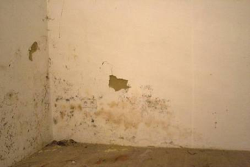

Figure 17: Mould developing in corners that form thermal bridges (source: GrAT)

## Identifying the thermal bridges in the energy balance

In planning a passive house, it is a requirement to identify thermal bridges and to implement details in the best way possible.

|  |
| --- |
| Background on assessing thermal bridges  If the heat loss via a junction between elements is compared to the other heat-transmitting parts of the building envelope, the resulting difference is the linear thermal transmittance (Ψ) in W/mK. If there is full-thickness insulation at an outside corner, the geometrical advantage there results in a negative value of Ψ. This means that optimized details in a building can result in a bonus from thermal bridges as compared to the thermal energy requirement calculated by area. |

## Types of thermal bridges

**Several different types of thermal bridge can be distinguished:**

* The so-called **geometrical** thermal bridge is due to a discrepancy between the inside and outside area of an external wall (e.g. at the corner of the building), whereas the rest of the building element is implemented uniformly.

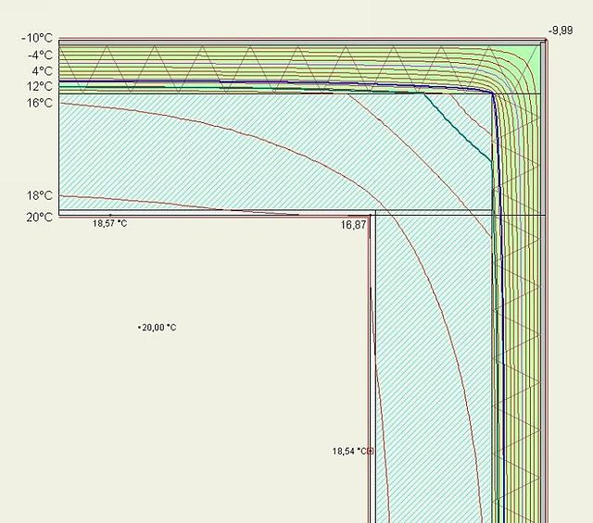

Figure 18: Geometrical thermal bridge: section through the corner of an externally insulated external wall showing the isotherms at an outside temperature of -10 °C and an inside temperature of 20 °C. The 18 °C isotherm is located on the wall surface when it is close to the corner, but lies within the wall when it is further away from the corner (source: Bauigel; https://de.wikipedia.org/wiki/W%C3%A4rmebr%C3%BCcke#/media/File:Waermebruecke_geometrisch.jpg)

* A **material** thermal bridge occurs where more than one type of material is used in a structure. A simple example is a horizontal fire barrier with a different thermal conductivity incorporated in a composite thermal insulation system.
* **Structural** thermal bridges occur for example because of structural requirements applying to a building element, e.g. a reinforced-concrete pillar in single-shell insulating masonry.

It should also be noted that linear thermal bridges generally occur at edges, connections and junctions, but spot weaknesses can also occur, e.g. at anchor points for curtain walls, canopy roofs, balconies, etc.

## Planning and construction practice in Central Europe

As early as the preliminary design phase, one should strive for solutions which make simple junctions and thermal bridge details possible. This particularly applies to elements in contact with the soil.

During design and work planning the thermal bridge effects must be assessed and details be drawn that minimize heat loss and are easy to implement in real life.

From the beginning of construction on, coordination between planners and tradesmen must be ensured, in order to implement the details as planned.

## Planning tools to avoid thermal bridges

To sum up, in the planning phase the following rules can help reduce thermal bridging:

* **Rule of avoidance:** wherever possible, do not penetrate the insulating envelope.
* **Rule of penetration:** if penetrating the insulation envelope is unavoidable, the resistance to heat transfer within the insulation layer should be as great as possible. This may mean using high-strength insulating materials, for example consisting of solidified foam insulation. Alternatively, the cross-section can be kept as small as possible and implemented in a high-strength, low-conductivity material, e.g. stainless steel anchors instead of aluminium.
* **Rule of junction:** at junctions between building elements, merge insulation layers without gaps (transition over the whole area).

**Tip**

In general spot thermal bridges are less of an issue than linear thermal bridges. Therefore: reduce linear penetrations to structurally necessary spot penetrations.

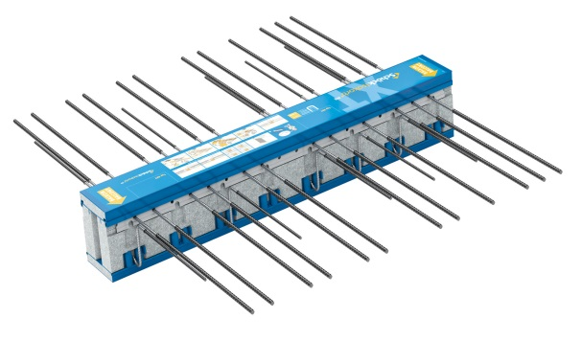

Figure 19: Load-bearing insulation element for projecting balconies (source: Schöck Bauteile GmbH)

# How to plan the “airtight layer”

**The heat transferring surface of the building must be implemented with a permanent airtight seal.** For airtightness in **passive houses**, the minimum requirement is an **ACH50** of at most **0.6 per hour**. This means that at a pressure differential of 50 pascal only 60 percent of the air inside a building may be exchanged per hour.

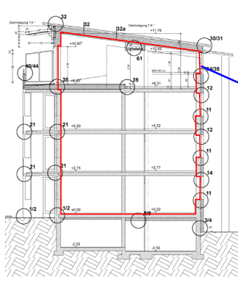

Figure 20: Continuous airtight layer in a building (source: Schulze Darup)

## What benefits are provided by a proper air seal?

**Airtight and draught-proof implementation has numerous benefits for the users:**

* **Structural damage is avoided:** if air flows through permeable building elements from inside to outside, water vapour cools down and condenses within the structure, forming droplets inside the elements, which results in structural damage.
* **Effectiveness of thermal insulation:** if air flows through the insulation layer, the insulating capacity of the structure is significantly reduced in practice.
* **Soundproofing:** every leak makes soundproofing less effective. A proper air seal is therefore part of the soundproofing strategy.
* **Optimized ventilation:** in the absence of a proper air seal, air is exchanged because of wind pressure or thermals, which are very much a function of the weather. Excessive air exchange then takes place exactly when it is not welcome: with strong winds and in very cold weather. During ordinary, relatively low-exchange weather almost all run-of-the-mill new buildings have an air change rate of only 0.10 per hour or so, regardless of how well they are insulated and what thermal standard they meet. So ventilation via leaks is completely inadequate. For ventilation systems to work properly, the building has to be airtight.
* **Thermal comfort:** cold air coming in through leaks leads to draughts, pools of cold air resulting in cold feet, and an uncomfortable vertical layering of temperatures both in individual rooms and throughout the building.
* **Reduced thermal energy requirement:** for the reasons given, making a building airtight leads to significant savings in energy and cost. As a comparison, the decrease in ventilation heat loss through an improvement from 3 to 0.6 per hour is approximately equal to the insulation effect of 10 extra cm of insulation.

## Planning principles for airtightness

In planning a building, the air seal strategy needs to be developed early on. Some aspects of this in keywords are:

* Select **the simplest possible shape for the heat transferring envelope of the building**, with **little variation in material**.
* Define the position of the windproof and airtight layer, with unheated areas such as the basement clearly separated.
* **Minimize the length of junctions**, make surfaces as homogeneous as possible.
* **Choose simple structures, avoid penetrations.**
* **Reduce penetrations for building services**; if appropriate, plan a service layer.
* Define materials and installing techniques that seal areas and joints.
* **Precise planning of details and coordination with tradesmen are vital.**

**Rule of thumb**

The more joints between different building elements, the more potential leaks in the airtight layer!

## What are the problem areas to take into account?

The following diagram presents an overview of the potential weak spots in the airtight layer (junctions between and penetrations through building elements).

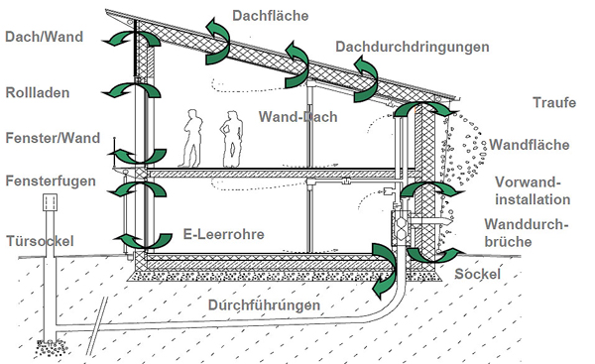

Roof surface

Penetrations through roof

Eave

Wall surface

Pre-wall installation

Penetrations through wall

Wall/roof

Roller shutters

Window/wall

Window joints

Empty electrical conduits

Wall/roof

Dado

Door base

Leadthrough

Figure 21: Section through a passive house, showing the problem areas within the airtight layer (source: Schulze Darup, PHS 2.1 slide p. 20, adapted)

## Blower door test

The blower door test is a method for checking how airtight a building is. For this purpose a fan is installed airtight in the front door, and a pressure differential is created and increased step by step up to 50 pascal (equivalent to a pressure of 5 mm water column).

The values measured are listed and entered into a coordinate system (flowrate/pressure differential). The intersection point at 50 pascal is read off for negative and positive pressure. Usually these values are close to each other, unless there is a check-valve effect from a leak or wind effects are too high. The mean is the measured ACP50 value, i.e. the rate of air change at a pressure differential of 50 pascal.

The test must be carried out as soon as all sealing building elements have been installed, but before the cladding over them has been put in place – usually after the windows, the vapour barrier and the interior plaster have been installed. It is advisable to invite the tradesmen concerned to the test. Experience shows that they are perfectly willing to rework leaks immediately after they have been found – sealing materials should be on site then!

The leaks can be localized using an anemometer, which measures the speed of incoming air at damage-prone spots at negative pressure. Alternatively a smoke generator in the form of a small tube can be used to make air movements visible. For hard-to-access leaks a fog generator can also be employed: combined with positive pressure the fog becomes visible on the outer surface where the leaks are.

If the locations of the leaks are supposed to be recorded permanently, infrared thermography is a more expensive, but effective medium. Outdoor air is drawn in at negative pressure and the entry points are captured thermographically. The greater the difference between indoor and outdoor temperature, the more effective this method is.

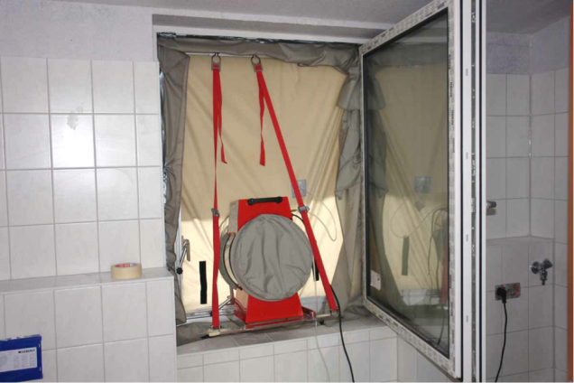

Figure22: blower door test: in this case the device was built into a window because the front door was very likely to leak (source: Schulze Darup)

# Ventilation

Indoor air quality takes top priority in planning a building, so planning passive houses also involves the requirements of health-promoting building. The goal is to minimize pollutant immissions and damage to health. If possible the Pettenkofer threshold of 0.1 % v/v CO2 should not be exceeded. This leads to a requirement of 30 m3 of fresh air per hour for each person at normal levels of activity.

Controlled ventilation systems help to increase comfort and ensure hygienically satisfactory indoor air. In addition, heat recovery via a heat exchanger can save energy. The following parameters are prerequisites for a ventilation system appropriate to passive houses:

* Heat recovery rate ηWRG,eff ≥ 75 %
* Intake air temperature > 16.5 °C to ensure comfort
* Electrical efficiency pel < 0.45 Wh/m³
* Ventilation device largely leak-free
* Noise level in living space < 25 dB(A)

**Example box**

|  |
| --- |
|  |
|  |
|  |

Figure 23: Air distribution in a plus-energy building. Upper floor (above) and ground floor (below) (source: Benjamin Wimmer, Architekt Nürnberg)

# Building technology in passive and surplus-energy houses

In planning residential buildings one must remember that providing hot water often requires more energy than space heating does. Many heating systems allow for heat to be generated mainly from renewable sources of energy.

Electricity should also be used in the most efficient way in a passive house. If the building generates electricity renewably, e.g. with photovoltaic panels, it can produce more energy than it consumes overall – and thus become a surplus-energy building.

For planning a passive house it is imperative to assess the building’s physics using the Passive House Planning Package. The Passive House Planning Package (PHPP for short) was developed by the Passive House Institute (PHI) (<http://www.passivhaus-institut.de/>) in Darmstadt, Germany, under the supervision of Dr Wolfgang Feist. It is an extremely realistic method, neutral to the time of year, to determine whether a building meets the criteria for passive houses.

PHPP is a program based on Microsoft Excel, with numerous spreadsheets. The package serves to calculate the energy balance sheet of the respective building, to determine the heat load and to identify how much primary energy the building requires.

The analysis method of PHPP precisely mirrors the planning of a passive house. Currently there is no other method capable of yielding results at the same level of detail with a reasonable amount of effort. PHPP is essential to evaluate a building as a passive house to passive-house standard, and to verify that the criteria are fulfilled.

# List of figures

Figure 1: windbreak provided by natural tree and bush growth (source: Stefan Prokupek, GrAT) 5

Figure 2: on left: spherical form (< 0.3); in centre: cube (approx. 0.5), on right: large surface area (> 0.8) (source: Stefan Prokupek, GrAT) 6

Figure 3: S-HOUSE in Böheimkirchen, Lower Austria (source: GrAT) 6

Figure 4: S-HOUSE – interior glazing (source: GrAT) 8

Figure 5: Floor plan of ground floor (source: Benjamin Wimmer) 8

Figure 6: Timber frame structure (source: Holka Genossenschaft) 9

Figure 7: Vacuum insulation on a non-frame timber wall; cladding is provided by a curtain wall (source: Variotec, Neumarkt) 9

Figure 8: ETICS insulation with an anchoring point (implemented to minimize thermal bridging) for a light (source: Schulze Darup) 10

Figure 9: “Schwarzer Panther” (“Black Panther”), Graz, Austria, architects: GSarchitects Graz. Curtain wall as glass façade (source: STO) 10

Figure 10: Single-shell brick masonry for a passive house (source: Schulze Darup) 10

Figure 11: Inner masonry shell with wall anchors for the façade shell (source: Schulze Darup) 11

Figure 12: Glazed southern façade (source: GrAT) 12

Figure 13: on left: shade from a deciduous tree in summer; on right: taking advantage of the low sun in winter to warm the interior, as the tree has no leaves then (source: Stefan Prokupek, GrAT) 13

Figure 14: S-HOUSE – natural shading (source: GrAT) 14

Figure 15: Student residence in Vienna (source: GrAT) 15

Figure 16: SunnyWatt settlement in Switzerland (source: kämpfen für architektur ag) 15

Figure 17: Mould developing in corners that form thermal bridges (source: GrAT) 15

Figure 18: Geometrical thermal bridge: section through the corner of an externally insulated external wall showing the isotherms at an outside temperature of -10 °C and an inside temperature of 20 °C. The 18 °C isotherm is located on the wall surface when it is close to the corner, but lies within the wall when it is further away from the corner (source: Bauigel; https://de.wikipedia.org/wiki/W%C3%A4rmebr%C3%BCcke#/media/File:Waermebruecke_geometrisch.jpg) 16

Figure 19: Load-bearing insulation element for projecting balconies (source: Schöck Bauteile GmbH) 17

Figure 20: Continuous airtight layer in a building (source: Schulze Darup) 18

Figure 21: Section through a passive house, showing the problem areas within the airtight layer (source: Schulze Darup, PHS 2.1 slide p. 20, adapted) 20

Figure22: blower door test: in this case the device was built into a window because the front door was very likely to leak (source: Schulze Darup) 21

Figure 23: Air distribution in a plus-energy building. Upper floor (above) and ground floor (below) (source: Benjamin Wimmer, Architekt Nürnberg) 22

# List of tables

Table 1: overview of planning criteria for passive houses 4

# Legal notice

Published by:



e-genius – Verein zur Förderung und Entwicklung offener Bildungsmaterialien im technisch-naturwissenschaftlichen Bereich

Postfach 16  
1082 Vienna  
Austria

E-mail: info(at)e-genius.at

Project leader:   
Dr. Katharina Zwiauer  
E-mail: katharina.zwiauer(at)e-genius.at

Authors: Dr. Burkhard Schulze Darup, Dr. Katharina Zwiauer, Stefan Prokupek

Adapting for teaching purposes: Dr. Katharina Zwiauer

Translation and editing: Magdalena Burghardt, Andrew Kilpatrick

Layout: Magdalena Burghardt

August 2015

|  |  |  |  |  |
| --- | --- | --- | --- | --- |
| This learning unit was funded with support from the European Commission. This publication reflects the views only of the author, and the Commission cannot be held responsible for any use which may be made of the information contained therein. | B:\e-genius\Leonardo TOCEB\AP 8 Dissemination\Logo\LLL.jpg | |  | |
| The basis for this learning unit was developed within a project of „Building of Tomorrow“. |  |  | |

**Terms of use**

This learning unit is provided under the following Creative Commons Licence:

[Creative Commons License](http://creativecommons.org/licenses/by-nc-nd/4.0/)

[Creative Commons Attribution-NonCommercial-NoDerivatives 4.0 International License](http://creativecommons.org/licenses/by-nc-nd/4.0/).

**You are free to:**

* **Share** — copy and redistribute the material in any medium or format

The licensor cannot revoke these freedoms as long as you follow the license terms.

**Under the following terms:**

* **Attribution** — You must give appropriate credit, provide a link to the license, and indicate if changes were made. You may do so in any reasonable manner, but not in any way that suggests the licensor endorses you or your use.
* **NonCommercial** — You may not use the material for commercial purposes.
* **NoDerivatives** — If you remix, transform, or build upon the material, you may not distribute the modified material.

**No additional restrictions** — You may not apply legal terms or technological measures that legally restrict others from doing anything the license permits.

**Attribution to e-genius as the copyright owner must take the following form:**

Texts: authors of the learning unit, year of publication, title of the learning unit, publisher: Verein e-genius, www.e‑genius.at/en

Illustrations: attribution to owner of copyright, e-genius – www.e-genius.at/en

**Exclusion of liability:**

All content on the e-genius platform has been carefully checked. Nevertheless, we are unable to offer any guarantee as to the correctness, completeness, topicality and availability of the content. The publisher does not accept any liability for damage or disadvantages that may arise from the use or exploitation of the content. The provision of the content on e-genius is not intended to replace the obtaining of professional advice and the ability to access the content does not constitute an offer to create an advisory relationship.

e-genius contains links to external websites. The insertion of links is a reference to representations and (also other) opinions, but does not mean the content of such links are endorsed. The publisher of e-genius does not accept any liability for websites that are referred to via a link. This applies both to their availability and to the content that can be accessed on such websites. As far as the operators are aware, the linked pages do not contain any unlawful content; should such content be discovered, it will be immediately removed in fulfilment of the legal obligations of the electronic reference.

Third-party content is identified as such. Should you nevertheless become aware of an infringement of copyright, please let us know accordingly. Upon being notified of legal infringements, we will immediately remove or correct such content.

Link to the open content platform: http://www.e-genius.at/en