Shaping cities for better quality of life - Fostering collaboration through Living Labs

Preliminary remark

Topic overview
Cities are dynamic places that undergo constant change. They inspire people to develop innovative solutions to different challenges they face in everyday life. An enhanced collaboration between different urban actors is crucial for ensuring a liveable space for the citizens, while improving their quality of life.
The e-learning course “Shaping cities for better quality of life – Fostering collaboration through Living Labs” has been designed for people who want to bring about change in their city or neighborhood by working together on specific urban challenges. We call these people “change agents”.

A Living Lab is a low-threshold place of cooperation, learning and co-creation of solutions. This e-learning course provides guidelines for designing and setting up a Living Lab, supported by a series of different tools, practical tasks and materials and interactive examples.
The chosen approach is mainly based on the principles of design thinking, a proven innovation method that has been tested within the framework of the ERASMUS+ project SMACC (www.smacc-project.eu ).

THINK!
What does a high quality of life mean to you? Make a list of the aspects that you consider the most important!
Figure 1: Photo credit: Nikolaus Kurnik

Shaping cities for better quality of life - Fostering collaboration through Living Labs

Part 1: Introduction

Abstract
In this learning unit cities are introduced as places for innovation and change. Firstly, the need for shifting towards more sustainable urban space is explained and different forms of innovation are introduced. Secondly, a short introduction into the topic of Smart Cities and Neighborhoods is provided. Some major criteria and other relevant aspects are discussed. Smartness covers a large number of approaches, including living space, job opportunities, education, culture and other services needed in everyday life.

Objectives
After completing this unit, you will be able to …
- explain the need for sustainable urban change
- discuss basic concepts concerning innovation
- critically evaluate the role of innovation for sustainable urban change
- explain the idea of Smart Cities and Neighborhoods

1. Cities as places for innovation and change
Cities are dynamic places that undergo constant change. Their social, ecological and technological assets are essential for economic and social development at both local and global level. In the face of rapid urbanisation and changing climate, cities have to be adapted in a long-term and an environmentally responsive way in order to ensure a liveable space for their citizens.

Watch this short video on changing cities, then answer the question: What makes a city a good place to live?
http://edition.cnn.com/videos/health/2016/05/19/beltline-urban-planning-cities-future-orig-jnd.cnn

A sustainable city can be defined as a city that enables its citizens to enjoy a good economic and social life, taking into account a conscious use of natural resources. Through actively incorporating social and environmental aspects into urban management and planning, multiple challenges related to human health or climate change in cities can be addressed. Achieving high quality of live, therefore, requires shifting from today’s urban environment to a future sustainable one. This is a long process, but several conditions can contribute to its faster implementation:
- it should involve multiple actors from different sectors, thus enhancing collaboration;
- it should combine long-term goals (e.g.: increases in resources efficiency) with short-term experiments in order to define the action plan for the future;
- innovation, spread of knowledge and information as well as further research are important elements in this process.
Innovation can be considered the catalyst for growth in cities. It has an enormous impact on governments, industries and businesses. According to Rogers (2003, p. 12) innovation can be defined as “an idea, a practice, or an object that is perceived to be new by an individual”.

THINK!
In your opinion, why is innovation important? Can you give some examples of innovation?

Innovation makes our lives easier, it enhances our health, improves productivity and connects globally. Car-sharing, for instance, not only reduces the number of cars on the road, but also helps save money. E-cars provide clear and silent mobility alternative, thus having a beneficial impact on human health in terms of air pollution and noise reduction. Thanks to different communication platforms, including Skype or Google Hangout, conferences and meetings can be now organised “virtually”, connecting multiple partners across different locations and different time zones.
Innovation can be an incremental idea, which makes an existing product or service better in terms of new qualities or new design, or a groundbreaking idea that can replace an existing product with something new, think about 3D printer.
Although innovation is often associated with new technologies that improve economic and environmental features in energy, transport, communications and other systems by introducing new products or services, innovation can come in many forms. We can also distinguish institutional innovation (changed framework conditions) or social innovation that aims at creating a societal value, changing lifestyles and consuming patterns. For instance, food cooperatives bring together local food producers that use innovative business strategies to sell fresh, local products to their members, thus strengthening local economies.

SOCIAL INNOVATIONS are new ideas (products, services and models) that simultaneously meet social needs and create new social relationships or collaborations.
- Innovation is about using change to better meet human needs and values
- Addressing innovative opportunities must reflect changing social expectations

Get inspired by watching this interesting TED Talk on how to design “happy” cities:
https://www.youtube.com/watch?v=7WiQUzOnA5w

2. Smart City concept
THINK!
What makes a city/neighborhood smart?
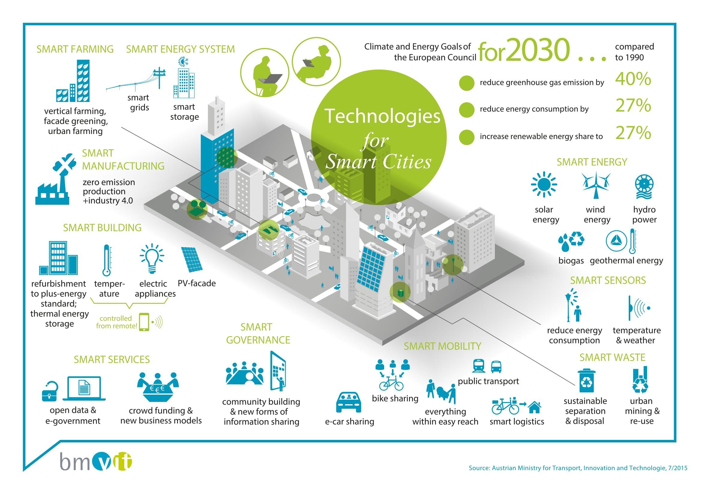
Figure 2: Living in a Smart City. Source: bmvit

“Smartness” is a social construct, which means it has no objective presence, but it is “defined into existence”. In other words, it is part of our shared understanding and consensus.
There is no universally accepted definition of a Smart City. It means different things to different people and it varies from city to city and country to country, depending on the level of development, willingness to change, resources and aspirations of the citizens.
Smart Cities should be regarded as systems of people interacting with and using flows of energy, resources, products, services and financing models to catalyse sustainable urban development, thus improving quality of life. These flows and interactions become “smart” by making strategic use of information and communication, infrastructure and other services in a process of transparent urban planning that is responsive to the social and economic needs of todays’ society. In the recent understanding, a Smart City is an integrated urban area.
Integrated means that services like
- Living space
For infants and the elderly, rich and poor, people from different cultures
- Job opportunities
For all types of qualification and for all ages
- Education
From kindergarten to Life-Long Learning
- Culture
Opera and festivals, museums, cinema, temples, …
- Leisure
Sport, pubs, bars, meditation, …
- Medical services
Doctors, hospitals, …
are within short distances. Enhancing these factors can be achieved through infrastructure (physical capital), human capital (skills, knowledge, health of individuals in a population to produce economic value), social capital (social networks that can be economically valuable) and ICT infrastructure. Logistics as well as new transport systems are “smart” systems, which improve the urban traffic and the inhabitants’ mobility.

AREAS relevant for Smart City development are as follows:
- Economy
  - People who move to cities search for new job opportunities. Besides traditional production and service companies, new forms of entrepreneurship along with innovative financing schemes for start-ups have to be promoted.
  - Large enterprises and smaller firms, production and service companies as well as voluntary institutions coexist together.
- Ecology
  - Green areas and open waters are of great importance for achieving high quality of life in cities.
  - Green walls and roofs help cool cities and reduce the need for air conditioning.
  - Urban gardening is important not only in terms of social cohabitation and integration, but can also contribute significantly to food supply.

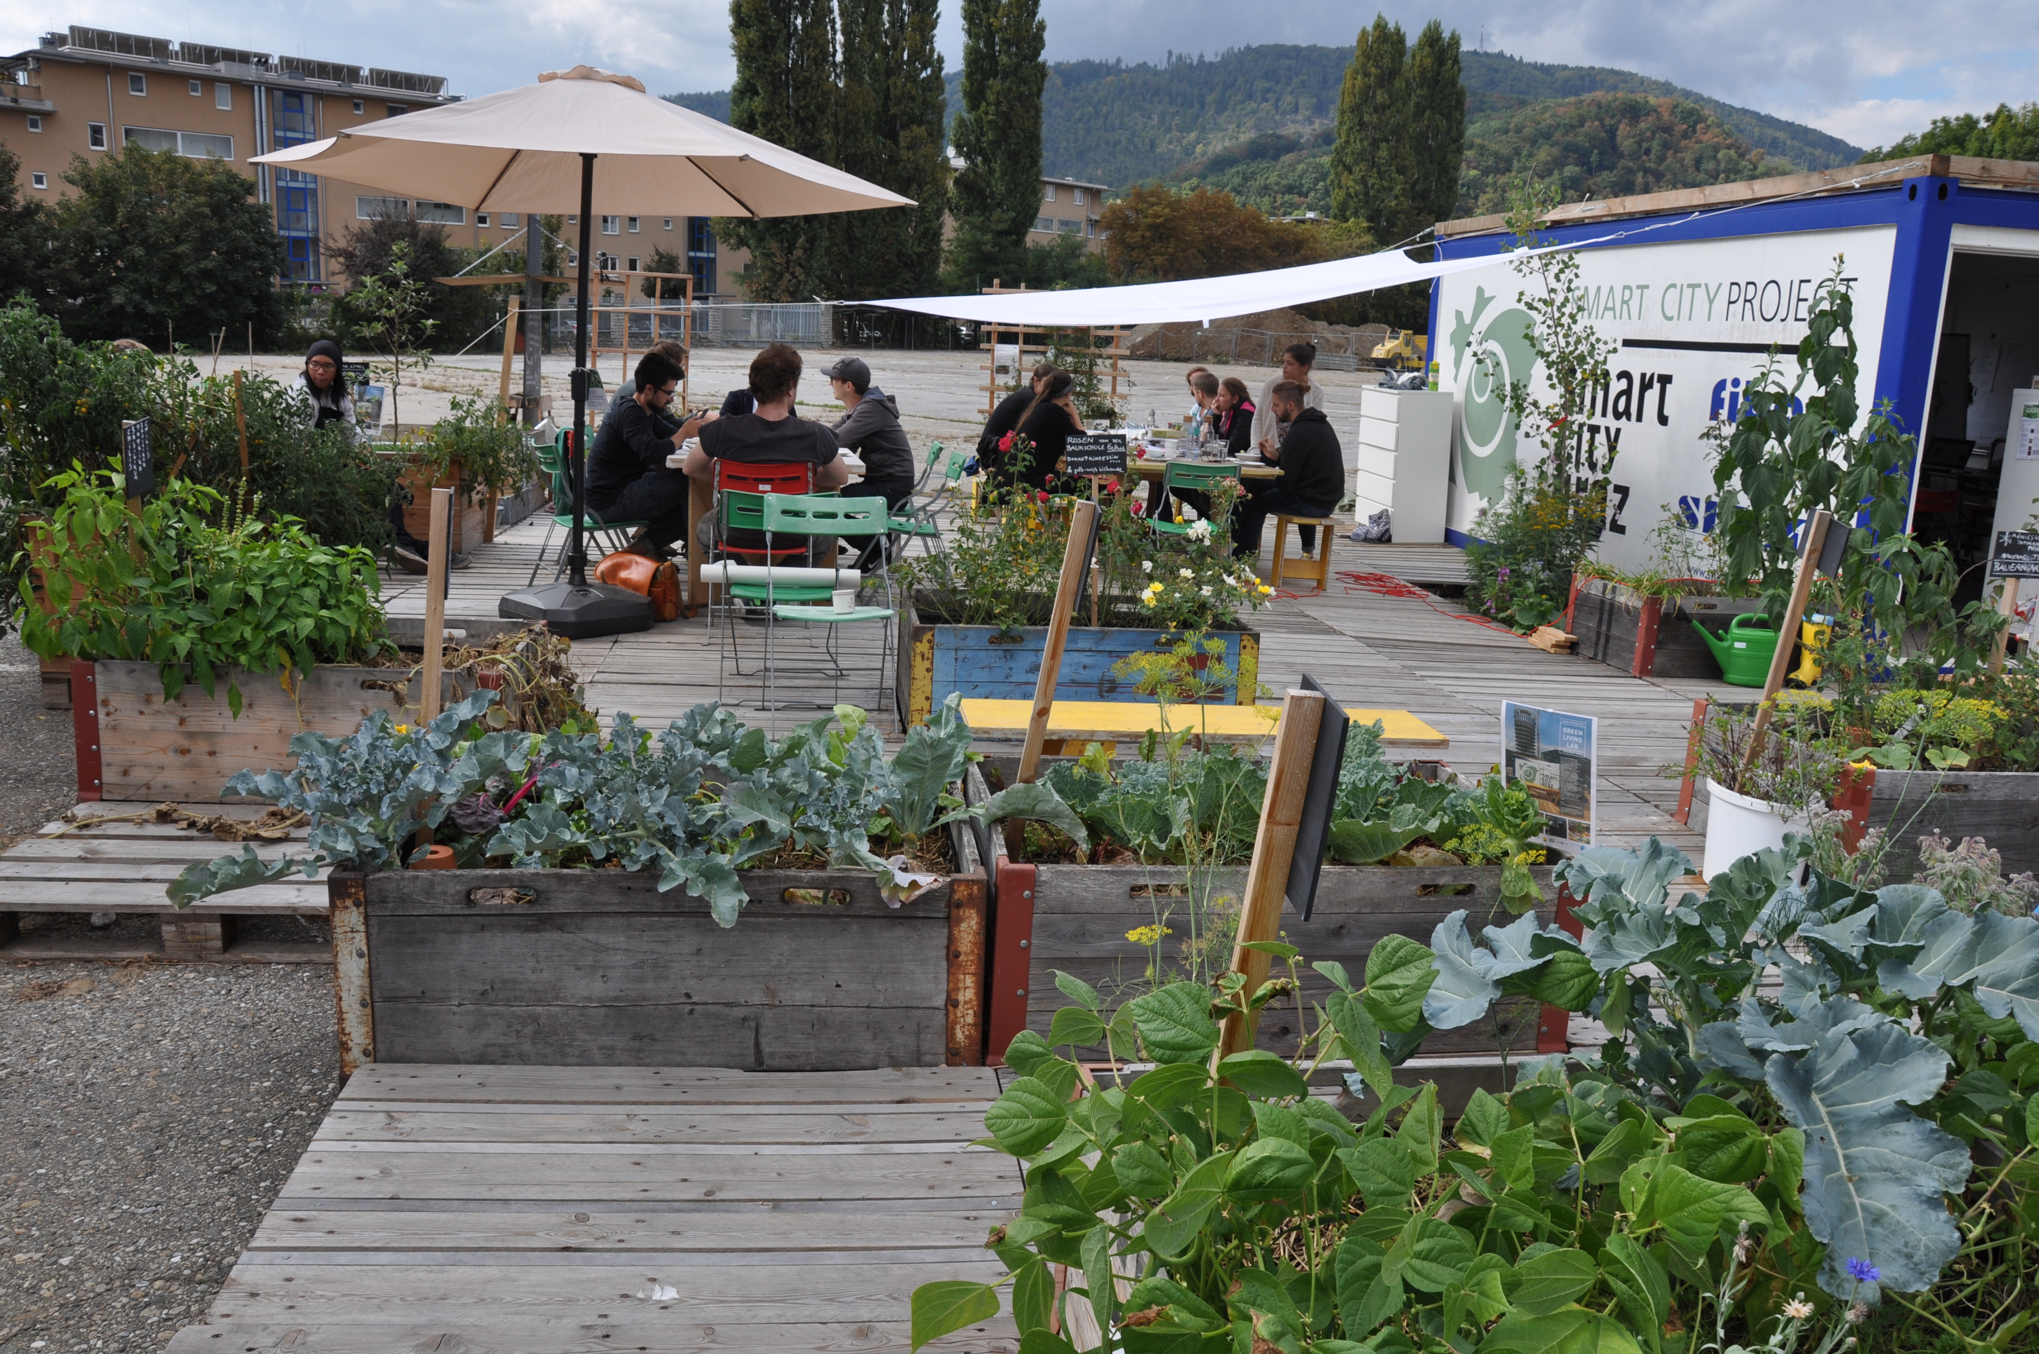
Figure 3: Urban Green Living Lab in Graz/Austria. Source: Project Living Green City, StadtLABOR

- Mobility
  - The present problems related to traffic and mobility (emissions, noise, low quality of public transport, traffic jam, accidents, etc.) have to be tackled. Some viable solutions may include: e-mobility, car-sharing, improved bike lanes and public transport.
  - It is important to reduce the need for mobility by implementing the concept of short distances.
- Buildings
  - “Low energy – zero energy – plus energy” are the keywords when it comes to smart buildings. Low energy solutions can be easily implemented within the new houses, but they are a real challenge in case of refurbishment. New cooperative models for buildings have to be developed in order to achieve these goals.
  - Life cycle of the materials used for the construction of new buildings has to be included within the design process.
- Social life
  - Quality of life significantly depends on how people organise their interactions in the city quarter. A good relationship within the neighborhood has a positive effect on the overall well-being of its residents. A great variety of people from different backgrounds can render life more interesting. Urban safety and security are also critical issues.

THINK!
Read this article, then answer the questions:
What is the sharing economy? Can you name some examples?
In your opinion, what are the major benefits and disadvantages of the sharing economy?
https://www.forbes.com/sites/bernardmarr/2016/10/21/the-sharing-economy-what-it-is-examples-and-how-big-data-platforms-and-algorithms-fuel/

In order to cope with many urban challenges and improve the quality of life, several MEASURES and SOLUTIONS can be applied:
- Energy
  - Improved energy efficiency and a shift to renewable forms of energy are essential in order to mitigate global warming. This can be achieved by:
- reduction of energy services (shorter distances to be covered due to better alternatives for mobility, less heating needed due to energy-efficient buildings, …)
- implementation of energy efficient technologies (heat pumps, cogeneration units, …)
- a shift to renewable energy (solar thermal, PV, biomass, …)
- development of new financial and business models, such as cooperatives or community-owned projects
- City planning
  - City planning has to shift towards an integrated city in order to become more effective, linking all important areas of development. Planning has to include a more participatory process rather than using a top-down approach.
  - With a better understanding of citizen’s motivations and needs, cities could define effective strategies and tools to involve citizens in urban development process: ensure that they are well-informed, motivated to act responsibly, participative or even co-creative. If smartly mobilised, the effects of citizen’s behaviour, choices or creativity could be enormous.

The most important aspects of Smart Cities can be summarised as follows:
- Short distances
  - All daily living activities can be accomplished without having a car.
- Minimised buildings- and traffic space-usage
  - Smart Cities are dense.
- Low GHG emissions
  - Smart Cites do not contribute to Climate Change, since they do not emit greenhouse gases.
- Low material streams with ecological effects
  - Smart Cities are (nearly) Zero Emissions Cities.
- Low ecological footprint
  - People care about origin and quality of products and services they purchase.
- Low additional costs
  - Smart Cities should not be more expensive than the conventional ones.
  - Higher costs at the beginning are compensated by lower operating costs.
- High productivity
  - Smart Cities contribute to national wealth. They host production and service companies.
- High interaction
  - Smart Cities are not isolated “islands of sustainability”, but they strongly interact with their surroundings.
  - Since a Smart City is not self-sufficient in terms of food, energy and natural resources like clean water and fresh air, it exchanges goods and services with the neighboring areas.
- High diversity
  - In a Smart City, young and old, rich and poor, various cultures coexist together. Urban systems with high diversity fostered by social and economic integration are more resilient.
- High development potential
  - Smartness is not a state, but a process. Therefore, it is important that the city remains open to new development and ideas. This can be understood not only in terms of new technologies, but also social innovations.

A SMART CITY is an integrated urban area with high quality of life, developing and implementing sustainable practices and solutions in cooperation with local citizens, based on renewable energy and materials and supported by ICT. It provides efficient, reliable and transparent public services and ensures a sustainable and liveable environment for its citizens.

EXERCISE 1
Based on what you have learnt in this section, summarise the most important aspects of a Smart City!
Which solutions can be applied to cope with urban challenges related to energy? And mobility?

Recently we have witnessed a rapid expansion of the so-called “Living Labs” as vehicles for addressing social and environmental challenges as well as supporting sustainable urban development. In the next learning unit the most relevant concepts revolving around Living Labs will be introduced.

Impressum
Published by:
e-genius –Open Education Initiative
in Science and Technology
Postfach 16
1082 Wien
Austria
E-mail: info(at)e-genius.at
E-mail: katharina.zwiauer(at)egenius.at

Authors: Marcel Crul, Hans Schnitzer, Barbara Hammerl, Gosia Stawecka
E-Learning Consultant: Katharina Zwiauer (e-genius)
Layout: e-genius –Open Education Initiative
January 2017

Project: SMACC – Smart City Coaching
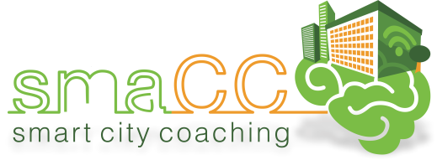 | 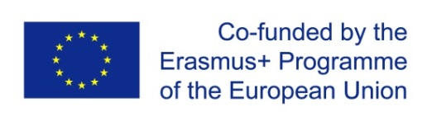
This learning unit was funded with support from the European Commission. This publication reflects the views only of the author, and the Commission cannot be held responsible for any use which may be made of the information contained therein.

Partner:
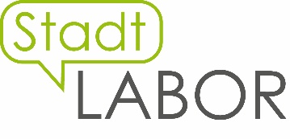
Legal notice
This learning unit is provided under the following Creative Commons Licence:
Attribution-NonCommercial-ShareAlike 4.0 International (CC BY-NC-SA 4.0) https://creativecommons.org/licenses/by-nc-sa/4.0/deed.en
You are free to:
- Share — copy and redistribute the material in any medium or format
- Adapt — remix, transform, and build upon the material
The licensor cannot revoke these freedoms as long as you follow the license terms.
Under the following terms:
- Attribution — You must give appropriate credit, provide a link to the license, and indicate if changes were made. You may do so in any reasonable manner, but not in any way that suggests the licensor endorses you or your use.
- NonCommercial — You may not use the material for commercial purposes.
- ShareAlike — If you remix, transform, or build upon the material, you must distribute your contributions under the same license as the original.
No additional restrictions — You may not apply legal terms or technological measures that legally restrict others from doing anything the license permits.
Attribution to e-genius as the copyright owner must take the following form:
Texts: authors of the learning unit, year of publication, title of the learning unit, publisher: e-genius –Open Education Initiative, www.e-genius.at/en
Illustrations: attribution to owner of copyright, e-genius – www.e-genius.at/en
Exclusion of liability:
All content on the e-genius platform has been carefully checked. Nevertheless, we are unable to offer any guarantee as to the correctness, completeness, topicality and availability of the content. The publisher does not accept any liability for damage or disadvantages that may arise from the use or exploitation of the content. The provision of the content on e-genius is not intended to replace the obtaining of professional advice and the ability to access the content does not constitute an offer to create an advisory relationship.
e-genius contains links to external websites. The insertion of links is a reference to representations and (also other) opinions, but does not mean the content of such links are endorsed. The publisher of e-genius does not accept any liability for websites that are referred to via a link. This applies both to their availability and to the content that can be accessed on such websites. As far as the operators are aware, the linked pages do not contain any unlawful content; should such content be discovered, it will be immediately removed in fulfilment of the legal obligations of the electronic reference.
Third-party content is identified as such. Should you nevertheless become aware of an infringement of copyright, please let us know accordingly. Upon being notified of legal infringements, we will immediately remove or correct such content.
Link to the open content platform: http://www.e-genius.at/en

Rogers, E.M. (2003). Diffusion of Innovations. New York: The Free Press, 5th Edition.
European Commission (2013). Guide to Social Innovation.
Jucevicius, G., Maital, S. (2015). National strategies of smart development: turning constraints into growth opportunities. Baltische Studien zur Erziehungs- und Sozialwissenschaft, Band 30, International Practices of Smart Development.
European Innovation Partnership on Smart Cities & Communities (2013). Retrieved from http://ec.europa.eu/eip/smartcities/.
https://en.wikipedia.org/wiki/Human_capital
Source: http://www.investopedia.com/terms/s/socialcapital.asp
Idem.
Source: Stadtlabor Graz

