Shaping cities for better quality of life - Fostering collaboration through Living Labs

Part 3: DREAM

Abstract
Have you ever used a route planner? It does not work without typing in the place where you want to go. The same applies for the practice of the Living Lab. You have to know where you start and where you intent to end up. Then the roadmap can be designed.
In this learning unit, the future vision for your city and the most pressing challenges will be defined.

Objectives
After completing this unit, you will be able to ...
- create a vision for your city
- list existing problems in your city
- define the most important areas of activities for your Living Lab

1. Defining your dreams and visions
You were probably already thinking (or dreaming) about how things should look like in your city or neighborhood. For example, you may want more green spaces and parks close to where you live. You might want that the public spaces are safe at night. You might wish to have a better relationship with your neighbors. In this section, you will turn your dreams into a vision. A vision is a description of an ideal and desired future state and can be defined at both city or neighborhood level. Having a shared vision is a crucial aspect of a Living Lab, as it helps define the actions and future decisions necessary for achieving a desired state, while enhancing collaboration, mutual understanding and trust.

How can you start outlining vision for your city? Here are some important aspects that you should focus on:
- define the area of activity (city/neighborhood)
- consider the following questions:
  - How does your ideal city look like in 2040?
  - How does your neighborhood look like in 2040?
  - What do you envision for your city in terms of green and public spaces, transportation, buildings, safety, job opportunities, etc.?
  - Is there already a future vision for your city? This could be a starting point to elaborate on!
- try to avoid discussion about the present and foreseeable problems. Different people have different ideas on how the city ought to be.
- Try to write down statements that everybody can agree with.
- A vision should be ambitious but not impossible. Dream big, but try to come up with ideas that are possible to achieve, and therefore:
  - desirable: solutions should reflect the real needs of all people
  - feasible: solutions have to be technically feasible (example: no efficiencies above 100%)
  - viable: solutions have to be doable from a business perspective

Example Box
Example 1 describes a general vision for the city of Graz developed as a result of a participatory process. Once you have defined the general vision, it might be useful to define ideal situation for more specific fields, like energy or green space (see example 2).
Example 1: A general vision for the city of Graz
- In 2050, the metropolitan area of Graz is a dynamic city with compact building development and urban mixed usage, attractive public spaces and a high quality of life.
- By efficiently implementing Smart City strategies and raising awareness among the citizens, resource and energy consumption as well as related emissions have been notably reduced. Graz is an energy-autonomous and waste-free city.
- Graz is an international benchmark for innovative urban technologies and systems, and therefore an attractive location for research, training and business and a desirable place to live and work at every stage of life.
- Soil and water quality as well as biodiversity have significantly improved, while noise pollution has decreased in downtown Graz.

Example 2: The vision for the city of Graz in the energy sector
- In 2050, the city of Graz finds itself at a sustainable energy equilibrium.
- The required energy is produced 100% regionally from renewable energy sources.
- The citizens of Graz understand the value of energy and use it consciously and efficiently.

EXERCISE 1

Draft the general vision for your city!
In this exercise you will use the method of Backcasting, where you define a desired future situation and then work backward to construct a causal chain between the future and the present state.
1. Begin with the end in mind.
2. Move backwards from the vision to the present.
3. Move step by step towards the vision.
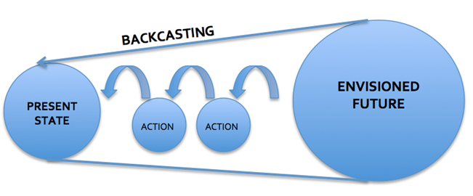
Figure 1: Backcasting process. Source: SMACC after The Natural Step
In order to develop a vision for your city, follow the instructions:
- Imagine your city/neighborhood in 2040. What is your desired situation in the future?
- Is there already a future vision for your city? Make an online research!
- Write a short story (100-150 words) starting with “My city in 2040…”. Be creative and specific! You can also make a drawing instead of writing a story.
- Backcasting in three steps 2040 ->2030 ->2020 -> now
  - Describe the current state
  - Decide on the future states in 2020 and 2030
  - Determine actions that are needed to achieve these states (work backwards)
- Draw a timeline with “now” on the left side and the 2040 on the right side. Place your actions on the timeline.

Materials:
Sticky notes in multiple colors, flipover sheets, pens, A4 sheets

2. Defining your starting point and challenges
After you developed a vision for your city, starting point for the future work of your Living Lab can be defined by listing up possible fields of activity. The goal is to identify the most important challenges in your city or neighborhood that will serve as a basis to focus on in the next phases of the design thinking process.

THINK!
What are the major problems in a city? List 5 different examples!
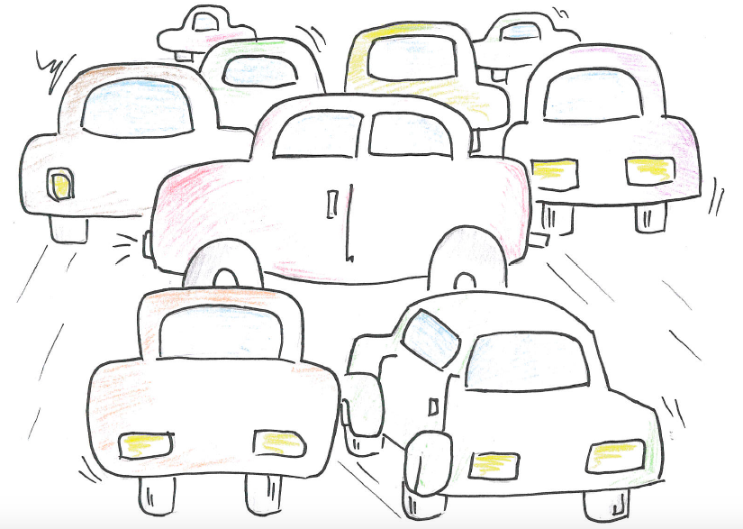
Figure 2: Increased traffic is one of the most common problems in cities. Source: SMACC
There are many urban-related topics to consider when you plan your Living Lab. It depends on you to define issues that are the most relevant in your specific context.
Examples are:
- Water supply and water quality
- Energy
- Transport / mobility
- Waste (solid waste, wastewater, air pollution, chemical waste, landfill)
- Safety / security
- Food / health
- Social challenges like social cohesion and social tensions
- Destruction of cultural heritage and its preservation
After you selected the topic to elaborate on, think about how your Living Lab can work in relation to the following aspects of the city development:
- Buildings
- Social structures
- Consumption / lifestyles
- IT infrastructure
- Physical infrastructures (for energy, water or waste)
- Public spaces
- Citizen participation

EXERCISE 2
Define the most pressing challenges in your city!
In this exercise you will use the Mindmapping approach. A mind map is a hierarchical representation of a topic connected by branches and associated topics. You can use different visual techniques, like colors, symbols and other graphic representations, as you can see in the example.
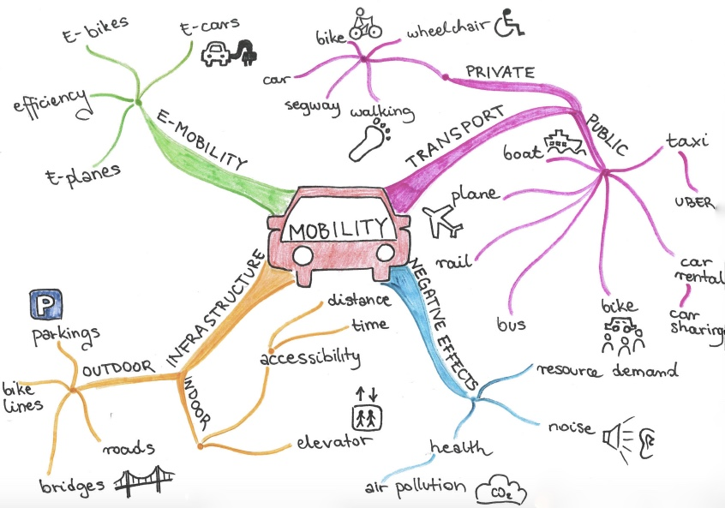
Figure 3: A mobility mind map. Source: SMACC

In order to create a mind map outlining the most pressing challenges in your city, consider the following steps:
- What are the main challenges in your city/neighborhood. Be specific!
- Define the central theme. What is the starting situation (water, energy, waste etc.)?
- Write the name of the theme in the centre of a sheet and draw a circle around it.
- Brainstorm each major facet of that theme, placing your thoughts on lines drawn outward from the central thought like roads leaving a city, and add branches to these lines, if necessary.
- Use additional visual techniques, like different colors for major lines of thought or symbols.
- Reshape or restructure the mind map if necessary.
- Finally, write down a list of the most urgent challenges in your city or neighborhood.

Materials:
A4 sheets, pens, A0 flipover sheet, felt pens, your brain and imagination

What can be the other outcomes of the DREAM phase?
It can be a video, picture, drawing, text, “a day in the life of…”, describing the ideal city of the future. But it can also be a story describing the “nightmare-scenario”, i.e.: what would happen if we don’t do anything to improve the current situation.

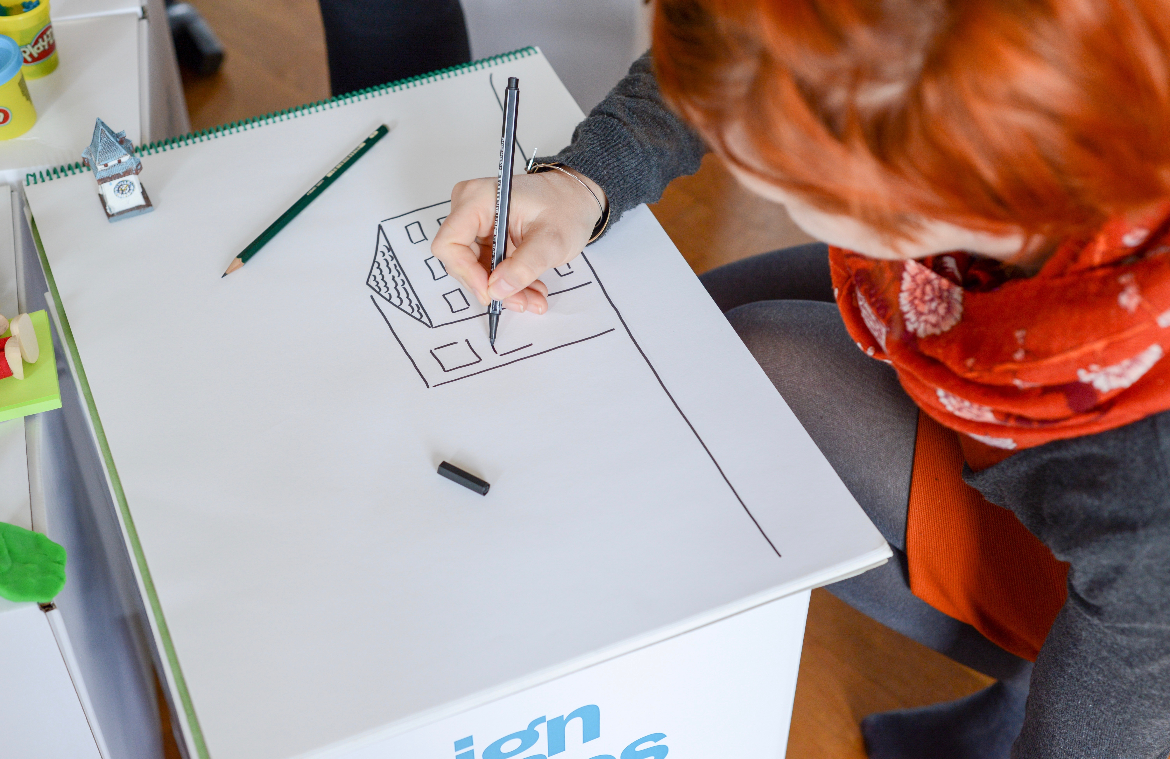
Figure 4: Photo credit: Nikolaus Kurnik

Impressum
Published by:
e-genius –Open Education Initiative
in Science and Technology
Postfach 16
1082 Wien
Austria
E-mail: info(at)e-genius.at
E-mail: katharina.zwiauer(at)egenius.at

Authors: Marcel Crul, Hans Schnitzer, Barbara Hammerl, Gosia Stawecka
E-Learning Consultant: Katharina Zwiauer (e-genius)
Layout: e-genius –Open Education Initiative
January 2017

Project: SMACC – Smart City Coaching
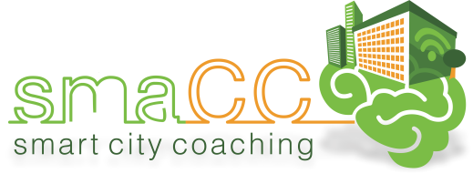 | 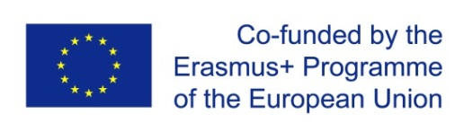
This learning unit was funded with support from the European Commission. This publication reflects the views only of the author, and the Commission cannot be held responsible for any use which may be made of the information contained therein.

Partner:
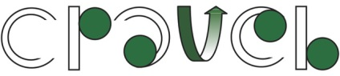
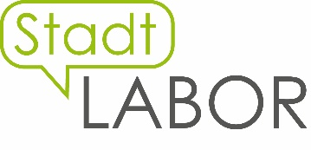
Legal notice
This learning unit is provided under the following Creative Commons Licence:
Attribution-NonCommercial-ShareAlike 4.0 International (CC BY-NC-SA 4.0) https://creativecommons.org/licenses/by-nc-sa/4.0/deed.en
You are free to:
- Share — copy and redistribute the material in any medium or format
- Adapt — remix, transform, and build upon the material
The licensor cannot revoke these freedoms as long as you follow the license terms.
Under the following terms:
- Attribution — You must give appropriate credit, provide a link to the license, and indicate if changes were made. You may do so in any reasonable manner, but not in any way that suggests the licensor endorses you or your use.
- NonCommercial — You may not use the material for commercial purposes.
- ShareAlike — If you remix, transform, or build upon the material, you must distribute your contributions under the same license as the original.
No additional restrictions — You may not apply legal terms or technological measures that legally restrict others from doing anything the license permits.
Attribution to e-genius as the copyright owner must take the following form:
Texts: authors of the learning unit, year of publication, title of the learning unit, publisher: e-genius –Open Education Initiative, www.e-genius.at/en
Illustrations: attribution to owner of copyright, e-genius – www.e-genius.at/en
Exclusion of liability:
All content on the e-genius platform has been carefully checked. Nevertheless, we are unable to offer any guarantee as to the correctness, completeness, topicality and availability of the content. The publisher does not accept any liability for damage or disadvantages that may arise from the use or exploitation of the content. The provision of the content on e-genius is not intended to replace the obtaining of professional advice and the ability to access the content does not constitute an offer to create an advisory relationship.
e-genius contains links to external websites. The insertion of links is a reference to representations and (also other) opinions, but does not mean the content of such links are endorsed. The publisher of e-genius does not accept any liability for websites that are referred to via a link. This applies both to their availability and to the content that can be accessed on such websites. As far as the operators are aware, the linked pages do not contain any unlawful content; should such content be discovered, it will be immediately removed in fulfilment of the legal obligations of the electronic reference.
Third-party content is identified as such. Should you nevertheless become aware of an infringement of copyright, please let us know accordingly. Upon being notified of legal infringements, we will immediately remove or correct such content.
Link to the open content platform: http://www.e-genius.at/en

