Shaping cities for better quality of life - Fostering collaboration through Living Labs

Part 4: FOCUS

Abstract
Not all “dreams” identified in the previous learning unit can become the subject of your Living Lab. You have to focus on a certain topic in order to better organise your work and obtain fast and valuable results. The goal of the FOCUS phase, therefore, is to determine a specific challenge as well as set boundaries to your Living Lab.
In this learning unit you will also learn how to identify and select important actors that support your work and you will get some valuable insight into how to create a physical space for your lab.

Objectives
After completing this unit, you will be able to ...
- focus the content of your Living Lab on important issues
- set boundaries
- work with the Business Model Canvas
- identify the important actors and stakeholders
- define the most important organisational aspects and the funding possibilities for your lab

1. Focusing the content and setting up the boundaries
Out of many ideas generated in the DREAM learning unit, now you have to select a topic that you will work on within your Living Lab. By narrowing down your challenge both greater quantity and higher quality ideas and solutions to your problem can be generated. The focus can be on issues (water, energy mobility, waste, etc.) and/or areas (entire city, selected neighborhood).

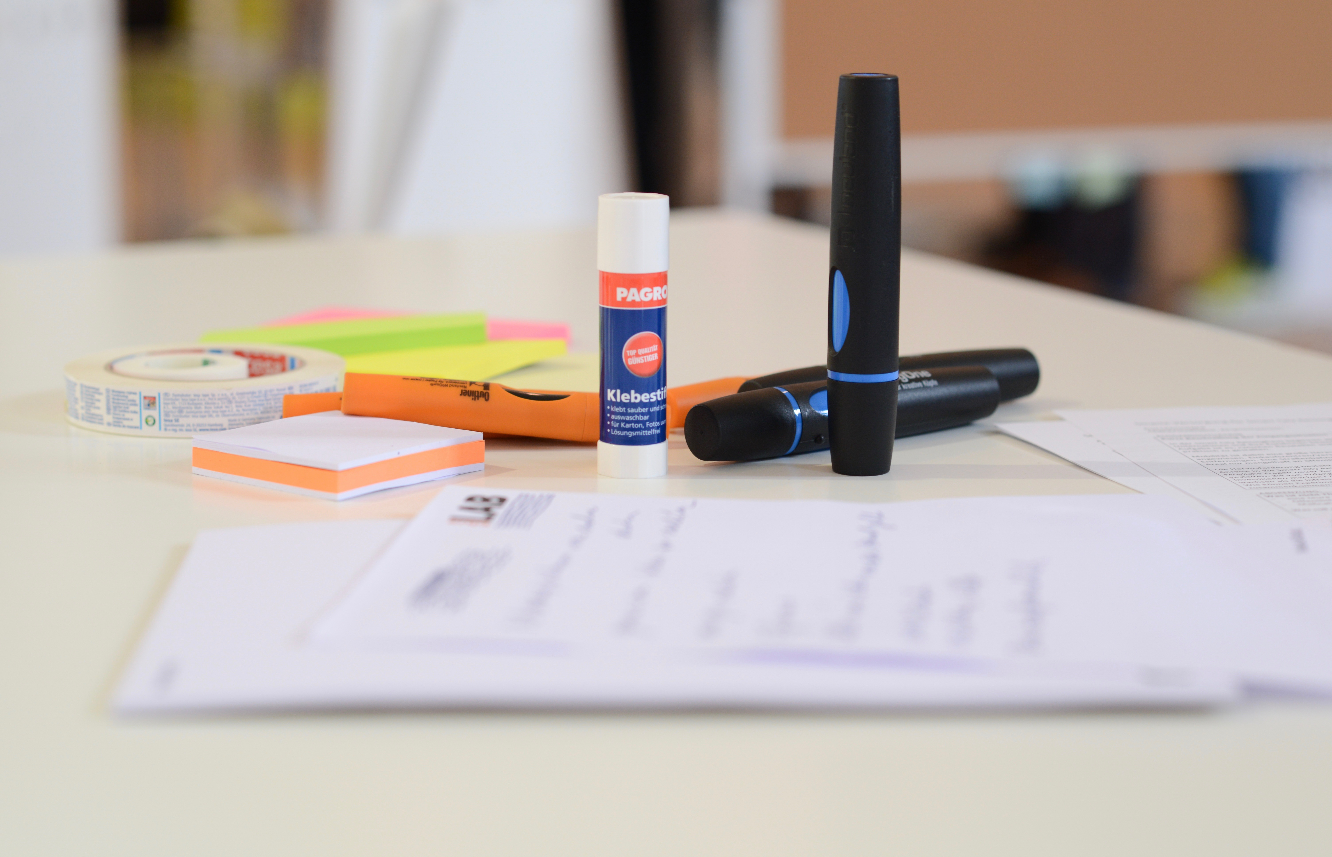
Figure 1: Photo credit: Nikolaus Kurnik
While narrowing down the content of your Living Lab consider the following questions:
- What is the focus of your Living Lab?
  - Eg.: The Energy Lab, The Water Lab, the Social Innovation Lab, etc.
  - Smart City Lab (including all subjects)
- Is your challenge related to one specific sector? Or there are different sectors involved?
- What are the possible advantages of involving different sectors? How could the various sectors benefit from each other?

While defining the boundaries of your Living Lab you should take account the following aspects:
- Are you going to focus on one specific topic or solution or a broader set of topics?
- Will you focus on a niche area, neighborhood or will you consider the city as a whole?
- Examples: smart mobility solutions for a specific group of citizens (wheelchair), smart and sustainable buildings, smart energy systems for your neighborhood, the waste collection system for your city, etc.

EXERCISE 1
Pick up a specific challenge within your city (or city district) that you would like to focus on throughout the entire course and describe it briefly. You can either use examples proposed in section DREAM point 2. Defining your starting point and challenges or come up with your own challenge.
Then answer the questions:
- Why did you choose this particular challenge?
- Which important problems in your city/city district does it tackle? Justify your choice.

HINT: Promising initiatives
There are different initiatives and projects already going on in your city. Think of projects conducted by local governments, businesses, research organisations, grassroots or small-scale community movements.

EXERCISE 2
Are there any projects already happening in your city that tackle your challenge?
Make an online research and list up to 5 different projects!
Project 1: …
Project 2: …
Project 3: …
Project 4: …
Project 5: …

Tool Box
Tool: Business Model Canvas
Th Business Model Canvas (BMC) is a useful tool to define the focus of your Living Lab. In this learning unit, you will use the adapted version of the Business Model Canvas (BMC). Now look at the model and read the key definitions below.

Key partners | Key activities | Value proposition  - Mission  -Main Programme  - Brand |  | Relationships | Ultimate beneficiaries
 | Key resources |  |  | Programme delivery methods
Expenditure |  |  | Income
Table 1: Adopted version of the Business Model Canvas. Source: Sanderse 2014: 4

Key definitions of the BMC cells adapted for Living Labs (in short: Lab)
Business model | A business model describes the framework through which a Lab creates, delivers and captures value.
Vision | A vision outlines what a Lab wants to achieve. It is a source of inspiration for future work. An example of a vision could be “Becoming a sustainable city.”
Key Partners | The network of cooperative agreements with other people or organisations necessary to efficiently distribute Lab’s work.
Key Activities | The main actions that a Lab needs to perform to create its value proposition.
Key Resources | The physical, financial, intellectual or human assets required for the business model.
Value Proposition | The Lab’s mission, and the defined program of work.
Mission | A mission defines the fundamental purpose of a Lab, describing why does it exist and what it does to achieve its vision. Example: “Creating sustainable energy and transport systems for our city”.
Relationships | The type of relationship a Lab has established or wants to establish with its key beneficiaries or donors.
Program delivery methods | The methods that a Lab uses to achieve its mission or program activities.
Ultimate Beneficiaries | The target group to be addressed by the Lab in order to achieve its vision/mission.
Income | Sources of income. This could be donations, merchandises/sales, investments or other income streams available for a Lab to work on its value proposition.
Expenditure | The total expenses of a Lab for implementing its activities.
Table 2

EXERCISE 3

Define the content of your Living Lab with help of the Business Model Canvas! Define the following elements and fill them in the Canvas in form of bullet points:
- Value proposition: Based on your vision, what is your mission and the main programmes?
- Key Activities: Which activities will your Living Lab focus on?
- What Programme delivery methods will you use?

Key partners | Key activities | Value proposition  - Mission  -Main Programme  - Brand |  | Relationships | Ultimate beneficiaries
 | Key resources |  |  | Programme delivery methods
Expenditure |  |  | Income
Table 3: Adopted version of the Business Model Canvas. Source: Sanderse 2014: 4

2. Actors and Stakeholders - the Living Lab Community
Think!
Who are the major groups of actors (stakeholders) involved in city development?
Why do you think that collaboration of actors from different sectors might be important in the city planning process?

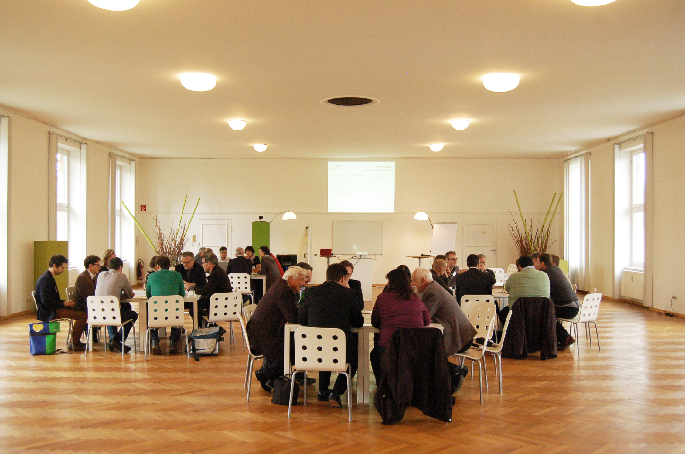
Figure 2: Different stakeholders working together on a challenge in the city of Graz. Photo credit: Stadtlabor Graz
A STAKEHOLDER is a person or an organisation that can affect or is affected by a strategy or project. In the city planning and development the key stakeholders are local government officials, policy makers, city developers, investors, entrepreneurs, citizens, NGOs, cultural associations and others.
An effective stakeholder involvement is a necessary condition for an efficient work of your Living Lab. Successful stakeholder engagement requires a commitment to actively engage with stakeholders, build a relationship and respond to their needs and concerns.

Stakeholder participation offers cities several key benefits:
- Decisions taken with stakeholder input are based on a broader knowledge
- Stakeholder engagement from an early stage can improve the quality, acceptance and effectiveness of projects and proposals
- Discussions with key stakeholders may open up further opportunities for collaboration and joint projects
- Stakeholders collaboration can secure long-term support for strategies and actions in the city
- Participatory decision making is more transparent

The following information on the stakeholders can be useful while developing your Living Lab:
- Who should I involve? Who could support my idea?
- Who are the driving organisations/change agents in my city/neighborhood?
- Who can help find budget, funds, management support?
- How and what should I communicate with the key stakeholders (core community) and the outside community?

EXERCISE 4

Identify the most important stakeholders to be involved within the challenge in your city. In this exercise you will use the technique of Stakeholder Mapping. Consider the following steps:
1. Draw a Table on a flipchart.
Expertise
Value
Willingness

Stakeholder | Contribution | Legitimacy | Willingness to engage | Influence | Necessity of involvement
Stakeholder A
Stakeholder B
etc.

2. Brainstorm a list of stakeholders, including everyone who has an interest in your objectives today and who may be interested tomorrow. Be specific by naming concrete organisations, firms, etc.
3. Rate the stakeholders for each column: High, medium, low.
4. Draw a grid on a flipchart and position the stakeholders according to your rating.
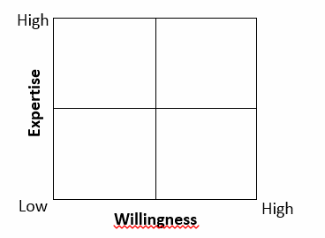
Materials:
2x A0 flipover sheet, felt pens, Pens

3. Living Lab as a physical space
Living Labs can be defined as “physical regions or virtual realities, or interaction spaces in which different stakeholders are collaborating for creation, prototyping, validating and testing ideas in real life contexts”. There are many examples of Living Labs in Europe, several videos can be found at the end of this training course.
In this section you will focus on setting up a Living Lab meant as a physical space. Here are some major aspects to be considered:
- What are the demands regarding the physical space?
  - Visible location?
  - Should citizens be able to just walk in?
  - Should students be able to work there?
  - Should the lab be located close to the city centre or directly in the neighborhood/city district?
  - Close to the other companies, universities, city hall?
- What is the demand for:
  - office space
  - shared working spaces
  - creative spaces like prototyping, mock-up, fablab environments
  - workshops spaces
  - exhibitions and lecturing spaces
- Are there any tools or machines that you might need?
- Are there any other local initiatives/labs that you can cooperate with?

4. Living Lab as a learning environment
Creating a learning and cooperative environment is a crucial aspect of the Living Lab. Below you will find a set of design principles that will help you design your Lab as a learning environment.

Tool Box
Design principles for establishing a Living Lab as a learning environment
The following organisational and learning principles can be applied when designing the physical and virtual space for your lab (Source: Hanze University of Applied Science - Guidelines Innovation Labs (in Dutch) 2015)
1. Create an authentic working environment
The Lab (context, tasks and activities, roles and communication) represents the practice in your city and has a professional working culture and organisation.
2. Form a learning community
Each participant is considered a part of the lab community. Everyone learns on his/her own pace.
3. Make use of diversity
Diversity is welcomed and highly appreciated. It is used to the fullest when it comes to team and project work, at the organisation level as well as within external networks.
4. Integrate learning and working
The organisational structure of the lab supports the working process, knowledge creation and sharing of information at all levels (personal, team, organisation, society).
5. Facilitate reflective practice
Participants learn by reflecting on tasks and experiences done within the lab, as a person, a team or an organisation.
6. Embed the lab in its environment
The lab is well embedded in its contextual environment (partner organisations and other important stakeholders).

5. Organisation and funding
In its initial phase, a Living Lab is often formed by an informal group of enthusiastic people who have joined forces to bring about change in their city. At some point a decision has to be made on whether or not a lab should be formalised.
There are many different organisational solutions for formalising your Living Lab. You could for instance form an independent company, institute or association or join a department or branch of an exiting governmental or non-governmental organisation or commercial entity.
If you are thinking about formalising your Living Lab, you should consider the following questions:
- Who owns the Living Lab? What are the requirements for the ownership?
- How independent do you want to be?
- Would it be beneficial to be part of a larger organisation? What are the major benefits and drawbacks?
The table below illustrates the most important organisational and funding aspects that have to be taken into account while planning your Living Lab.

Legal issues | - Does the Lab have any responsibilities?  - Can the Lab be eligible for project funding (legal status)?  - Can the Lab have employees and pay salaries?
Money/budget | What money comes in?  - What is the business model of the Lab? (all for free, all paid, some things for free to attract people)  - Which kind of funding can I get for my projects and where can I search for it?  What expenditures go out?  - Who pays the salaries for the employees?  - How much budget do I need for projects?
Risks | - What are the risks associated with running the Lab?  - Who could be against the Lab? (competitors, similar initiatives etc.)
Timing/planning | - What is the starting date of the Lab?  - What is the end-date of the Lab?  - Is it a project (with clear beginning and end) or a programme (longer term vision containing smaller projects)?
Table 4
Funding is an important aspect when it comes to realisation of your projects. There are several funding agencies and programmes at national (national and local governments) and international (European Union) level that provide financial sources for project related to Smart Cities.
Here are some European references and strategic documents where you can apply for funding.
- EU funding mechanisms for Smart Cities, p.13-17 (Recommended!!! )
https://eu-smartcities.eu/sites/all/files/Guideline-Using%20EU%20fundings%20mechanism%20for%20smart%20cities.pdf
- The European Innovation Partnership on Smart Cities and Communities
http://ec.europa.eu/eip/smartcities/
- Horizon 2020 Research and Innovation programme
https://ec.europa.eu/programmes/horizon2020/en/what-horizon-2020

Several smaller initiatives can be financed directly on a local level. There is always a possibility to submit your proposal in front of the respective authorities in your city. This could be, for instance, the city environmental department for issues related to waste, or the office for green and water resources for the urban gardening initiatives. What really matters is the idea, an innovative concept and a good plan.
It can be also helpful to connect to other already existing initiatives in your neighborhood that deal with similar challenges. Maybe you can work and implement some of the ideas together.

Example Box
A successful example of financing small urban gardening initiatives is the so-called “Capital Growth Campaign” run by Sustain’s London Food Link. It offers practical and financial support to communities around London to help people grow more food, and to have greater access to land and growing spaces for community benefit.
You can read more about the initiative here: http://www.capitalgrowth.org

EXERCISE 5
This exercise will help you create a map of the potential financial sources for the projects within your lab.
Identify funding opportunities for your Living Lab by filling in the table below!
Follow the guidelines below:
- Potential Source: you should mention at least 1 source or programme that refers to Smart Cities (example: Horizon 2020). Do this exercise for each level.
- Smart City concept: shortly describe to what extent Smart City aspects are considered within the identified source or programme (example: secure, clean and efficient energy). Do this exercise for each level.
- Usefulness of the source: Write YES or NO depending on whether or not the identified source tackles your Living Lab challenge.
Territorial/ Organisational Level of the source | Potential  Source | Smart City Concept | Usefulness of the source
European
National
Regional
Local
Other (foundations/ banks / etc.)

The easiest way to proceed is to go online and …
- check out the programmes at EU level (use links listed above)
- check out government websites at national or regional level that work on aspects related to Smart Cities
- look for local sources that deal with this topic

Impressum
Published by:
e-genius –Open Education Initiative
in Science and Technology
Postfach 16
1082 Wien
Austria
E-mail: info(at)e-genius.at
E-mail: katharina.zwiauer(at)egenius.at

Authors: Marcel Crul, Hans Schnitzer, Barbara Hammerl, Gosia Stawecka
E-Learning Consultant: Katharina Zwiauer (e-genius)
Layout: e-genius –Open Education Initiative
January 2017

Project: SMACC – Smart City Coaching
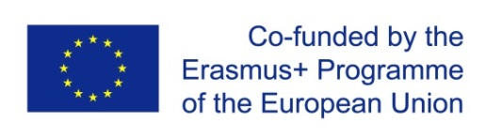
This learning unit was funded with support from the European Commission. This publication reflects the views only of the author, and the Commission cannot be held responsible for any use which may be made of the information contained therein.

Partner:
Legal notice
This learning unit is provided under the following Creative Commons Licence:
Attribution-NonCommercial-ShareAlike 4.0 International (CC BY-NC-SA 4.0) https://creativecommons.org/licenses/by-nc-sa/4.0/deed.en
You are free to:
- Share — copy and redistribute the material in any medium or format
- Adapt — remix, transform, and build upon the material
The licensor cannot revoke these freedoms as long as you follow the license terms.
Under the following terms:
- Attribution — You must give appropriate credit, provide a link to the license, and indicate if changes were made. You may do so in any reasonable manner, but not in any way that suggests the licensor endorses you or your use.
- NonCommercial — You may not use the material for commercial purposes.
- ShareAlike — If you remix, transform, or build upon the material, you must distribute your contributions under the same license as the original.
No additional restrictions — You may not apply legal terms or technological measures that legally restrict others from doing anything the license permits.
Attribution to e-genius as the copyright owner must take the following form:
Texts: authors of the learning unit, year of publication, title of the learning unit, publisher: e-genius –Open Education Initiative, www.e-genius.at/en
Illustrations: attribution to owner of copyright, e-genius – www.e-genius.at/en
Exclusion of liability:
All content on the e-genius platform has been carefully checked. Nevertheless, we are unable to offer any guarantee as to the correctness, completeness, topicality and availability of the content. The publisher does not accept any liability for damage or disadvantages that may arise from the use or exploitation of the content. The provision of the content on e-genius is not intended to replace the obtaining of professional advice and the ability to access the content does not constitute an offer to create an advisory relationship.
e-genius contains links to external websites. The insertion of links is a reference to representations and (also other) opinions, but does not mean the content of such links are endorsed. The publisher of e-genius does not accept any liability for websites that are referred to via a link. This applies both to their availability and to the content that can be accessed on such websites. As far as the operators are aware, the linked pages do not contain any unlawful content; should such content be discovered, it will be immediately removed in fulfilment of the legal obligations of the electronic reference.
Third-party content is identified as such. Should you nevertheless become aware of an infringement of copyright, please let us know accordingly. Upon being notified of legal infringements, we will immediately remove or correct such content.
Link to the open content platform: http://www.e-genius.at/en

Sandarse, J. (2014): The Business Model Canvas of NGOs, Retrieved from: https://www.academia.edu/6935967/The_business_model_canvas_of_NGOs_The_business_model_canvas_of_NGOs_door_Judith_Sanderse
Nutt, P., Backoff, R. (1992). Strategic Management of Public and Third Sector Organisations: A Handbook for Leaders. San Francisco: Jossey-Bass, p.439.
Strategies Towards Energy Performance and Urban Planning (STEP UP) Project. Retrieved from http://www.stepupsmartcities.eu
Leminen, S. (2013). Coordination and Participation in Living Lab Networks, Technology Innovation Management Review, p.7
Fabrication Laboratory; example: https://www.youtube.com/watch?v=EAh5gJ3zbcM&feature=youtu.be

