Shaping cities for better quality of life - Fostering collaboration through Living Labs

Part 5: CREATE

Abstract
In the CREATE learning unit you will focus on generating a broad range of ideas to address your challenge. It is about developing a wide selection of solution, not simply finding the best one. In doing so, you give your imagination and creativity a voice, which encourages new ideas to come forward. The ideas generated in this phase are the basis for identifying innovative solutions and building prototypes.

Objectives
After completing this unit, you will be able to ...
- identify solutions responding to the defined problem
- define selection criteria for the identified solutions
- elaborate on a business model for your Living Lab

1. Creating solutions
THINK!
Why do we need creativity?

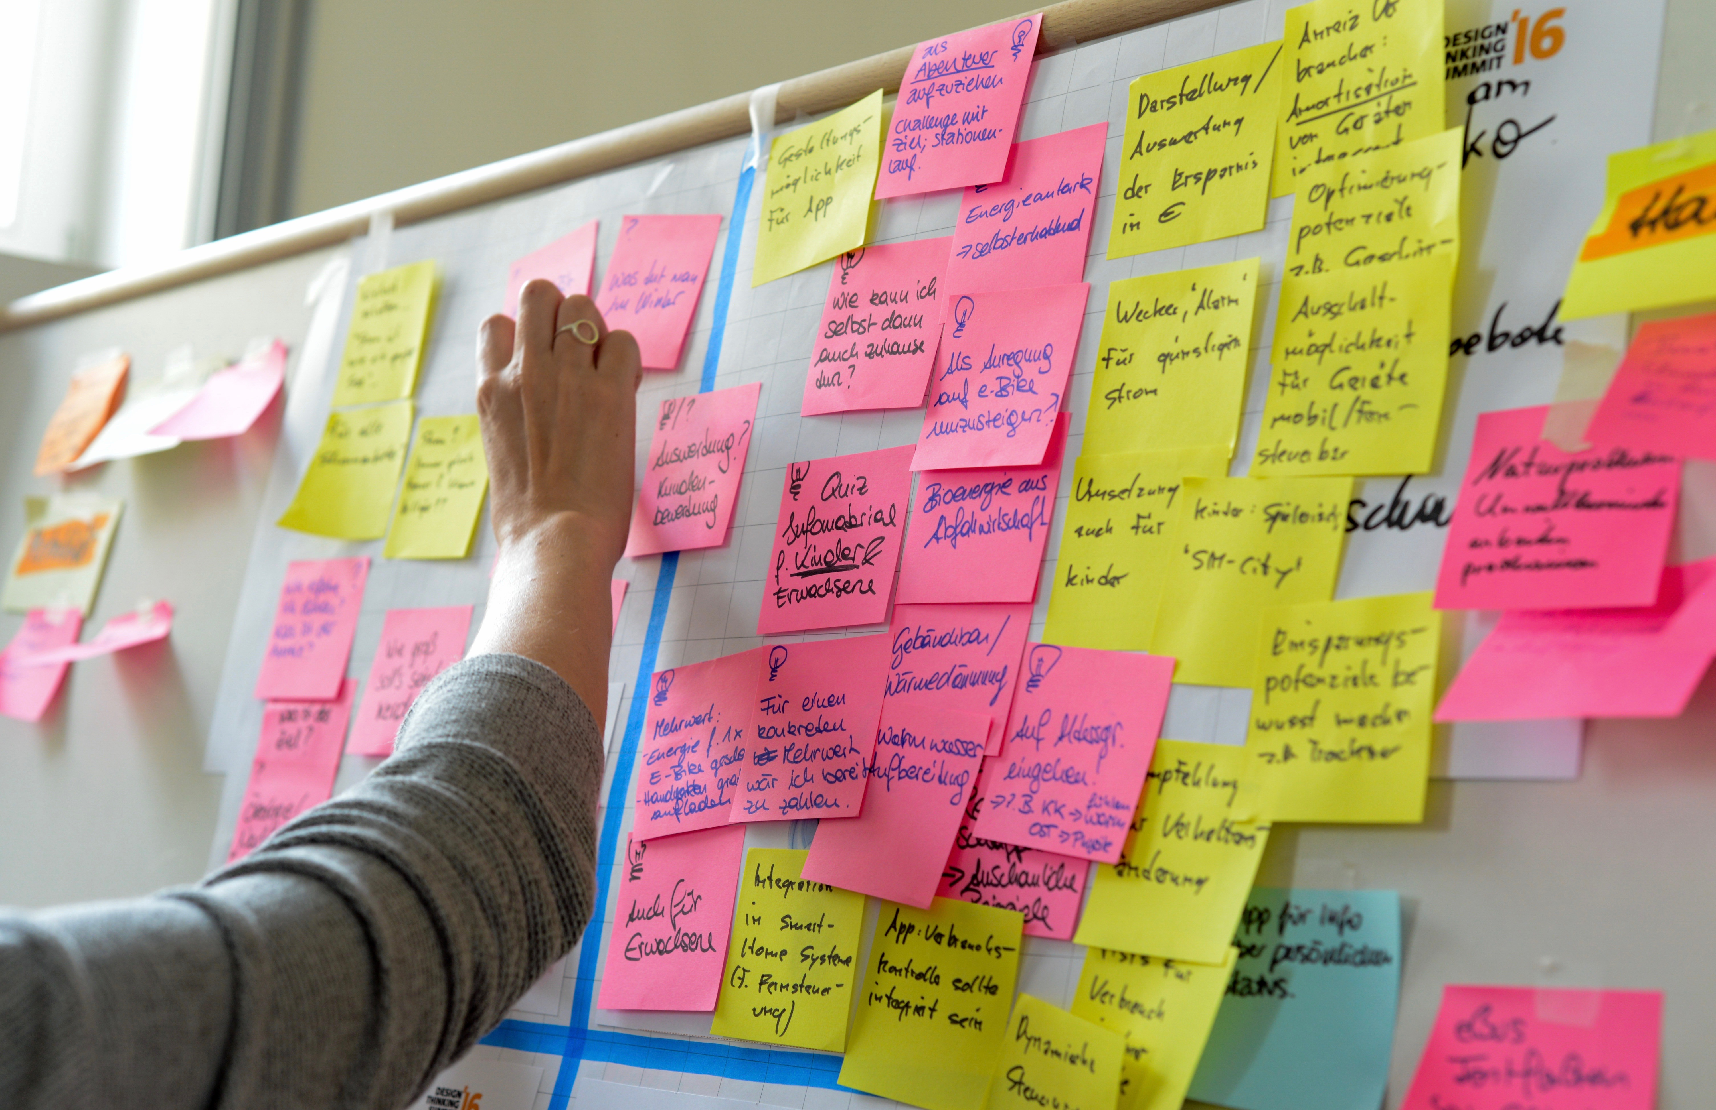
Figure 1: Photo credit: Nikolaus Kurnik

Why create?
- go beyond obvious solutions and therefore enlarge the innovation potential
- unveil unforeseen areas for further exploration
Based on the defined challenge in the previous phase of the design thinking approach, you can now concentrate on generating solutions to your problem. This could be for instance a creative session during which many different ideas to solve your challenge are developed. Following aspects should be considered:
- You should generate as many ideas as possible.
- Which solutions already exist for your challenge?
  - Within government?
  - Within companies?
  - Within societal stakeholders?
  - Within universities?

Tool Box
There are different creation techniques such as brainwriting, brainstorming, bodystorming, mindmapping or sketching. The advantage of these methods consists in increasing the synergy of the group to develop new ideas by building on ideas of the others. For example, BRAINWRITING is an alternative method to brainstorming that consists in a silent, written generation of ideas in a group.

EXERCISE 1

In this exercise you will use the brainwriting method in order to find many creative solutions to the challenge your Living Lab wants to tackle! As you may need at least three participants to solve this task, invite your friends or family to participate. In the second step, select your best ideas using SMART selection criteria (Specific, Measurable, Achievable - or Ambitious, Realistic, Time-bound). Follow the instructions below:

1. Write down the challenge you want to tackle. Be specific!
2. Each participant brainstorms (silently) three solutions and writes them on top of a separate sheet. Be creative!
3. Pass the sheets to the next person.
4. Add or build upon the existing solutions by writing down your own ideas.
5. Again pass the sheet to the next person, repeat this task until everyone has written down his/her ideas on every sheet. (For example: if there are 5 participants, there should be 3x5x5=75 ideas)
6. Divide the ideas into logical categories.
7. Select the best 5 ideas using SMART selection criteria (Specific, Measurable, Achievable - or Ambitious, Realistic, Time-bound). Write them down on a flipover sheet.
8. In a group, assess the feasibility to implement the selected ideas.

Materials:
A4 sheets, pens, scissors, A0 flipover sheet, felt pens

2. Designing the business model for your Living Lab
After you have outlined the ideas and solutions to be implemented within your Living Lab, in this section you will finish your business model. Firstly, you have to decide on the possible projects to be implemented. Secondly, you have to create your network and decide who your core team is. Finally, you have to think about the physical space for your Living Lab. A series on practical exercises below will help you answer all these questions.

EXERCISE 2

Based on your selection of solutions in the previous section, define 5 practical projects for your Living Lab.
Define the following aspects for every project:
- Project name
- Type of challenge (complex, simple, ...)
- Type of stakeholders involved
- Timeline (1 day, 1 week, 1 year?)

Then rank these projects, according to urgency, resources available, impact, economic and organisational feasibility, and other criteria that you find important.

Materials:
A4 sheets, pens

EXERCISE 3
Build your team!
Design the network of people and organisations that you will work with within your lab. The following questions may help you with this task:
- Who is the part of your core team?
- Who is the inner/outer circle?
- How to create a shared understanding?

HINT: For inspiration - look back at the design principles for establishing a Lab as a learning environment in the unit FOCUS.

EXERCISE 4
Design the physical space for your Living Lab by sketching it on a sheet of paper. If possible build a mock-up, like an architectural drawing. As alternative, you can use Lego to build your own Lab. Use your imagination!

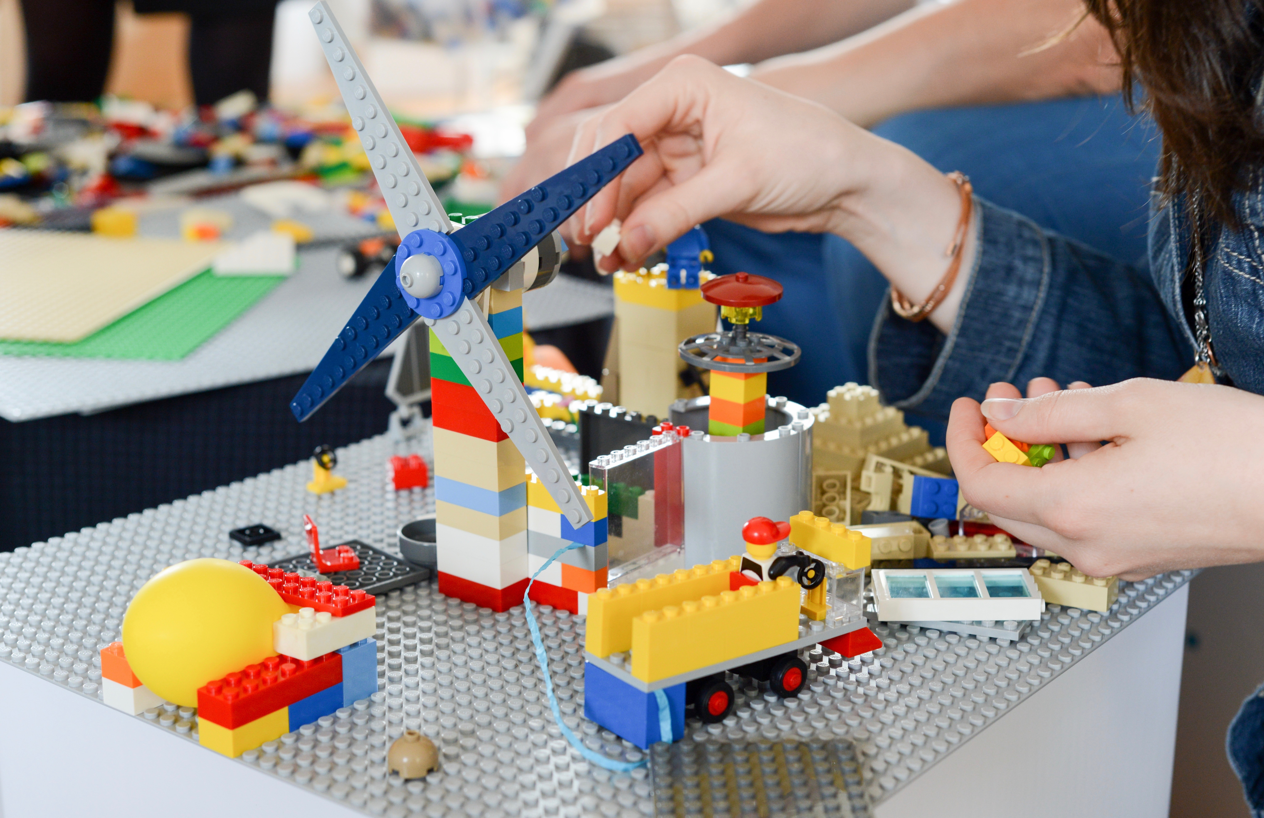
Figure 2: An example of a mock-up build up with Lego during a Design Thinking session. Proto credit: Nikolaus Kurnik
Materials:
A4 sheets, pens, Lego, glue, scissors and other materials

3. Finalising the business model for your Living Lab
With the input gathered in this learning unit, you can now finalise the business model for your Living Lab using the Business Model Canvas.
The Business Model Canvas approach has been introduced at the beginning of the learning unit FOCUS. The Value, Mission, Activities and Programme delivery methods have been already described. Now you can fill in the other cells based on the information your have gathered in the previous sections. Consider the following steps:
- Define your key Partners and ultimate Beneficiaries
- Describe the type of Relationships your lab has to establish with the main partners and beneficiaries
- Fill in the cells Expenditures and Income based on the funding and organisational aspects
- Define the Key Resources for your lab
- Review your full canvas - Any need for change or improvement? Do it now!

Key partners | Key activities | Value proposition  - Mission  -Main Programme  - Brand |  | Relationships | Ultimate beneficiaries
 | Key resources |  |  | Programme delivery methods
Expenditure |  |  | Income
Table 1: Adopted version of the Business Model Canvas. Source: Sanderse 2014: 4

Impressum
Published by:
e-genius –Open Education Initiative
in Science and Technology
Postfach 16
1082 Wien
Austria
E-mail: info(at)e-genius.at
E-mail: katharina.zwiauer(at)egenius.at

Authors: Marcel Crul, Hans Schnitzer, Barbara Hammerl, Gosia Stawecka
E-Learning Consultant: Katharina Zwiauer (e-genius)
Layout: e-genius –Open Education Initiative
January 2017

Project: SMACC – Smart City Coaching
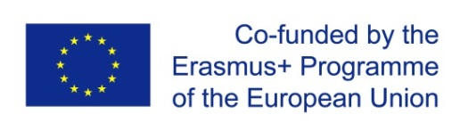
This learning unit was funded with support from the European Commission. This publication reflects the views only of the author, and the Commission cannot be held responsible for any use which may be made of the information contained therein.

Partner:
Legal notice
This learning unit is provided under the following Creative Commons Licence:
Attribution-NonCommercial-ShareAlike 4.0 International (CC BY-NC-SA 4.0) https://creativecommons.org/licenses/by-nc-sa/4.0/deed.en
You are free to:
- Share — copy and redistribute the material in any medium or format
- Adapt — remix, transform, and build upon the material
The licensor cannot revoke these freedoms as long as you follow the license terms.
Under the following terms:
- Attribution — You must give appropriate credit, provide a link to the license, and indicate if changes were made. You may do so in any reasonable manner, but not in any way that suggests the licensor endorses you or your use.
- NonCommercial — You may not use the material for commercial purposes.
- ShareAlike — If you remix, transform, or build upon the material, you must distribute your contributions under the same license as the original.
No additional restrictions — You may not apply legal terms or technological measures that legally restrict others from doing anything the license permits.
Attribution to e-genius as the copyright owner must take the following form:
Texts: authors of the learning unit, year of publication, title of the learning unit, publisher: e-genius –Open Education Initiative, www.e-genius.at/en
Illustrations: attribution to owner of copyright, e-genius – www.e-genius.at/en
Exclusion of liability:
All content on the e-genius platform has been carefully checked. Nevertheless, we are unable to offer any guarantee as to the correctness, completeness, topicality and availability of the content. The publisher does not accept any liability for damage or disadvantages that may arise from the use or exploitation of the content. The provision of the content on e-genius is not intended to replace the obtaining of professional advice and the ability to access the content does not constitute an offer to create an advisory relationship.
e-genius contains links to external websites. The insertion of links is a reference to representations and (also other) opinions, but does not mean the content of such links are endorsed. The publisher of e-genius does not accept any liability for websites that are referred to via a link. This applies both to their availability and to the content that can be accessed on such websites. As far as the operators are aware, the linked pages do not contain any unlawful content; should such content be discovered, it will be immediately removed in fulfilment of the legal obligations of the electronic reference.
Third-party content is identified as such. Should you nevertheless become aware of an infringement of copyright, please let us know accordingly. Upon being notified of legal infringements, we will immediately remove or correct such content.
Link to the open content platform: http://www.e-genius.at/en

