Shaping cities for better quality of life - Fostering collaboration through Living Labs

Part 6: DELIVER

Abstract
After you have focused on themes and outlined solutions, the most promising ones have been selected and processed in a business model. In order to avoid losing all of the innovation potential you have just generated through creation, you can bring some of your ideas forward into prototyping. This will be the content of the DELIVER learning unit. The goal is to summarise the main insights gathered in the previous units in a short presentation.

Objective
After completing this unit, you will be able to ...
- make a leaflet or a poster of your Living Lab

1. Delivering solutions
Delivering solutions means transforming ideas into something tangible that can be tested and then adopted for further implementation or rejected at an early stage, thus saving time and money. Prototyping provides a unique way to evaluate new ideas that can help achieve desired outcomes for a given challenge. A PROTOTYPE can be anything that you can interact with, an early sample or model.

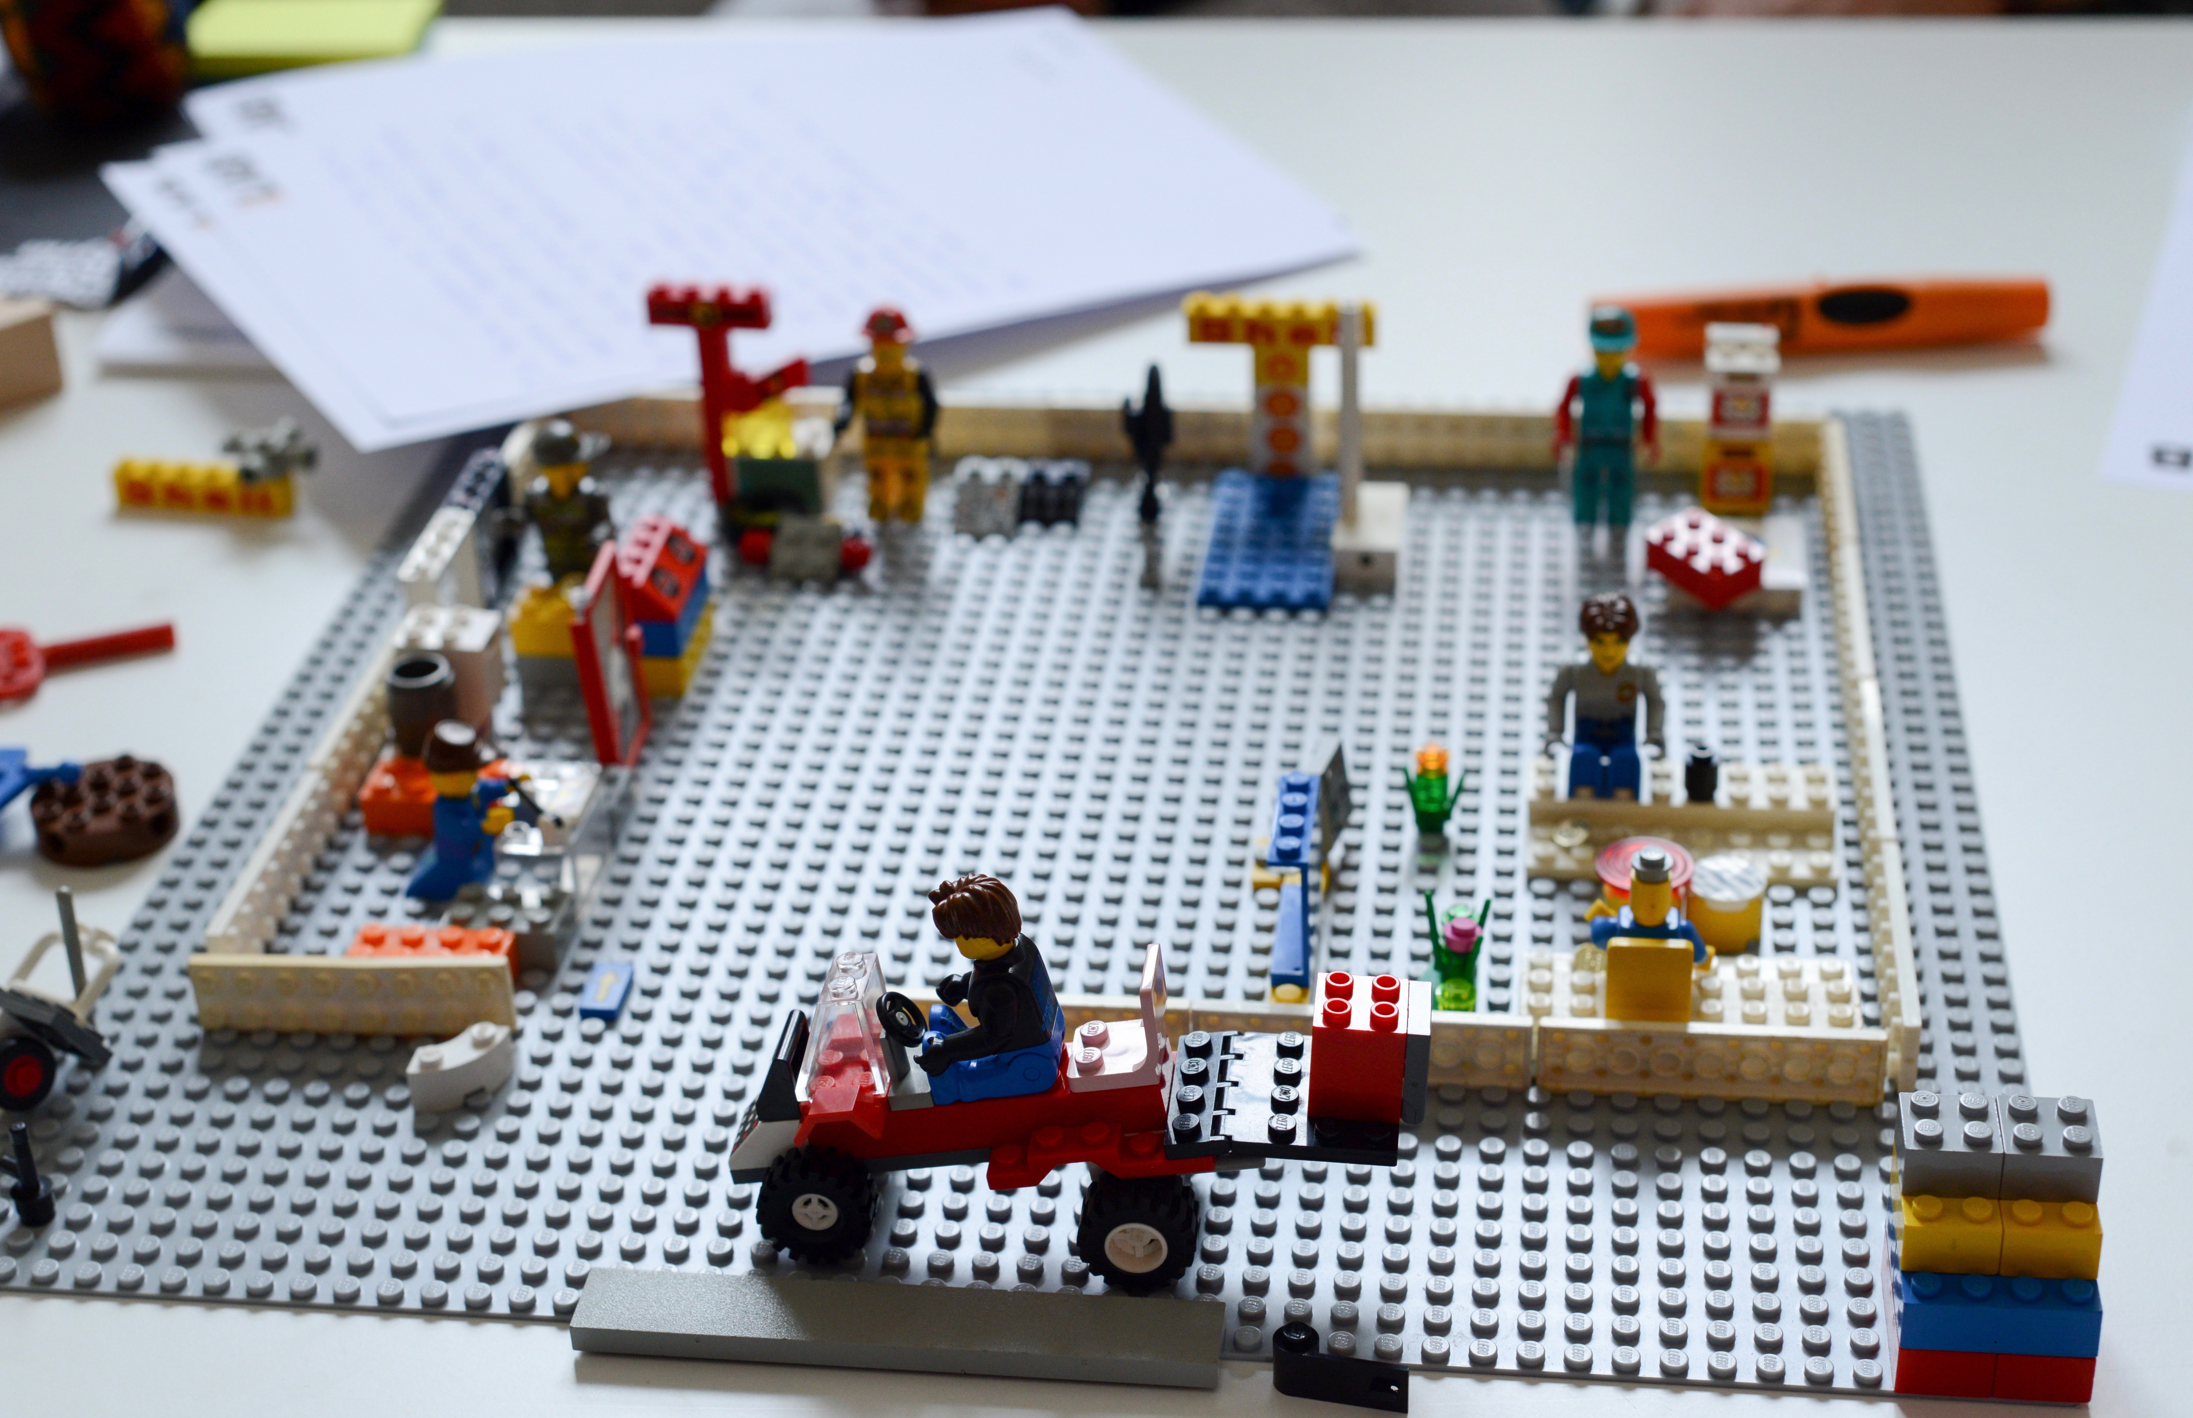
Figure 1: A prototype developed during a design thinking session. Photo credit: Nikolaus Kurnik

EXERCISE 1

Develop a leaflet or a poster for advertising your Living Lab!

- Be concise! Keep your text short but informative. Break your information into sections.
- Use images, sketches, drawings and other visual elements that catch up attention of the reader.
- Think of the aspects of your lab that you have already defined in the previous learning units:
- What are the major problems identified in your city/neighborhood?
- What is the vision of your lab? What would you like to achieve in a long-term?
- What is the mission of your lab?
- What is the content of your lab? (core topics, projects etc.)
- Which methods do you use within your lab?
- Who are your major stakeholders?
- Finally, show your leaflet or poster to your friends or family members, explain briefly the content and ask how they like it.

Materials:
Flipover sheet, felt pen

Impressum
Published by:
e-genius –Open Education Initiative
in Science and Technology
Postfach 16
1082 Wien
Austria
E-mail: info(at)e-genius.at
E-mail: katharina.zwiauer(at)egenius.at

Authors: Marcel Crul, Hans Schnitzer, Barbara Hammerl, Gosia Stawecka
E-Learning Consultant: Katharina Zwiauer (e-genius)
Layout: e-genius –Open Education Initiative
January 2017

Project: SMACC – Smart City Coaching
This learning unit was funded with support from the European Commission. This publication reflects the views only of the author, and the Commission cannot be held responsible for any use which may be made of the information contained therein.

Partner:
Legal notice
This learning unit is provided under the following Creative Commons Licence:
Attribution-NonCommercial-ShareAlike 4.0 International (CC BY-NC-SA 4.0) https://creativecommons.org/licenses/by-nc-sa/4.0/deed.en
You are free to:
- Share — copy and redistribute the material in any medium or format
- Adapt — remix, transform, and build upon the material
The licensor cannot revoke these freedoms as long as you follow the license terms.
Under the following terms:
- Attribution — You must give appropriate credit, provide a link to the license, and indicate if changes were made. You may do so in any reasonable manner, but not in any way that suggests the licensor endorses you or your use.
- NonCommercial — You may not use the material for commercial purposes.
- ShareAlike — If you remix, transform, or build upon the material, you must distribute your contributions under the same license as the original.
No additional restrictions — You may not apply legal terms or technological measures that legally restrict others from doing anything the license permits.
Attribution to e-genius as the copyright owner must take the following form:
Texts: authors of the learning unit, year of publication, title of the learning unit, publisher: e-genius –Open Education Initiative, www.e-genius.at/en
Illustrations: attribution to owner of copyright, e-genius – www.e-genius.at/en
Exclusion of liability:
All content on the e-genius platform has been carefully checked. Nevertheless, we are unable to offer any guarantee as to the correctness, completeness, topicality and availability of the content. The publisher does not accept any liability for damage or disadvantages that may arise from the use or exploitation of the content. The provision of the content on e-genius is not intended to replace the obtaining of professional advice and the ability to access the content does not constitute an offer to create an advisory relationship.
e-genius contains links to external websites. The insertion of links is a reference to representations and (also other) opinions, but does not mean the content of such links are endorsed. The publisher of e-genius does not accept any liability for websites that are referred to via a link. This applies both to their availability and to the content that can be accessed on such websites. As far as the operators are aware, the linked pages do not contain any unlawful content; should such content be discovered, it will be immediately removed in fulfilment of the legal obligations of the electronic reference.
Third-party content is identified as such. Should you nevertheless become aware of an infringement of copyright, please let us know accordingly. Upon being notified of legal infringements, we will immediately remove or correct such content.
Link to the open content platform: http://www.e-genius.at/en

