Shaping cities for better quality of life - Fostering collaboration through Living Labs

Part 7: REFLECT

Abstract
Reflecting means synthesizing what you have learnt and deciding on how to move forward, i.e. come up with the plan. In this learning unit you will develop an action plan for your Living Lab.

Objectives
After completing this unit, you will be able to ...
- decide what actions have to be done in future
- develop an action plan for your Living Lab

1. Reflecting on the process
Reflecting is a powerful learning tool that helps improve performance and efficiency of your actions. It also involves applying what you have learned over time, while helping determine future actions and projects.

Watch this video summarizing the most important aspects of Urban Living Labs. It can help you organise your thoughts, get inspired and move forward!
https://www.youtube.com/watch?v=ITjSWVcWeiE

Action planning is a powerful tool that can help you clarify your ideas, decide what actions have to be taken to reach particular objectives and check your own progress over time.
An effective action plan should give you a detailed timetable and set precisely defined actions to help you achieve your goals. While outlining your action plan, take into account the following aspects:

- Set objectives that are achievable and measurable
- Prioritise your tasks effectively; distinguish between short-term and long-term tasks
- Identify the actions that are needed to achieve your goals. Arrange them in a chronological order, then set a specific date for every single action

Working together on an action plan within a Living Lab can help build stronger relationships between all participants, while creating a deeper shared understanding of which action have to be taken in future in order to achieve common goals.

Figure 1: Photo credit: Nikolaus Kurnik

EXERCISE 1
Develop an action plan for setting up your Living Lab!
Use the form of matrix to arrange your plan according to time (short-term actions come first). The following questions will help you solve this task:

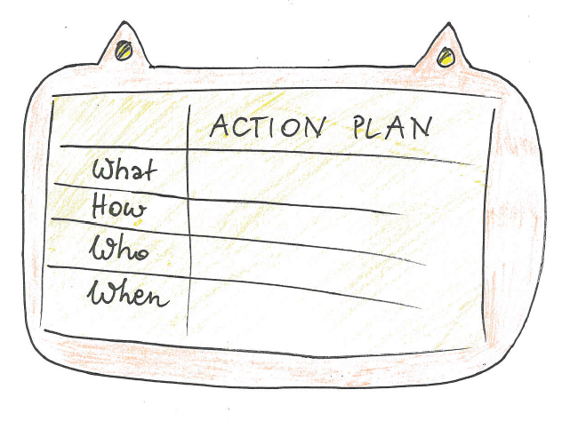
- What actions need to be done? Be specific.
- How are you going to perform the action?
- Who needs to be involved within the action?
- When does the action take place, or over what period of time? Divide between short term, medium term and long term actions.
Source: SMACC
- Where does the action take place?
What resources are needed for the action?

Materials:
Flipover sheet, felt pens

More resources
Smart City: Amsterdam example
https://www.youtube.com/watch?v=Uzjqtxox3lY
Smart City: Norwegian Centres of Expertise
https://www.youtube.com/watch?v=KSJWA8YTdKM
Smart City: Adelaide example
https://thenextweb.com/syndication/2017/08/26/this-australian-capital-yes-theres-more-than-one-shows-that-smart-cities-will-be-awesome-for-everyone/
Smart City: Florida and Colorado example
https://www.theguardian.com/sustainable-business/2016/aug/09/florida-colorado-smart-cities-sustainable-solar-babcock-ranch-pena
Smart City and participation
https://www.techgoondu.com/2017/08/29/qa-a-smart-city-has-to-solve-problems-not-just-deploy-technology-says-imec/
A talk “How do we build the cities of tomorrow”
https://www.youtube.com/watch?v=YGOVEvm7dm0
Internet of Things
https://www.youtube.com/watch?v=3xOK2aJ-0Js
Europe's first carbon neutral neighborhood - Malmo example
https://www.youtube.com/watch?v=6yZYXSsWnsg
A Talk on changing mindsets about urban planning and living
https://www.youtube.com/watch?v=Lid9ELzzT8Y
New public and private funding strategies for urban parks
https://cities-today.com/new-public-and-private-funding-strategies-for-urban-parks/
The six top trends in government innovation
https://apolitical.co/trends-government-innovation/
The sharing economy
https://www.forbes.com/sites/bernardmarr/2016/10/21/the-sharing-economy-what-it-is-examples-and-how-big-data-platforms-and-algorithms-fuel/
Bike sharing: San Francisco example
http://www.sfchronicle.com/business/networth/article/San-Francisco-issues-permit-rules-for-stationless-11281616.php
Urban Heat Islands
https://www.theguardian.com/sustainable-business/2017/feb/21/urban-heat-islands-cooling-things-down-with-trees-green-roads-and-fewer-cars
Design Factory Global Network
http://dfgn.org/
IDEO's Design Thinking for educators toolbox
http://www.designthinkingforeducators.com/
Videos on Design Thinking Approach
https://www.youtube.com/watch?v=Ee4CKIPkIik
https://www.youtube.com/watch?v=0DeBHxnR0kM
Problem solving with design thinking: book tip
https://yourstory.com/2015/05/problem-solving-with-design-thinking/
Business Model Canvas
http://www.businessmodelgeneration.com/canvas/bmc
Labcraft: How Innovation Labs cultivate change through experimentation and collaboration. Hendrik Tiesinga and Remko Berkhout (2014)
http://labcraft.co/
The Living Lab Methodology Handbook
https://www.ltu.se/cms_fs/1.101555!/file/LivingLabsMethodologyBook_web.pdf

Impressum
Published by:
e-genius –Open Education Initiative
in Science and Technology
Postfach 16
1082 Wien
Austria
E-mail: info(at)e-genius.at
E-mail: katharina.zwiauer(at)egenius.at

Authors: Marcel Crul, Hans Schnitzer, Barbara Hammerl, Gosia Stawecka
E-Learning Consultant: Katharina Zwiauer (e-genius)
Layout: e-genius –Open Education Initiative
January 2017

Project: SMACC – Smart City Coaching
This learning unit was funded with support from the European Commission. This publication reflects the views only of the author, and the Commission cannot be held responsible for any use which may be made of the information contained therein.

Partner:

Legal notice
This learning unit is provided under the following Creative Commons Licence:
Attribution-NonCommercial-ShareAlike 4.0 International (CC BY-NC-SA 4.0) https://creativecommons.org/licenses/by-nc-sa/4.0/deed.en
You are free to:
- Share — copy and redistribute the material in any medium or format
- Adapt — remix, transform, and build upon the material
The licensor cannot revoke these freedoms as long as you follow the license terms.
Under the following terms:
- Attribution — You must give appropriate credit, provide a link to the license, and indicate if changes were made. You may do so in any reasonable manner, but not in any way that suggests the licensor endorses you or your use.
- NonCommercial — You may not use the material for commercial purposes.
- ShareAlike — If you remix, transform, or build upon the material, you must distribute your contributions under the same license as the original.
No additional restrictions — You may not apply legal terms or technological measures that legally restrict others from doing anything the license permits.
Attribution to e-genius as the copyright owner must take the following form:
Texts: authors of the learning unit, year of publication, title of the learning unit, publisher: e-genius –Open Education Initiative, www.e-genius.at/en
Illustrations: attribution to owner of copyright, e-genius – www.e-genius.at/en
Exclusion of liability:
All content on the e-genius platform has been carefully checked. Nevertheless, we are unable to offer any guarantee as to the correctness, completeness, topicality and availability of the content. The publisher does not accept any liability for damage or disadvantages that may arise from the use or exploitation of the content. The provision of the content on e-genius is not intended to replace the obtaining of professional advice and the ability to access the content does not constitute an offer to create an advisory relationship.
e-genius contains links to external websites. The insertion of links is a reference to representations and (also other) opinions, but does not mean the content of such links are endorsed. The publisher of e-genius does not accept any liability for websites that are referred to via a link. This applies both to their availability and to the content that can be accessed on such websites. As far as the operators are aware, the linked pages do not contain any unlawful content; should such content be discovered, it will be immediately removed in fulfilment of the legal obligations of the electronic reference.
Third-party content is identified as such. Should you nevertheless become aware of an infringement of copyright, please let us know accordingly. Upon being notified of legal infringements, we will immediately remove or correct such content.
Link to the open content platform: http://www.e-genius.at/en

http://www.kent.ac.uk

